The Effectiveness of Android-Based Interactive Physics Mobile Learning Media to Improve Students’ Psychomotor and Self-Efficacy

Tiara Kusuma Ardiyati
Graduate School
Yogyakarta State University
Yogyakarta, Indonesia
atkindson@gmail.com

Suparno
Graduate School
Yogyakarta State University
Yogyakarta, Indonesia
suparno_mipa@uny.ac.id
Beatrix Elvi Dasilva
Graduate School
Yogyakarta State University
Yogyakarta, Indonesia
beatrix.elvi@gmail.com

Sukardiyono
Faculty of Mathematics and Natural Sciences
Yogyakarta State University
Yogyakarta, Indonesia
sukardiyono@uny.ac.id

Abstract—This study aims to find out know the effectiveness of learning using android-based IPMLM to improve psychomotor and self-efficacy of high school students. The research design uses Pretest-Posttest Control Group Design. The research subjects were 185 students of Class X MIPA from SMA N 1 Pakem, SMAN 2 Sleman, and MAN 3 Sleman and 210 students from class XI MIPA from SMAN 2 Kupang, SMAN 5 Kupang and SMAN 5 Kupang. Each school was taken two classes, namely the experimental class and the control class. Data collection instruments were self-efficacy questionnaires and psychomotor observation sheets checklist. Data were analyzed using descriptive statistics and inferential statistics. Descriptive statistical analysis was used to know the achievement of students' psychomotor and self-efficacy. The results showed that learning using Android-based IPMLM can improve students’ psychomotor and self-efficacy. Psychomotor skills increased by 46.6% through learning using Android-based IPMLM. Meanwhile, the effective contribution of Android-based IPMLM to self-efficacy was 53%.
Keywords—Android based-IPMLM, psychomotor, self-efficacy

Introduction
The demands of the 21st century require that every individual can utilize and be familiar with technology, including in education. One of its implications is the use of technology-based media as a support for learning activities. The integartion of technology in learning is expected to be a tool of achieving 21st century skills, such as critical thinking, problem solving, communication, and collaboration. The curriculum in Indonesia has tried to answer these demands. It is indicated by the necessity of mastering competence, which not only focuses on the cognitive domain, but also affective and psychomotor, including in Physics subjects [1]. This is in line with Mundilarto that one of form of Physics learning outcomes can be categorized into competencies in the form of behavior, namely cognitive, affective, and psychomotor [2]. Psychomotor skills are skills that require integration of motor skills that related to knowledge and values with require practice to master it [3]. Subjects related to psychomotor skills tend to aim at movement and focus on physical responses and hand dexterity. These skills indicate the level of proficiency in doing the task [4]. The example of psychomotor skills in physics is using tools such as calipers, stopwatches, and others.
Trowbridge and Bybee suggest that psychomotor aspects that can be assessed in Physics include moving, manipulating, communicating, and creating [5]. The moving aspect refers to a number of limb movements which implies coordination of physical movements. Manipulating refers to activities that encompass coordinated patterns of movements that connect parts of the body, for example coordination between the eyes, ears, hands, and fingers. Communicating refers to understanding activities that provide ideas and feelings for others to know. Meanwhile, creating refers to the process and performance that generated by the results of new thinking.
Beside the psychomotor domain, student’s self-efficacy is also important in physics learning. Self-efficacy is very influential on achievement in cognitive aspects. Bandura states that self-efficacy is related to one's belief in his ability to perform an action that is needed to achieve the goal [6]. Every person has different self-efficacy towards an ability. These differences can be seen through three aspects namely magnitude, strength, and generality [6]. The magnitude aspect is the level of difficulty associated with individual tasks. The strength aspect is related to the strength of one's belief in his abilities. The generality aspect is related to the wide range of actions that a person believes can be carried out.
Self-efficacy is very influential on the acquisition of knowledge and the development of student skills. Students who have higher self-efficacy towards learning make greater effort in their learning process [7] . In addition, students who have higher self-efficacy will be eager to do the assignments. Students with lower self-efficacy have low effort and can even avoid the assignments or problems that are given. Students who have more self-efficacy in learning will be more diligent and make greater effort [8]. Students with high self-efficacy always try to achieve goals, challenges, gain new knowledge and always try to surpass others [9]. This is evidenced by the results of research by Hamdi and Abdi that students who have higher self-efficacy get better learning outcomes than students with low self-efficacy [10]. Therefore, students’ self-efficacy in learning Physics need to be improved.
Physics learning practices in schools have not fully implemented the psychomotor and self-efficacy aspects. Based on observations at SMAN 1 Pakem, SMAN 2 Sleman, and MAN 3 Sleman showed that Physics practicum activities are rarely carried out. This results in psychomotor mastery not optimal, even though direct experience through practicum in Physics learning is very important to support students’ understanding. In addition, the results of observations and interviews conducted at SMAN 2 Kota Kupang, SMAN 3 Kota Kupang and SMAN 5 Kota Kupang showed that students’ motivation was still low. Students stated that Physics is a difficult subject to understand, so motivation to understand Physics concepts is low. The low of students’ learning motivation shows that self-efficacy is also low.
The problems in learning can be fixed by the use of technology as a medium for Physics learning. This is in line with the demands of 21st century that have been mentioned in previous statements. The integration of technology in learning can give an impact on improvement of students’ performance. Technology can facilitate self-learning, increase students’ involvement in learning, So, interactive learning can be occurred [11]. Technologies such as interactive multimedia can be learning tools for practicing psychomotor skills and strengthening students’ memory recall [12]. Technologies such as PhET simulations combined with simple practical tools can facilitate the achievement of psychomotor learning outcomes [13].
Along the rapid development of Android-based technology, the last few years have been much researched about mobile learning with smartphone technology. Faloon states that mobile learning using a smartphone device helps students arrange experiments, understand procedures, think about the influence of variables, communicate and present the results obtained [14]. The acceleration sensor on a smartphone can be used to measure the acceleration of gravity in a variety ways, namely free fall motion and reflection of the ball [15]. Abstract physical concepts can be imagined by android-based applications [16]. Students’ conceptual understanding and learning physics motivation is better when using Android-based animation media in learning [17]. Students can also become more active in discussing content with classmates and teachers, and also have an opportunity to collaborate through the use of applications on smartphone [18, 19]. The results of these studies indicate that mobile learning media in this case is an Android-based smartphone application is good and effective to improve students’ ability in the affective and psychomotor domains.

methodology
The research design used was Pretest-Posttest Control Group Design. The research subjects were 185 students of Class X MIPA from SMA N 1 Pakem, SMAN 2 Sleman, and MAN 3 Sleman and 210 students from class XI MIPA from SMAN 2 Kupang, SMAN 5 Kupang and SMAN 5 Kupang. Each school was taken two classes, namely the experimental class and the control class. Students in the experimental class using Android-based IPMLM in learning and students in the control class using the Physics textbook in learning.
Data collection instruments were self-efficacy questionnaires and psychomotor checklist observation sheets. Data were analyzed using descriptive statistics and inferential statistics. Descriptive statistical analysis was used to know the achievement of students’ psychomotor and self-efficacy. The categories of these results based on the ideal assessment criteria presented in Table 1 [20].
TABLE 1. THE CATEGORIES OF STUDENTS’ PSYCHOMOTOR
No | Range of scores | Predicate | Categories
1 | 75 < X bar | A | Very high
2 | 58.33 < X bar ≤ 75 | B | High
3 | 41.67 < X bar ≤ 58,33 | C | Sufficient
4 | 25 < X bar ≤ 41,67 | D | Low
5 | X bar ≤ 25 | E | Very low
The inferential statistic used is the ANAVA mixed design test.

Result and discussion
Psychomotor observations were carried out through Physics practicum activities three times. The first practicum is Newton's first law experiment, the second practicum is Newton's third law experiment, and the third practicum is the friction force experiment. Psychomotor aspects observed in this study were moving, manipulating, communicating, and creating. Every aspect is divided into indicators that are easy to observe. The moving aspect consists of four indicators, aspects of manipulating, communicating, and the aspect of creating consists of six indicators. The indicators achieved by each student are then summed and converted to scale of 100. Each psychomotor acquisition of these students is then categorized based on the ideal assessment criteria according to Sudijono presented in Table 1 [20].
Psychomotor results achieved by students are presented in the Figure 1.
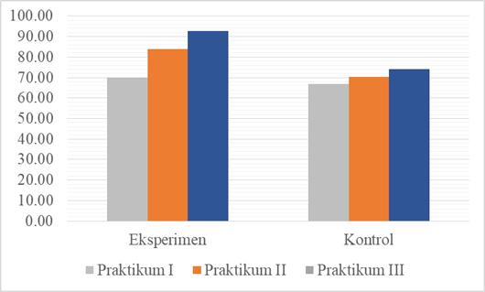
Fig. 1. The chart of psychomotor improvement
Figure 1 shows that the average psychomotor values of the experimental class at meetings I, II, and III are 69.98; 83.89; and 92.69. Meanwhile, the average psychomotor scores obtained by control class students at meetings I, II and III are 66.92; 70.28; and 74.19.
Psychomotor scores are further elaborated based on the categories achieved by students in first practicum and third practicum. Figure 2 presents the initial psychomotor scores in first practicum (pretest) in both classes.
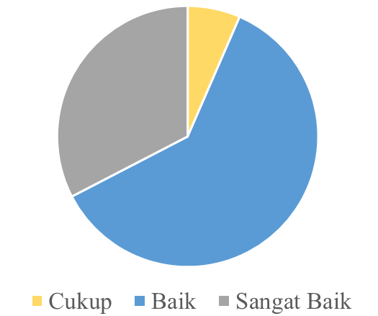 | 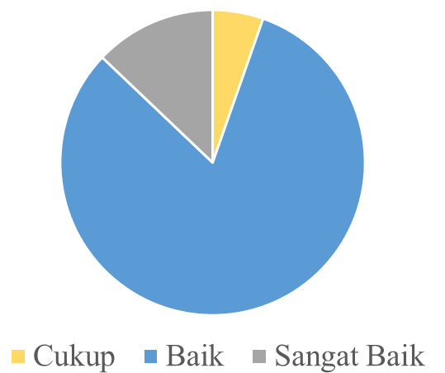
(a) | (b)
Fig. 2. Percentage of psychomotor pretest categories in experiment class (a) and control class (b)
Figure 2 shows that there are 6.5% of students included in the sufficient category; 60.9% of students are in high category; and 32.6% of students are included in the very high category in the experimental class. Meanwhile, in the control class there were 5.4% of students categorized as sufficient; 82.6% of students were in the high category; and 13% of students are in the very high category.
Psychomotor posttest results using scores of third practicum. Figure 3 presents these results in the experimental class and the control class.
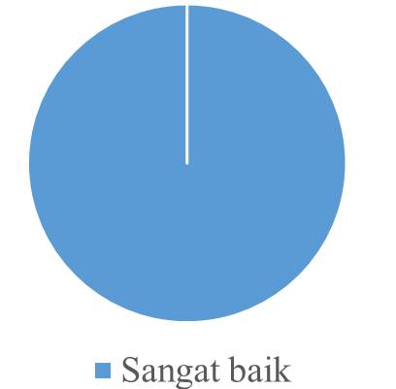 | 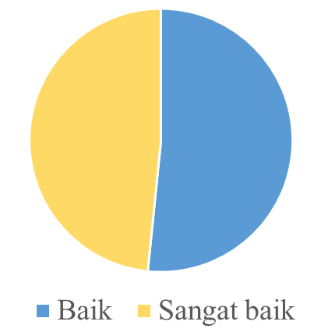
(a) | (b)
Fig. 3. Percentage of psychomotor posttest categories in experiment class (a) and control class (b)
Figure 3 shows an increase in psychomotor scores, both in the experimental class and the control class, compared to first practicum. However, the psychomotor improvement that occurs in the experimental class is better than the control class. All students in the experimental class can achieve very high category in third practicum. Meanwhile, 52% of students in the control class reach the high category and 48% reach very high category.
The significance of psychomotor uses partial eta squared parameter in ANAVA mixed design analysis and the result is 0.466. It means that the learning using Android-based IPMLM can improve student psychomotor up to 46.6%. The difference in the improvement of psychomotor between the experimental class and the control class can be observed in Figure 4.
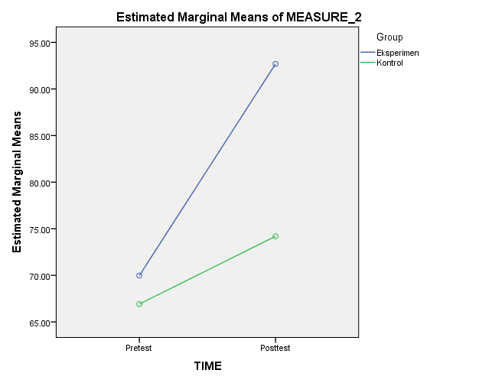
Fig. 4. The graph of psychomotor improvement
Figure 4 shows that there are differences in improvement between the experimental class and the control class. This is indicated by the slope of the graph in the experimental class is steeper than the graph in the control class. The difference between the initial positions of the two graphs is due to the psychomotor pretest data obtained from first practicum namely Newton’s first law experiment. The practicum was conducted at the first meeting when the students in the experimental class had received learning treatment. Meanwhile, the posttest was taken from the results of third practicum, that is the friction force experiment.
Based on the results of the achievement of psychomotor, it can be said that learning using Android-based Interactive Physics Mobile Learning Media has a positive effect on the improvement of high school students’ psychomotor. It can be occurred because Interactive Physics Mobile Learning Media can facilitate students in elaborating psychomotor skills through the presentation of material that helps providing a basic understanding for students before doing practicum. Another role of IPMLM is to help present practical instructions in the form of video at the beginning of the practicum, so students can do experiment independently. These results are in line with Rajendra and Sudana who argue that information and communication technology is an effective tool to be used in the development of new learning methods and techniques. Interactive technologies such as multimedia devices are effectively used to teach cognitive, psychomotor skills, and strengthen subject matter memories [12]. In addition, Erlinawati, Suherman, and Darmawan found that m-learning media can improve understanding and practical ability. Enhanced aspects include creating, observing, identifying, and differentiating practicum objects [21].
Self-efficacy is one of the factors that affects students’ learning outcomes. The learning process, both in the control class and in the experimental class is expected to be able to improve students’ self-efficacy. Students’ self-efficacy is measured before learning to determine the students’ initial self-efficacy. Furthermore, after participating in learning as many as three meetings, Students’ self-efficacy were measured again. Self-efficacy is measured using a questionnaire with a rating scale, consisting of positive statements and negative statements. Students’ self-efficacy can be identified through three aspects namely magnitude, strength and generality. Figure 5 shows the results of students' self-efficacy before and after learning.
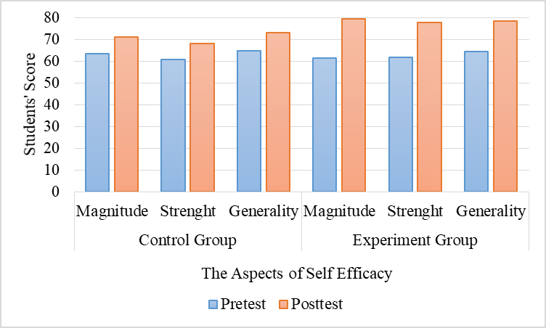
Figure 5. The graph of students’ self-efficacy
Figure 5 shows that every aspect of students’ self-efficacy in the control class and the experimental class have increased. The magnitude aspect in the control class increased by 7.69 and in the experimental class by 18.02;The strength aspect in the control class increased by 7.15 and in the experimental class by 15.33; The generality aspect in the control class increased by 8.23 ​​and in the experimental class by 13.83. These results are in line with the results of Bandura’s research that students’ self-efficacy can be improved and developed [22].
Figure 5 shows that the improvement of every aspect of self-efficacy in the experimental class is better than the control class. It happens because the effective contribution of using the media is greater than using the Physics textbook. Table 2 is the result of multivariate test of hotelling’s Trace type which shows the amount of effective contribution in each group towards students’ self-efficacy.
TABEL 2. THE RESULT OF MULTIVARIATE TEST
Group | F | Sig. | Partial Eta Squared
Experiment | 239,095 | 0,000 | 0,53
Control | 28,635 | 0,000 | 0,12
Table 2 shows that the effective contribution of the experimental class that implement learning using IPMLM application is 53%. The effective contribution to the control class that implement learning using Physics textbooks is 12%. Based on the effective contribution, it can be concluded that the learning process assisted by IPMLM is greater in improving self-efficacy abilities compared to the learning using Physics textbooks.
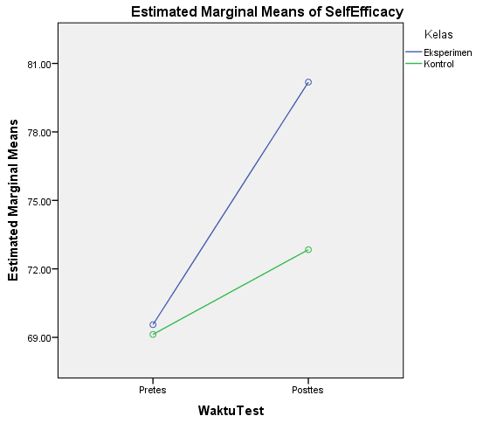
Fig. 6. The estimation of students’ self-efficacy
Figure 6 proves that students in the experimental class achieved higher self-efficacy than the control class. The IPMLM media used in Physics learning about thermodynamics positively influences students’ self-efficacy. The IPMLM media used is interactive, allowing students to choose different topics to study. By empowering students with freedom and responsibility to operate IPMLM content and applications, students can be motivated, so that self-efficacy will increase [23].
Learning using Physics textbooks is less effective in increasing self-efficacy compared to using Android-based IPMLM application. Similar research results show that the conception of low-level learning (memorizing, testing, counting and practicing) decrease students’ self-efficacy in learning science, while the conception of high-level learning (increased knowledge, application, and understanding) positively influences self-efficacy in learning science [24]. Learning using the IPMLM application in this study helps students find their understanding in depth. The teacher in learning, acts as a facilitator to help students find knowledge. For example, when students observe an animation video of thermodynamic processes presented in the IPMLM application. After observing the video, students express their understanding of thermodynamic processes based on video. So, it can be concluded that the method that requires students to think can improve self-efficacy better than the informative learning method.
The results of other studies indicate that self-efficacy can be increased through learning experiences. Students’ self-efficacy will increase if the learning process is associated with prior knowledge [25]. These results are consistent with Piaget’s theory of constructivism, which states that learning is easier when learners can connect new knowledge with existing knowledge, by linking new knowledge into existing cognitive schemes [26]. Learning in the experimental class, the teacher connects the material with everyday phenomena assisted by IPMLM application. For example, the teacher conveys the concept of thermal equilibrium in the early stages of learning by showing the phenomena (in IPMLM) commonly encountered by students (nurses measure the temperature of a fevered patient and the temperature of the thermometer increase). In addition, the teacher guides the students to understand the concept of thermal equilibrium by connecting the material with the phenomena of compressing a fevered body with a cold towel. This process also sharpens the aspect of self-efficacy, that is the generality aspect. This learning process causes self-efficacy in the experimental class to be higher than in the control class.

CONCLUSION
The results showed that learning using Android-based IPMLM can improve students’ psychomotor and self-efficacy. The average of psychomotor pretest in experimental class is 69.98 and the posttest is 92.69. Therefore, psychomotor skills increased by 46.6% through learning using Android-based IPMLM. Meanwhile, the average of self-efficacy pretest in experimental class is 69.557 and the posttest is 80.181. Therefore, the effective contribution of Android-based IPMLM to self-efficacy is 53%. Android-based IPMLM can facilitate students in elaborating psychomotor skills through the presentation of material that helps providing a basic understanding for students before doing practicum. Android-based IPMLM helps present practical instructions in the form of video at the beginning of the practicum, so students can do experiment independently. Beside that, students’ self-efficacy can increase when students’ connects the physics concepts with everyday phenomena presented in Android-based IPMLM application.
.

References
- Direktorat Pembinaan Sekolah Menengah Atas, Implementasi Pengembangan Kecakapan Abad 21 dalam Perencanaan Pelaksanaan Pembelajaran (RPP), Jakarta: Kementerian Pendidikan dan Kebudayaan, 2017.
- Mundilarto, Penilaian Hasil Belajar Fisika, Yogyakarta: UNY Press, 2012.
- J. Tollefson and E. Hillman, Clinical Psychomotor Skills: Assesment tools for nurses (3-point), Melbourne: Cengage Learning Australia Pty Limited, 2019.
- Amirono & Daryanto, Evaluasi dan Penilaian Pembelajaran Kurikulum, Yogyakarta: Gava Media, 2016.
- L.W. Trowbridge and R.W. Bybee, Becoming a Secondary School Science Teacher (4th Edition), Europe: Merril Publishing Company, 1973.
- A. Bandura, “Self-efficacy: toward a unifying thery of behavioral change,” Psychological Review vol. 84 (2), pp.191-215, 1977.
- A. Bandura, Self efficacy: the exercise of control, New York: W.H. Freeman and Company, 1997.
- J.E. Ormrod. , Psikologi Pendidikan, Jakarta: Erlangga, 2009.
- M. Komarraju and D. Nadler, “Self-efficacy and academic achievement:why do implicit beliefs, goals, and effort regulation matter,” Learning and Individuals Differences, vol. 25, pp. 67-72. https://doi.org/10.1016/j.lindif.2013.01.005
- S. Hamdi and A.M. Abadi, “Pengaruh motivasi, self-efficacy dan latar belakang pendidikan terhadap prestasi matematika mahasiswa PGSD STKIP-H dan PGMI Iaih,” Jurnal Riset Pendidikan Matematika, vol. 1, pp. 77-87, 2013. https://doi.org/10.21831/jrpm.v1i1.2666
- K. Ciampa, Gallagher, and L. Tiffany, “Getting in Touch: Use of Mobile Devices in the Elementary Classroom,”. Computers in the Schools, vol. 30, pp. 309–328, 2013. http://dx.doi.org/10.1080/07380569.2013.846716.
- I.M. Rajendra and I.M Sudana, “Influence of Interactive Multimedia Technology to Enhance Achievement Students on Practice Skills in Mechanical Technology,” Journal of Physics Conference Series, vol. 953, pp. 1-5, 2018. http://dx.doi.org/10.1088/1742-6596/953/1/012104.
- S. Prihatiningtyas, T. Prastowo, and B. Jatmiko, “Implementasi Simulasi PhET dan Kit Sederhana untuk Mengajarkan Keterampilan Psikomotor Siswa pada Pokok Bahasan Alat Optik” Jurnal Pendidikan IPA Indonesia, vol. 2, pp. 18-22, 2013. https://doi.org/10.15294/jpii.v2i1.2505.
- G. Faloon “Mobile devices and apps as scaffolds to science learning in the primary classroom,” Journal of Science Education and Technology, vol. 26 (6), 2017. http://dx.doi.org/10.1007/s10956-017-9702-4.
- J. Kihn, “Smartphones as experimental tools: different methods to determine the gravitational acceleration in classroom physics by using everyday devices,” European Journal of Physics Education, vol. 4 (1), 2013. Retrieved from https://search.proquest.com/openview/9e42af64fb7ee1e6de6cddbe2b324d76/1?pq-origsite=gscholar&cbl=1946345.
- W. S. Hadi and P. Dwijananti, “Pengembangan komik Fisika berbasis android sebagai suplemen pokok bahasan radioaktivitas untuk sekolah menengah atas,” Unnes Physics Education Journal, vol. 4(2), 2015. Retrieved from http://lib.unnes.ac.id/23253/1/4201410097.pdf.
- R. D. Anggraeni and R. Kustijono, “Pengembangan media animasi fisika pada materi cahaya dengan aplikasi flash berbasis android”, Jurnal Penelitian Fisika dan Aplikasinya (JPFA), vol. 3, pp. 11-18, 2013. http://dx.doi.org/10.26740/jpfa.v3n1.p11-18.
- P. Santos, J. Cook, and D. Hernández-Leo,”M-AssIST: Interaction and scaffolding matters in authentic assessment” Educational Technology & Society, vol. 18 (2), pp. 33–45, 2015. Retrieved from http://www.jstor.org/stable/jeductechsoci.18.2.33.
- D. S. A. Hamdani, “Mobile Learning: A good practice,” Procedia Social and Behavioral Sciences, vol. 103 , pp. 665 – 674, 2013. https://doi.org/10.1016/j.sbspro.2013.10.386.
- A. Sudijono, Pengantar Evaluasi Pendidikan, Jakarta: Rajawali Pers, 2009.
- N.A. Erlinawati, U. Suherman, and D. Darmawan, “Media Pembelajaran Mobile Learning untuk Meningkatkan Motivasi dan Kemampuan Praktikum,” Jurnal Ilmu Kependidikan, pp. 298-310, 2016.
- A. Bandura, “Human agency in social cognitive theory,” American Psychologist, vol. 44, pp. 1175-1184, 1989.
- Zhu, Yue, W. Au, and Yates, “University students' self-control and self regulated learning in a blended course,” Internet and Higher Education, vol. 30, pp. 54-62, 2016. https://doi.org/10.1016/j.iheduc.2016.04.001.
- C. C. Tsai, H.N.J. Ho, J. C. Liang, and H. M. Lin “Scientific epistemic beliefs, conceptions of learning science and self efficacy of learning science among high school students,” Learning and Instruction, vol. 21, pp. 757-769, 2011. https://doi.org/10.1016/j.learninstruc.2011.05.002.
- A. Littlejohn, N. Hood, C. Milligan, and P. Mustain, Learning in MOOCs: motivations and self-regulated learning, The Internet and Higher Education vol. 29, pp. 40-48, 2016. Retrieved from http://www.sciencedirect.com/science/article/pii/S1096751615300099
- R.E. Slavin, Psikologi pendidikan: Teori dan praktik, Jakarta: PT. Indeks, 2017.

