The Implementation of Flipped Classroom as an Attempt to Improve Indonesian EFL Learners’ Speaking Performance

Taufik
English Language Education Program
Universitas Negeri Yogyakarta
Yogyakarta, Indonesia
ofickone@gmail.com
Widyastuti Purbani
English Language Education Program
Universitas Negeri Yogyakarta
Yogyakarta, Indonesia
Purbani@uny.ac.id

Abstract—Speaking skill is considered as a crucial skill for English foreign language learners. This skill needs to be developed not only at schools but also outside. Hence, English teachers should facilitate their students in improving this skill both inside and outside schools. Unfortunately, in Indonesia, most of the teachers encourage their students to develop other skills required for facing the national examination. As a result, the students have a very poor speaking performance. It was in line with the preliminary finding in a private vocational high school in East Lombok. Based on the finding, this research aimed at improving the students’ speaking performance by administering a method called flipped classroom that can support students for developing their speaking skill both inside and outside schools. This research used the action research adopted from Kemmis and McTaggart by involving nineteen students in the tenth grade of a private vocational high school in East Lombok, Indonesia. The procedures were planning, acting and observing, and reflecting done collaboratively with the English teacher. Then, the data were collected from observation and speaking tests and analyzed using thematic analysis and a Paired Sample T-test of SPSS. After analyzing the data, the result showed that there was a significant improvement in the students' speaking performance. Thus, it can be concluded that the flipped classroom method significantly improves the students' speaking performance.
Keywords—flipped classroom, speaking, collaborative action research)

Introduction
English is still the favorite language in the world. It is the primary language used of 4000 to 5000 languages in the world [7]. It is because this is an international language used for communication with people around the world. Many people learn this language to find jobs, run businesses, study abroad, get scholarships, face national examinations, etc.
However, speaking English is not easy, particularly for EFL learners since it is not used in daily communication. It is called as an EFL language when it cannot be found beyond the school context [6]. Thus, Indonesian students are considered as EFL learners that they cannot use it in daily communication. Consequently, they did not get adequate input regarding elements of speaking, such as; vocabulary, pronunciation, fluency, etc. Unfortunately, in classrooms, teachers focused on preparing students for the national examination. Therefore, most teachers teach students to develop their reading and writing skills [2].
This little attention causes mostly Indonesian students do not have a good ability in speaking English. This was in line with my preliminary finding when assessing the students’ speaking performance in a private vocational high school. I found that the mean score was 47.37 that the score was considered as a very poor speaking performance.
To solve this problem, it is required a method that can facilitate the students in developing their speaking skill outside and inside the school. Several pieces of researches found that the flipped classroom can develop students' speaking skills [10, 17, 18].
The flipped classroom is an instructional method that supports the instructional process inside and outside school. Outside school, students can be assisted to get more inputs regarding elements of speaking, mainly vocabulary, pronunciation, accuracy, etc. These inputs might be delivered in the form of videos previous days before class hours. As a result, students will have better preparation before entering classrooms [10]. Meanwhile, in classrooms, students can ask, discuss, debate, and present the content of videos watched before. Hence, this research aimed at improving the students’ speaking performance in the private vocational high school in East Lombok.

literature review

Speaking
Speaking is one of the productive skills required by people to communicate with others. It is a process of practicing a language to deliver meanings that the listeners can get the ideas [7]. Also, it can be defined as a process for conveying purposes [12]. Furthermore, it is a process for maintaining a social life, communicating with friends, seeking and conveying ideas, persuading someone, clarifying information, giving instructions, describing something, etc. [15]. In other words, this is vital for students’ life.

Flipped classroom
The flipped classroom was formerly introduced by two chemistry teachers in 2007. Bergmann and Sams were well-known as the pioneers of this method because they told the emergence of this method comprehensively in a book, “Flipped Your Classroom Reach Every Student in Every Class Every Day,” published in 2012. These teachers started their teaching at Woodland Park High School in 2006. Due to their friendship and similar philosophies in teaching, they tried to collaborate for planning their teaching.
Unfortunately, few students missed the class in joining sports competitions. Besides, few others missed the class because of the distance from their house to school. For figuring out these problems, both teachers recorded their live teaching videos. In 2017, they published the videos on YouTube to help the students who could not attend the meetings to learn individually at home. Since the absent students loved the learning technique and others could re-watched the teaching videos, these teachers continued to record all their lectures beyond the school then published them online.
Nowadays, this method becomes “a trend” in teaching [11]. It is due to this method along with the development of technology. This method can be defined as a pedagogical method that shifts the traditional instructional process in which the materials are learned at home, meanwhile, the homeworks are completed at school [5]. Commonly, the materials are downloaded from YouTube then sent to students previous days before class hours that students have ample time for learning the materials before class hours. If feasible, teachers are allowed to create their teaching videos.
By watching videos delivered, students have the freedom to determine their learning environment [9]. They are allowed to determine where and where to learn. Besides, they may adjust their own speed in learning because videos can be paused, re-winded, and re-played [5,16]. Therefore, students with various learning abilities can be covered [3,5].
Meanwhile, during class hours, teachers have adequate time for checking and strengthening students’ comprehension regarding video content. Diverse activities can be implemented such as; asking and answering questions, discussing the contents, giving critiques, and completing assignments [1, 4, 5, 18]. Indeed, students can present the materials watched previously.
Flipped classroom
Beyond classrooms
Inside classrooms
Teachers deliver materials a few days before class hours
Teachers check and strengthen students' comprehension
Students watch videos sent
Students ask, discuss, present materials watched at home, etc.
Fig. 1. Instructional process in the flipped classroom
Numerous researches found that this method enhanced the students’ ability in communication. Tazijan, Abdullah, Zainol, Noor and Joharis researched 87 students of Universiti Teknologi Mara, Penang. This research aimed at analyzing the effectiveness of the flipped classroom method in improving the students' communication skills and abilities. It found that there was an improvement in the students’ communication skills and a positive relationship between the flipped classroom and active learning [17].
Another research was conducted by Teng. He researched 3 classes of English major students of a university in China to measure the possible impact that the flipped classroom had on the improvement of the students' academic performance, as well as their satisfaction in a cross-cultural communication course. Finally, he found that the students who were taught using the flipped classroom method had a more positive attitude and more satisfaction in learning. Further, this method improved the students' academic performance and communication, supported the format of the learning materials, encouraged autonomous learning, increased the students' participation in and out of the class hours, promoted active cooperation, self-assessment, and peer-assessment [18].
In a similar vein, El-sawy researched 49 students in Reading Course 1 at Al-Jouf University, KSA. He aimed at investigating the students’ perception of flipping EFL classes with the blackboard system. His research found that the flipped classroom supported the development of pronunciation, vocabulary learning, better preparation of classwork, better opportunities for communication with teachers, more reading at home, better reading comprehension, and the efficiency of time for more practice [10].
In light of researchers’ findings above, the flipped classroom can develop the students’ ability in communication. Thus, this research aimed at enhancing the speaking performance of the students at the private vocational high school using the flipped classroom method.

method
The participants of this research were 19 students in the tenth grade of a private vocational high school in East Lombok, Indonesia. Of 19 students, 10 were males and 9 were females. They were around 16 years old.
This research was conducted for 8 meetings, from February to April at the even semester of the academic year 2018/2019. Each meeting was carried out for 3 hours (3x45 minutes). Thus, there were 24 (24x45 minutes) class hours allocated for 8 meetings.
This research was done collaboratively with the English teacher by employing the action research method designed by Kemmis and McTaggart. The cycles of this method were planning, acting and observing, and reflecting. The data were qualitative and quantitative.
The qualitative data were collected from observation by writing vignettes, taking pictures, and recording in videos. Meanwhile, the quantitative data were obtained from the speaking tests in which the students were assigned to speak individually in front of the classroom.
Then, the students’ speaking performance was scored using the proficiency description and weighting table proposed by Adam and Firth [13]. This proficiency description was adapted and validated by 2 expert judgments before it was used for scoring the students’ performance. Elements of speaking measured were the accent, grammar, vocabulary, and fluency. The range score was 1-6 for each element. Then, the scores obtained were converted into the following weighting table;

TABLE 1. WEIGHTING TABLE
Aspects of speaking | Speaking Score |  |  |  |  |  | Amount  (A)
Aspects of speaking | 1 | 2 | 3 | 4 | 5 | 6 | Amount  (A)
Accent | 0 | 1 | 2 | 2 | 3 | 4
Grammar | 6 | 12 | 18 | 24 | 30 | 36
Vocabulary | 4 | 8 | 12 | 16 | 20 | 24
Fluency | 2 | 4 | 6 | 8 | 10 | 12
Total = (A) + 24
After scoring and inverting the scores into the weighting table, it was categorized into some level such as; very poor (1-49), poor (50-59), sufficient (60-74), good (75-84), and very good (85-100).
Furthermore, for qualitative data, I used thematic analysis referring to Norton’s book, “Action research in teaching and learning: A practical guide to conducting pedagogical research in universities [14].” Moreover, a Paired Sample T-test analysis of SPSS version 22 was used to analyze the quantitative data. Meanwhile, this research would be ended when the mean score of the students was larger than 65.00.

finding and discussion
This research was conducted in 2 cycles. However, before beginning cycle 1, the students were assessed to measure their prior ability in speaking. They were assigned to come forward one by one to tell their holiday experience in 3-5 minutes. Some clues were written down on the whiteboard to guide the students in telling their experience.
Vignette (Saturday/February, 16th 2019)
.... almost all students could not produce the language grammatically. They used verb 1 rather than verb 2. Also, they produced a very limited vocabulary that sometimes, they asked their friends the English of certain words. Besides, they frequently produced incorrect pronunciation.
TABLE 2. PRE-CYCLE SCORE CATEGORY
Speaking Scores in Pre-cycle
Category | Value range | Frequency | Percentage
Very good | 85-100 | 0 | -
Good | 75-84 | 0 | -
Sufficient | 60-74 | 3 | 15.78%
Poor | 50-59 | 3 | 15.78%
Very Poor | 0-49 | 13 | 68.42%
The findings above showed that the majority of the students had a very poor speaking performance. There were 13 or 68.42% of 19 students had a very poor speaking performance. Besides, 3 or 15.78% of students were identified at a poor speaking level and the rest students were at a sufficient level. Unfortunately, no one of the students was in a very good and good category since the highest score obtained was 62. Then, concerning the mean score, it was 47.37. Therefore, the category of the students’ speaking performance in this cycle was a very poor level.

Cycle 1
Based on the result found in the pre-cycle, the English teacher and I carried out collaborative action research to increase the students' speaking performance by implementing the flipped classroom method. Firstly, in the planning session, we discussed the lesson plans and the learning contents that would be delivered to the students. The learning contents were downloaded from YouTube. Numerous videos were downloaded regarding the list of regular and irregular verbs and its pronunciation, simple past tense, conjunction, adverb of time, and explanation of recount text.
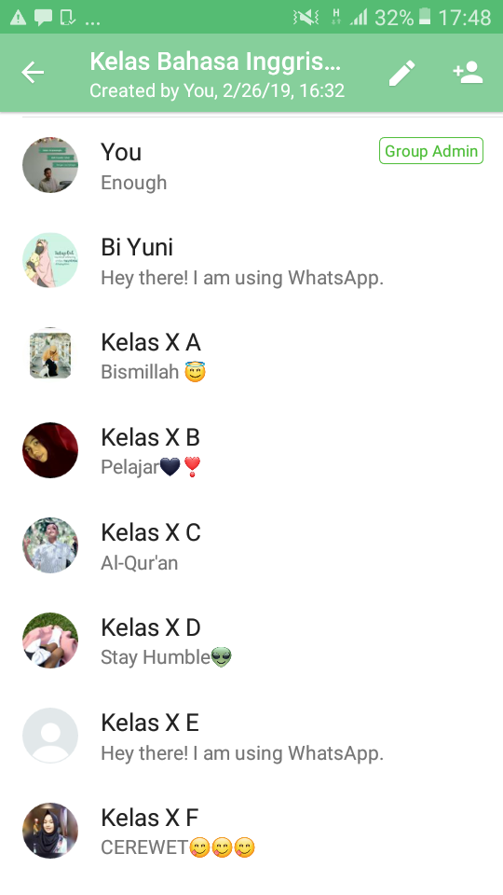

Fig. 2. WhatsApp group
Secondly, in the acting and observing session, I delivered the learning content videos previous days before class hours via WhatsApp group since the students and the collaborator recommended me to deliver the videos through the application.

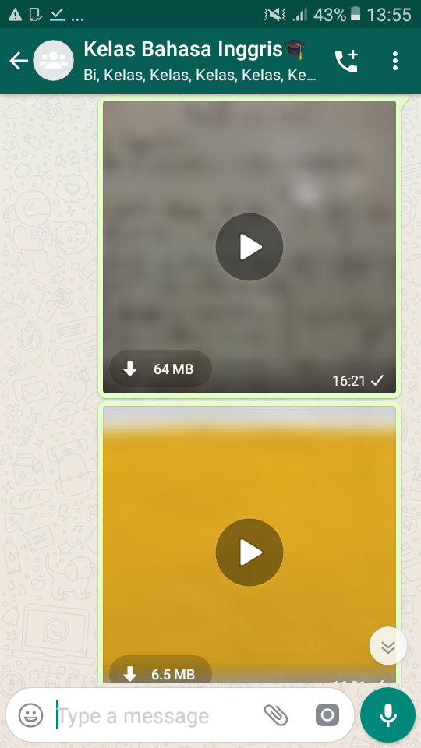
Fig. 3. Example of videos sent
Then, at class hours, the activities were asking and answering questions, discussion, playing games, practicing pronunciation, completing assignments, and presenting the content of the videos. In this sense, the collaborator and I facilitated and observed the instructional process.
Thirdly, in the reflecting session, the students were assigned to come forward one by one to re-tell their holiday experience in 3-5 minutes following the clues written on the whiteboard.
Vignette (Saturday/March, 30th 2019)
.... Based on my observation, the students’ speaking performance was much better than in the previous assessment. ....
TABLE 3. CYCLE 1 SCORE CATEGORY
Speaking Scores in cycle 1
Category | Value range | Frequency | Percentage
Very good | 85-100 | 0 | -
Good | 75-84 | 0 | -
Sufficient | 60-74 | 5 | 26.31%
Poor | 50-59 | 5 | 26.31%
Very Poor | 0-49 | 9 | 47.36%
The result of the students’ speaking performance above revealed that most students, 9 or 47.36% were identified at a very poor speaking level. Indeed, 5 or 26.31% of students were at a poor speaking level, the same as the students at a sufficient level. However, no one of the students was considered at a good and very good level. Further, in the sense of the mean score, it was 53.11. Therefore, there was development in the mean score from a very poor speaking performance to a poor level.
Then, after conducting the Paired Sample T-test, the result showed that the students’ speaking score in cycle 1 (M: 53.11, D: 75.12) was larger than in the pre-cycle (M: 47.37, D: 79.18, t(-5.33)) = 18, p<0.05. It means that there was a statistically significant difference in the mean score between pre-cycle and cycle 1. In other words, the students' speaking performance from pre-cycle to cycle 1 improved significantly.
Nevertheless, although there was a significant improvement in the mean score, it was lower than 65.00. Thus, we decided to continue to the next cycle.

Cycle 2
After completing the cycle 1, the collaborator and I continued to cycle 2 in which the similar cycle was carried out with some revised activities suggested by the students and the collaborator. Re-planning session, in this session, we discussed several obstacles found in cycle 1, such as; some students did not have a network connection; the videos were too long; the students could not use was and were in sentences. To solve the problems, we considered the following solutions; delivering materials via WhatsApp and Bluetooth application that all students might access the videos with or without an internet connection; editing learning content videos into shorter length; delivering lecturing videos of the usage of was and were.
In acting and observing session, I sent the videos regarding the explanation of was and were, the relevant vocabulary of biography figures and examples of biography figures a few days before meetings via WhatsApp group. Meanwhile, the collaborator sent the videos at school on the same day via Bluetooth.
Then, at the meetings, the students were asking and answering questions, playing games, discussion, completing assignments, and presenting the video contents. Finally, in the reflecting session, the students were assigned to come forward to re-tell the biography of their Idol in 3-5 minutes following the clues written on the whiteboard.
Vignette (Saturday/April, 27th 2019)
.... After the students presented their idol, I gave them feedback and appreciation. I told them that the students’ performance was very good. I was satisfied with it. ....

TABLE 4. CYCLE 2 SCORE CATEGORY
Speaking Scores in cycle 2
Category | Value range | Frequency | Percentage
Very good | 85-100 | 0 | -
Good | 75-84 | 4 | 21.05%
Sufficient | 60-74 | 12 | 6.315%
Poor | 50-59 | 3 | 15.78%
Very Poor | 0-49 | 0 | -
Based on the speaking assessment administered to the students in cycle 2, the finding showed that the majority of the students, 12 or 63.15% were at a sufficient level. Moreover, 4 or 21.05% of students were considered at a very good speaking level, and the rest of the students, 3 or 15.78% were at a poor speaking level. On the other hand, no one of the students was at a very poor speaking level. Besides, the mean score was 67.21, larger than the mean score in cycle 1, 53.11.
Meanwhile, after conducting the Paired Sample T-test, the result revealed that the scores of the students in cycle 2 (M: 67.21, D:75.10) were greater than in cycle 1 (M: 53.11, D: 75.12, t(-10.265)) = 18, p<0.05. Since the p-value was less than 0.05, it means that there was a significant difference in the mean score in cycle 1 and cycle 2. Thus, there was a significant improvement in the students’ speaking ability from cycle 1 to cycle 2.
The improvement was significant and consistent after the implementation of the flipped classroom method in cycle 1 and cycle 2. Because the mean score was larger than 65.00, the successful criteria were achieved. Hence, this cycle was not continued to the next cycle.

CONCLUSION
The findings showed that there was a significant improvement of the mean score from pre-cycle to cycle 1, and from cycle 1 to cycle 2. Respectively, the mean scores were 47.37, 53.11, 67.21. As a result, it can be concluded that the flipped classroom is a pedagogical method that can significantly improve the students' speaking performance.

Acknowledgment
Thanks to LPDP (Indonesia Endowment Fund for Education) that fully funded this research.

References
- B. S. M. Abdelshaheed, “Using flipped learning model in teaching English language among female English majors in Majmaah University,” Journal English language teaching, vol. 10, pp. 96–110, 2017.
- A. Z. Amrullah, “Developing language games to teach speaking skill for Indonesian senior high school learners,” JEELS, vol. 2, pp. 13-33, 2015.
- S. Arnold-Garza, “The flipped classroom teaching and its use for information literacy and instruction,” Communication in information literacy, vol. 8, pp. 7-22, 2014.
- A. Basal, “The implementation of flipped classroom in foreign language teaching,” Turkish online journal of distance education-TODJE, vol. 16, pp. 28-37, 2015.
- J. Bergmann, and A. Sams, Flip your classroom reach every student in every class every day, Washington, USA: iste, 2012.
- H. D. Brown, Teaching by principle in interactive approach to language pedagogy (2nd Ed), San Fransisco, USA: Longman, 2000.
- G. Broughton, C. Brumfit, R. Flavell, H. Hill, and A. Pincass, Teaching English as a foreign language (2nd Ed), New York, USA: Routledge, 1980.
- L. Cameron, Teaching language to young learners, New York, USA: Cambridge University Press, 2001.
- E. Ekmekci, “The flipped writing classroom in Turkish EFL context: A comparative study on a new model,” Turkish online journal of distance education-TODJE, vol. 18, 151-167, 2017.
- H. E. A. El-Sawy, “Flipping EFL university classes with blackboard system,” English language teaching, vol. 11, 31-43, 2018.
- Y. J. Han, "Successfully flipping the ESL classroom for learner autonomy," NYS Tesol journal, vol.2, 98-109, 2015.
- Holtgraves, "Speaking and listening," in Handbook of communicative competence, G. Rickheit, and H. Strohner, Eds. Berlin: Walter De Gruyter GmbH dan Co. K. G., 2008, pp.207-224.
- A. Hughes, Testing for language teachers (2nd Ed.), United Kingdom: Cambridge University, 2003.
- L. S. Norton, Action research in teaching and learning: A practical guide to conducting pedagogical research in Universities, Oxon: Routledge, 2009.
- K. Shumin, "Factors to consider: Developing adult EFL students' speaking abilities," in Methodology in language teaching: An anthology of current practice, J. C. Richards and W. A. Renandya, Eds. Cambridge: Cambridge University, 2002, pp.204-211.
- W. R. Slomanson, ”Blended learning: A flipped classroom experiment,” Journal of legal education, vol. 64, pp.93-102, 2014.
- F. N. Tazijan, C. H. Abdullah, N. Zainol, S. M. Noor, and N. R. Joharis, “Building communication skills through flipped classroom,” International academic research journal, vol. 3, pp.142-147, 2017.
- M. F. Teng, “Flipping the classroom and tertiary level EFL students’ academic performance and satisfaction, The journal of ASIA TEFL, vol. 4, 605-620, 2017.

