The Effectiveness of Javanese Graded Readers to Teach Reading Comprehension

Supartinah
Pendidikan Guru Sekolah Dasar
Universitas Negeri Yogyakarta
Yogyakarta, Indonesia
supartinah@uny.ac.id

Endang Nurhayati
Pendidikan Bahasa Jawa
Universitas Negeri Yogyakarta
Yogyakarta, Indonesia
endang_nurhayati@uny.ac.id

Sekar Purbarini Kawuryan
Pendidikan Guru Sekolah Dasar
Universitas Negeri Yogyakarta
Yogyakarta, Indonesia
sekarpurbarini@uny.a.c.id

Woro Sri Hastuti
Pendidikan Guru Sekolah Dasar
Universitas Negeri Yogyakarta
Yogyakarta, Indonesia
woro_srihastuti@uny.ac.id

Abstract– Reading in the Javanese language is challenging for early grade students of elementary schools. Graded reading books to ease up reading in the language have not been available. This R & D work has previously produced graded readers written in the Javanese language. This study is then intended to know the effectiveness of the books in the teaching of reading comprehension to the students of the early grades of elementary schools. This was a quasi-experimental research. The population of this study was all the 138 early grade students with class 2A and class 2B as samples. The data were collected using learning observation sheets and tests to be then analyzed using t-test. The results show that the t-count was 0.000 <t-table 0.005. There is a positive and significant influence of Javanese graded readers on the reading comprehension skills of the early grade elementary school students.

Keywords - Efectiveness, Javanese Graded Readers, Reading Comprehension

Introduction

Indonesia has many local languages. They have enriched the vocabulary of Indonesian as the national language. Many words of the local languages have become loanwords in Indonesian. These languages are important contributors to the enrichment of Indonesian. In this regard, the government has made various attempts to preserve them from extinction [1,2].

Javanese as one of the local languages with the largest speakers has officially become a compulsory local content to be taught in elementary, secondary, and senior high schools in three provinces in Indonesia [3,4,5]. The local governments of the Special Region of Yogyakarta, Central Java, and East Java have included a course of Javanese in the curriculum of formal education as an effort to preserve the Javanese language from extinction.

The course of Javanese teaches students the four language skills namely listening, speaking, reading, and writing. The teaching of skills is incorporated into the topics of literature, culture, art, and Javanese script. The local content is intended to educate students with ethical values, aesthetic values, moral values, spiritual values, and character building. in other words, the students are expected to be able to communicate effectively and efficiently with ethical values and with acceptable grammar; to respect and use the Javanese language as a means of communication, symbol of pride, and an identity; to use the language to improve intellectual abilities, emotional maturity, and social skills; to utilize and enjoy Javanese literary and cultural works to build their characters and to improve knowledge, and to appreciate Javanese language and literature as cultural and intellectual treasures of the Indonesian people [3,4,5].

The goals of Javanese language teaching can be achieved if all supporting variables are met. The preliminary research has indicated that the students of the early grades, namely grades 1, 2, and 3 still have not carried the ability to successfully read Javanese texts [6]. The absence of Javanese graded readers developed based on their levels of ability can be one of the causes.

Elementary school students need texts developed based on their intellectual development stage. The stages of intellectual, operational, and concrete developments begin when elementary school children are able to think, to logically identify the correlation between impressions, and to make decisions about what is logically connected [7]. This intellectual development usually begins when they enter an elementary school. Regarding the levels of intellectual development, they are divided into two groups namely the group of early grades (grades 1, 2, and 3) and the group of higher grades (grades 4, 5, and 6). Since children are at the level of logical reasoning about concrete events and are able to classify objects into different classifications [7], the materials and concepts taught must begin with concrete or real things found in their daily lives.

Suitable books that meet the abilities and characteristics of students of the early grade should help develop their reading comprehension skills. in this regard, this report reveals the effectiveness of Javanese graded readers developed to provide teaching materials for reading comprehension skills for students of elementary schools of grades 1, 2, and 3.

JAVANESE GRADED READERS TO TEACH READING COMPREHENSION

The books are developed based on such variables as levels of difficulty, needs, and reading abilities of the students. The quality criteria pertain to topic familiarity, the background knowledge of the students, the level of difficulty of the language used, the level of textual support, and the level of cultural suitability [8].

The next elements are vocabulary, text organization, style, content, text format (print and illustration), familiarity with the concepts and contents used, and genres [9]. By considering those elements, motivating and challenging graded reading books which are not boring and frustrating are developed.

Teaching reading to students of the early grades includes not only reading strategies but also reading comprehension. Reading comprehension is to get the messages of the texts. This must help connect the knowledge schemata that the readers already have with the new knowledge gained while reading. This way, the process of comprehension is developed optimally.

The schemata theory explains that the readers in reading comprehension depend not only on the information they read but also on the relevant cognitive structures that the readers have had [10]. This implies that in reading comprehension, new information is connected with background knowledge. Another similar theory mentions that reading is a transaction or two-way traffic which involves the readers and the text in a particular context [11]. In other words, the reader-response theory states that meaning is built on the interaction between the readers and the text. For example, each reader will respond to the same text differently because s/he carries his or her thoughts and feelings when reading. In this active reading actually, the readers construct meaning.

In addition, the sociocultural theory tells us that reading occurs in contexts that shape and are shaped by the readers themselves. This means that reading takes place in a sociocultural context that shapes and is shaped by the readers [11]. In other words, reading activities are associated with social interaction, as in the case of teachers and students when constructing meaning through interaction among them. This interaction is built on their previous experience, current situation, and implications in the future.

Class context can help build reading comprehension. Teachers can create a variety of activities by linking real-life events with reading and choosing interesting texts [12]. Reading comprehension strategies are acts of thinking that readers use to help comprehend a text. The readers use the strategies to sharpen their comprehension of the text and to solve problems [13]. Every strategy must be taught to students through explicit instruction so that the process of reading comprehension which is actually an invisible cognitive process becomes more concrete.

Reading comprehension is a broad concept. Comprehension means that students understand any forms of reading materials in both images and words. Teachers' ability in carrying out reading activities can motivate students to love reading. For this reason, teachers must build a pleasant, creative, and varied learning environment. Teaching reading requires suitable instructions to help develop students' reading skills. With varied activities, teachers can gather information regarding students 'abilities, design appropriate instructions and assessments, analyze the results of the assessments to design sustainable programs, and document the progress of students' reading abilities.

To select reading activities, teachers need to understand teaching principles that will help them perceive, demonstrate, and show the students the meaning and benefits of rich and diverse reading texts. They should understand that their students need enough time to read. The materials should be of interesting, easily accessed, and selected by the students themselves. Teachers should realize that students need clear and explicit instructions regarding good reading processes. The students must be provided with opportunities to respond to the reading materials. The books should also provide needs-based assessments and feedback. The students need the teachers to read the texts aloud [13]. These principles underpin the reading comprehension process.

RESEARCH METHODOLOGY

This research was quasi-experimental intended to find out the effectiveness of the Javanese graded readers developed through an R & D project. The books were used to teach reading comprehension to students of the early grades at Golo Public Elementary School, Yogyakarta [14]. This study used a pretest-posttest group design.

The population of this study was all of the 138 students of the early grades. This study involved two groups of subjects, namely 23 students of class 2B as the experimental group and 23 students of class A as the control group. The experimental group used Javanese graded readers, while the control group used their textbooks.

The data collected through the pretest and posttest determined the levels of students' reading comprehension levels. They were measured by assessing their ability to interpret difficult words, identify intrinsic elements of the story, identify events, retell the facts in the story, express explicit and implicit meanings, and conclude the content of the texts. Before being used, the instrument had been tested out in Public Elementary School, Yogyakarta, a school of the same characteristics as those found in Golo Public Elementary School.

Observation sheets were used to obtain data about the learning process. The data were to ensure that the learning process had utilized the Javanese graded readers appropriately. The test gave data about the levels of students' reading comprehension. The observation tools and the test had been validated by the material and learning experts before being used.

To determine the effectiveness of books, the data were then analyzed using descriptive statistical analysis.

RESULTS AND DISCUSSION

- The Criteria of Graded Readers for Early Grades

Three Javanese graded readers with different titles were used in this study by following the guidelines that had been set [6]. The books were Dolanan Together Bareng Kanca (Playing with Friends), Dolanan Dhakon (Playing Dhakon), and Tiba Kepleset (Slipping Over). These three books have different levels of difficulty. The description of the three books is as follows.

Dolanan Bareng Kanca (Playing with Friends) is a book of grade C intended for the beginning stage of Class II. The length is 15-20 pages, 4-5 words per sentence, and 3-4 sentences or 3-4 lines per page. The layout and fonts are made easy to read (using andika new basic) and printed in a large size. The spacing is 1.15, and the texts and illustrations are made proportional to the page. The structure and organization are reflected in word repetitions on each page and between pages.The highlights use letters with diacritical signs for such sounds as [t], [ṭ], [d], [ḍ], [a], [ ɛ], and [ↄ]. The sentences are simple and separated by commas. The book uses oral language structures (interrogative, declarative, and imperative). Question sentences, informative sentences, exclamation sentences are also used. Words rhyming uses vocabulary level I, II, and also level III. Punctuation (periods, commas, question marks, and exclamation marks) is employed. The illustrations are made in medium size and clearly printed. They represent ideas of the story, build reading atmosphere and interest, and improve understanding through settings, events, and characters all of which are presented in pictures. The content is about fantasy (simple and straightforward storyline) which are realistically presented in multiple topics (illustrating, comparing, and showing cause and effect). The text is informative, descriptive, and factual. The content of local wisdom is shown in the introduction of customs, traditional games, and tembang dolanan. The introduced character education is about responsibility, honesty, discipline, and environmental awareness. The language varieties used are Ngoko Lugu, Ngoko Alus, and Krama Lugu.

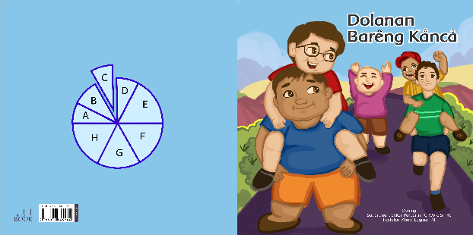

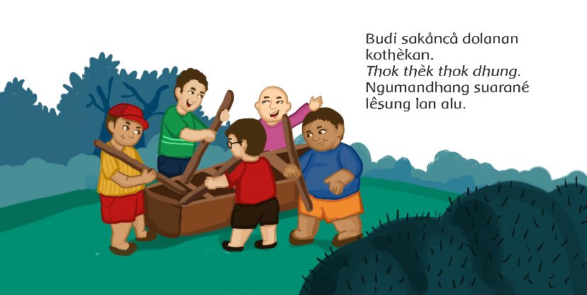

Fig. 1. Grade C Book

The graded reading books help students to understand texts. Students are also introduced to the pronunciation through the use of diacritical marks. This way, they can distinguish the pronunciation of [å], [a], and [o], and also of [ê], [é], and [è]. This is important to introduce from beginning levels because inaccurate pronunciation can create different meanings. The ability in distinguishing sounds is important to support the concept that words are formed from different sounds. The main reading skills to be promoted are a) phonological/phonemic awareness including listening to and mentioning the sounds of the language, b) abilities to read words/phonics using corresponding sounds/letters, c) fluency, which is the ability to read accurately using expressions and ability to know words including the meanings, and d) comprehension, which means understanding the texts [11].

Reading comprehension can be promoted by presenting good and proportional texts that meet the abilities and needs of the students. A good text should be both motivating and challenging as well. Being motivating, a text has contents easy to understand to help raise the confidence of the students. Challenging texts should carry input that is a bit beyond the current competency level of the students. Students need to do various reading activities to promote reading skills.

Next, illustrations that support the texts should help comprehension. One sample picture in the book above introduces a traditional game called kothekan that is played using a mortar and pestles (see Figure 1). The illustration helps students understand that the game requires a mortar and pestles to play. This kind of game has been found rare because traditional games that are full of cultural values have been replaced by digital games [15]. This book contains a descriptive realistic story, which tells about Budi and his friends who perform various traditional games during their holidays with great joy, harmony, and sportsmanship. The traditional games are cublak suweng, kothekan, benthik, ki lumpang ki lompong, kubuk, and kauman.

The second book used in this study is the grade D book entitled Dolanan Dhakon (Playing Dhakon). This book has similar criteria with the previous book. The Grade D book is developed for students who are in the last stage of class II. First, the length is 15-20 pages, 5-7 words per sentence, and 4-5 sentences or 3-4 lines per page. Second, the font is easy to read (using andika new basic) and printed in a large size. The spacing is 1.15 and the texts and illustrations are made balanced on each page. The structure and organization are manifested in word repetitions on each and between pages. The sentences are made simple and separated by commas. The book uses oral language structures (interrogative, declarative, and imperative); word rhyming; vocabulary of level I, II, and some of level III; and punctuation (periods, commas, question marks, and exclamation marks). Fourth, the illustrations are made in medium size. They represent the ideas of the story. They help build a positive atmosphere and interest and improve understanding because the settings, events, and characters are put in pictures. The content is about a fantasy story (simple and straightforward storyline) which is realistic and with multiple topics (illustrating, comparing, and showing cause and effect). The text is informative, descriptive, and factual. The local wisdom is introduced through customs, traditional games, and tembang dolanan. The character education is about responsibility, honesty, discipline, and environmental awareness. The language varieties used are Ngoko Lugu, Ngoko Alus, and Krama Lugu.

Level D book, Dolanan Dhakon, is still about a traditional game. Unlike the previous books which introduce several traditional games, this book only introduces one game with a detailed description of the steps to play the game. Another difference is that this book no longer uses diacritical marks. It aims to train students to read Javanese texts as what they will encounter when they are in the surrounding environment as in newspapers, magazines, institution names, street names, etc. all of which do not use diacritics.

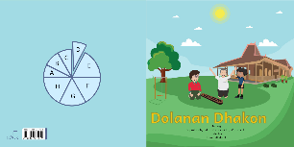

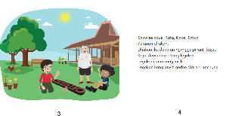

Fig. 2. Grade D Book

Illustrations that support texts help to understand the texts. One of the sample illustrations in the book above introduces a traditional game called dhakon played using a wooden instrument with the same number of holes on the right and left sides (see Figure 2). The steps of the game are illustrated in a simple way in the story by integrating the values of sportsmanship and responsibility. This book is about three brothers, namely Rafa, Kaka, and Satya who are playing a traditional Javanese game, Dhakon. They play the game in turns happily. The game is over when the call for prayer is heard. They have to go to the mosque to pray.

The next book used in this study is the grade E book, Tiba Kepleset (Slipping Over). The unique characteristics of this book are as follows.

The book is composed of 15-20 pages, 7-9 words per sentence, and 4-8 sentences or 4-7 lines per page. The layout is designed to help reading (using andika new basic. The font is printed in medium size. The line space is 1 and the texts and illustrations are made balanced on each page. New words are introduced on each page. To help differentiate the sound of a letter, minimal pairs (not diacritics) are used. Compound sentences and dialogues are introduced. The vocabulary belongs to levels I, II, and III. Punctuation (periods, commas, question marks, and exclamation marks) is also presented. The illustrations are in medium size, more complicated, and more detailed. Some illustrations indirectly support the texts. The content is about a fantasy story (simple and straightforward storyline) which is realistically presented in topics (illustrating, comparing, and showing cause and effect). The text is informative, descriptive, and factual. The local wisdom is presented through customs, traditional games, and tembang dolanan (children game songs), riddles, and poems. The presented character education is about responsibility, honesty, discipline, and environmental awareness. The language varieties used are Ngoko Lugu, Ngoko Alus, and Krama Lugu.

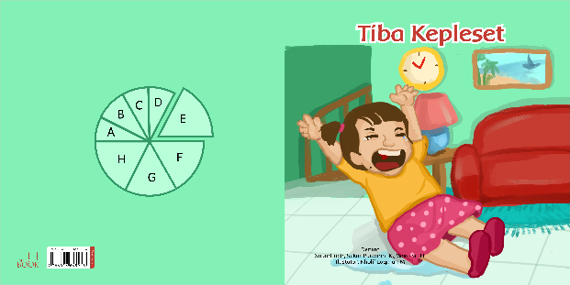

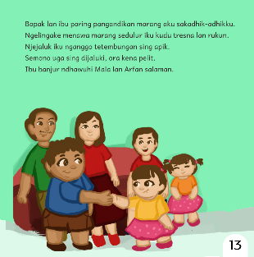

Fig. 3. Grade E Book

The book Tiba Kepleset (Slipping Over) is about Bisma's family who lives in a safe and comfortable village. This family loves to cooperate, to help each other, to clean the environment, and to discuss things to solve problems. In one of the sample pages above, it is illustrated that after an argument between brother and sister, they would shake hands to forgive each other. This is in fact about common problems that students find at home or at school (see figure 3).

- The Implementation of Teaching Reading Comprehension with Javanese Graded Readers

This research was carried out in three class sessions with similar processes. Students were to identify and interpret difficult words in the texts properly. They wrote and retold the contents of the texts correctly in the form of graphic organizers. The following are the core activities of the teaching.
- The teacher presented the rules of the class.
- The students observed the book of "Dolanan Bareng Kanca" (Playing with Friends).
- The teacher showed the cover of the book, read the title, the name of the author, the name of the illustrator while pointing to each word as she was reading.
- The students listened to the teacher reading the story. The teacher gave examples of fluent reading of Dolanan Bareng Kanca. Sometimes, students were required to continue reading the next sentences.
- The teacher and students have a question-and-answer session about the content of the page through the pictures on the page. The students predicted the content of the next page.
- The students wrote the difficult words on sticky notes.
- The students raised questions about the meaning of the difficult words. The teacher explained.
- The students were listening to the teacher explaining the content of "Dolanan Bareng Kanca" regarding the 'who, where, when, and what'.
- The students listened to the explanation and paid attention to the examples while preparing a graphic organizer.
- The students worked individually on the worksheets about the content of the book using the graphic organizer.
- The student representatives recounted the content of the book based on the graphic organizer they made in front of the class.
- In pairs, the students took turns to recount the content of the book based on the graphic organizer that they had made.
- The teacher and students reviewed the reading material that had just been read out.

In the teaching process, the observations focused on classroom conditions, teaching delivery, application of reading strategies, utilization of learning resources, students' involvement, assessment of learning processes and the outcomes, use of Javanese as the language of instruction, and the concluding activities of the learning process. The observations show that students were actively raising questions and giving answers. They also worked on the worksheets enthusiastically, either when doing it individually, in pairs, or in groups.

At the end of each session, an assessment was administered. In the process of teaching reading, assessment is part of a series of activities that must be carried out in addition to the steps of planning, implementation, and reflection. Assessment results serve as a benchmark for the success of learning [16]. Through assessment, teachers can obtain information about the success and failure of the class. The results of assessment give information to help design further assistantship or guidance.

- The Effectiveness of the Javanese Graded Readers in Teaching Reading Comprehension

The effectiveness of the book was identified by comparing the students' post-test scores of the experimental group and the control group using the t-test. The following are the results of the pre-condition test.

Table I. RESULTS OF NORMALITY TEST
 |  | Experimental Group | Control Group
N |  | 22 | 22
Normal Parameters^{a,b} | Mean | 5.5000 | 6.5455
Normal Parameters^{a,b} | Std. Deviation | 1.30018 | 2.44418
Most Extreme Differences | Absolute | .241 | .230
Most Extreme Differences | Positive | .124 | .158
Most Extreme Differences | Negative | -.241 | -.230
Kolmogorov-Smirnov Z |  | 1.129 | 1.078
Asymp. Sig. (2-tailed) |  | .156 | .195

A normality test is to determine if the population is normally distributed. The univariate normality test was used to achieve a near-normal population distribution. In this study, the normality test was using the Kolmogrov-Smirnov test carried out with the help of the SPSS version 21. The hypothesis is that H0 is accepted (the data are normally distributed) if the significance value is more than the alpha level of 0.05 or otherwise it is rejected. Based on the data above, the significance value of the pre-test variable of the experimental group is 0.156> 0.05, and 0.195> 0.05 for the control class. The scores indicate that the data is normally distributed. Therefore, the pre-condition is met. As for the two groups' performance, the post-test scores of the two were compared using a t-test to know if they were a significant difference. The result is as follows.

TABLE II. RESULTS OF t- TEST

Paired Samples Test
 |  | Paired Differences |  |  |  |  | t | df | Sig. (2-tailed)
 |  | Mean | Std. Deviation | Std. Error Mean | 95% Confidence Interval of the Difference |  | t | df | Sig. (2-tailed)
 |  |  |  |  | Lower | Upper | t | df | Sig. (2-tailed)
 | Postes | 1.63636 | 1.39882 | .29823 | 1.01616 | 2.25657 | 5.487 | 21 | .000

The t-test shows that the significance value of the post-test revels a t-count of 0.00 <t table 0.005. It shows that the Ha is accepted and the H0 is rejected. This means that there is a positive and significant influence of the books on the students' reading comprehension abilities among the elementary school students of the early grades.

CONCLUSION

The results of the study show that the Javanese graded reading books carry a positive and significant effect on the comprehension skills of the elementary school students of the early grades (Grades 1, 2, and 3). The students are capable of interpreting difficult words, identifying the intrinsic elements of a story, identifying events in a text, recounting facts in a story, expressing explicit and implicit meanings, and getting the content of a text.

ACKNOWLEDGEMENTS

This report is the results of the third year research on the Development of Local Wisdom-Based Graded Readers for Character Education Internalization Intended for Javanese Language Learning in Elementary Schools. The writers would like to thank the Director of Research and Community Service of the Directorate General of Strengthening Research and Development of the Ministry of Research, Technology, and Higher Education who have funded this research.

References
- M. Rosyid. “Urgensi penelitian bahasa di tengah punahnya bahasa lokal,” Arabia, vol. 6, pp. 178, Juli 2014.
- F.H. Tondo. “Kepunahan bahasa-bahasa daerah: faktor penyebab dan implikasi etnolinguistis,” Jurnal Masyarakat dan Budaya, vol. 11, pp.277-278, 2009.
- Peraturan Gubernur Daerah Istimewa Yogyakarta 2013, No. 64, Mata pelajaran bahasa Jawa sebagai muatan lokal wajib di sekolah/ madrasah, pp. 3-4.
- Peraturan Gubernur Jawa Tengah 2013, No. 57, Petunjuk pelaksanaan peraturan daerah provinsi Jawa Tengah Nomor 9 Tahun 2012 tentang bahasa, sastra, dan aksara Jawa, pp. 4.
- Peraturan Gubernur Jawa Timur 2014, No. 19, Mata pelajaran bahasa daerah sebagai muatan lokal wajib di sekolah/ madrasah, pp. 4 .
- Supartinah, S. Purbarini Kawuryan, dan W. Sri Hastuti, “Pedoman penjenjangan buku bacaan berbahasa Jawa bermuatan pendidikan karakter untuk sekolah dasar,” Jurnal Kependidikan, vol.1, pp.26-38, 2018.
- J.W. Santrock, Psikologi Pendidikan, New York: Mc Graw-Hill, 2009.
- N.L. Hadaway and T. A.Young, Matching Books and Readers: Helping English Learning Grades K-6, New York: The Guilford Press, 2010.
- I.C. Fountas and G.S. Pinnell, The Continum of Literacy Learning Grades Pre-K-8: A Guide to Teaching, Portsmouth, NH: Heinemann, 2008.
- W. Grabe, Reassessing The Term 'Interactive', in Carrell, P.L., Devine, J. and Eskey, D.E. (eds) (1988) Interactive Approaches to Second Language Reading. Cambridge: CUP.
- C. E. Snow, M. S. Burns, and P. Griffin, (Eds.). Preventing Reading Difficulties in Young Children, Washington, DC: The National Academy Press, 1998.
- J.T. Guthrie, Context for engagement and motivation in reading”. reading online,4(80.available at http:// www.readingonline.org/ articles/ handbook/guthrie/index/html, 2001.
- G.E. Tompkins, Literacy in The Early Grades: A Successful Start or Pre K-4 Readers and Writers. Boston: Pearson, 2011.
- D.T. Campbell and J.C. Stanley, Experimental and Quasi Experimental Designs for Research, Rand Menally& Company Chicago, 1996.
- S.P. Kawuryan, W.S. Hastuti, dan Supartinah, “Pengaruh model pembelajaran tematik berbasis permainan tradisional dan scientific approach terhadap kemampuan berpikir kreatif, Cakrawala Pendidikan, 2016.
- M. Maizatulliza and R. Kiely, “Students' evaluation of their English language learning experience, Dinamika Ilmu, vol. 17, P-ISSN: 1411-3031; E-ISSN: 2442-9651, 2017.

