Developing an Tracer Study Information System Based on SMS Gateway to Support Career Development Program in UPI Kampus Cibiru

Fahmi Candra Permana   
Program Studi Pendidikan Multimedia Kampus UPI di Cibiru  
Universitas Pendidikan IndonesiaBandung, Indonesia  
fahmi.candrap@upi.edu

Asep Herry Hernawan   
Program Studi Teknologi Pendidikan Fakultas Ilmu Pendidikan  
Universitas Pendidikan IndonesiaBandung, Indonesia  
asepherry@upi.edu

Feri Hidayatullah Firmansyah   
Program Studi Pendidikan Multimedia Kampus UPI di Cibiru  
Universitas Pendidikan IndonesiaBandung, Indonesia  
feri.firmansyah@upi.edu

Intan Permata Sari   
Program Studi Pendidikan Multimedia Kampus UPI di Cibiru  
Universitas Pendidikan IndonesiaBandung, Indonesia  
intanpermatasari@upi.edu

*Abstract* — Graduates’ waiting period of an educational institution in getting a job can be an institution standard quality in organizing the educational process for its graduates. In addition, one indicator of the success of the education process is the absorption of the graduates of the institution in the working environment. One solution to that problem is that an educational institution needs a system that can provide services and special attention to its graduates obtaining work-related information in accordance with their scientific fields quickly and sustainably. In this paper, an information system based on SMS Gateway technology is designed as a media that can provide information directly to graduates quickly and sustainably in accordance with the needs of graduates. The method used in this study is the Rapid Application Development as an information system design method. This system was built by using the HTML Programming Language, PHP, and Bootstrap as a CSS framework to send an information related job vacancies in accordance with the scientific fields of UPI Kampus Cibiru alumni.

Keywords— SMS Gateway, Graduates’, Information Systems.

# introduction

Finding an effective and efficient information is one of the success factors of an individual in the era of the industrial revolution 4.0 [1]. This also applies to a university graduate in getting information related to job vacancies that are in accordance with their respective scientific fields. The level of success of a college graduate is a shared responsibility between the individual graduates themselves and the extent to which the college is paying attention to each graduate in achieving success. In addition to a good educational process carried out while becoming a student, a college also has an obligation in the career development of its students after graduating. That is because alumni are elements that cannot be separated from the institutions and they are the institutions’ representative. The role of alumni for the institutions is very important to track and record because the success of alumni in the community is also the institutions success. Their feedback benefits in helping the university to improve the system and management of education, especially for accreditation forms standard 3 [2]. Currently, the existence of alumni is one part in the assessment of accreditation of a university. By knowing the existence of alumni, universities can measure the extent of success in educating students to be ready to work. In addition, in the 2016-2020 Universitas Pendidikan Indonesia (UPI) strategic plan it says "the waiting period for graduates under three months to reach 70%" [3]. Hence, it is very much needed by the efforts of UPI as a university institution to provide the best service for UPI alumni so that they can immediately get jobs in accordance with their scientific fields.

One of the solutions to tracer study problem of an alumni by building a good information system that can help college graduates in getting job vacancies information in accordance with their scientific fields. In addition to using a complete information system related to alumni tracer study, this research will combine the information system using SMS Gateway technology. SMS or Short Message Service is one of communication with text through mobile devices. SMS is one of the most widely used media today, besides being cheap, the process is very fast and straight to the destination [4]. Along with the development of SMS technology is not only used between one user and one other user, but also now there is an SMS Gateway technology. Besides that, an of the SMS Gateway-based application can send short messages that contain information directly to several people without limitation on the number of recipients. Initially the use of SMS Gateway technology was widely used in the business and banking sectors. For example, today almost all National and Private Banks have used the SMS Gateway to provide information to customers. So that customers get detailed information both the amount of balance and withdrawal of money. The choice of SMS Gateway technology in this study is due to the wide range of signal coverage of smartphones that have become a trend everyone has. This research is a development from previous research entitled "Implementation of SMS Gateway as Academic Information Dissemination Media at UPI Kampus Cibiru ". Apart from that, here are some of the researches that have been done related to the implementation of the SMS Gateway: P. Jumri who discussed the Student Academic Guidance Consultation Monitoring System with SMS Gateway-based Realtime Notification in 2012 [4], then T Husain, who discussed the Adzan time reminder application. based on SMS Gateway in 2017 [6]. Since the development of the SMS gateway is growing, the previous research continues to be developed the next stage is to implement the SMS Gateaway technology with an information system that can routinely provide messages related to vacancies to alumni of UPI Kampus Cibiru as the initial stage of the implementation of this information system.

# Literature review

**SMS Gateway Technology**

SMS Gateway is a technology for sending, receiving and even processing SMS through computers and computerized systems (software). As we know, in this day and age, almost all individuals already have cellular phones (cell phones), there are even individuals who have more than one cellular phone. SMS is one of the features on mobile phones that is definitely used by users, both for sending and receiving SMS. In terms of SMS speed, the more terminals (cell phones / modems) connected to the computer (and set to the SMS software), the faster the SMS sending process [5]. The following picture is the SMS Gateway scheme.

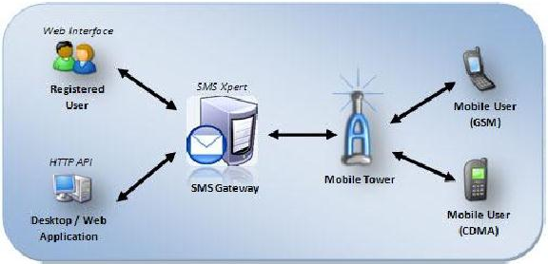

**Figure 1**. SMS Gateway scheme [4]

The mechanism of sending SMS is divided into 3 parts, namely: (a) Intra-operator SMS: sending SMS in one operator; (b) Inter-operator SMS: sending SMS between different operators; (d) International SMS: SMS sender from one country operator to another country [6]. The working mechanism of the SMS Gateway can be seen in Figure 2.

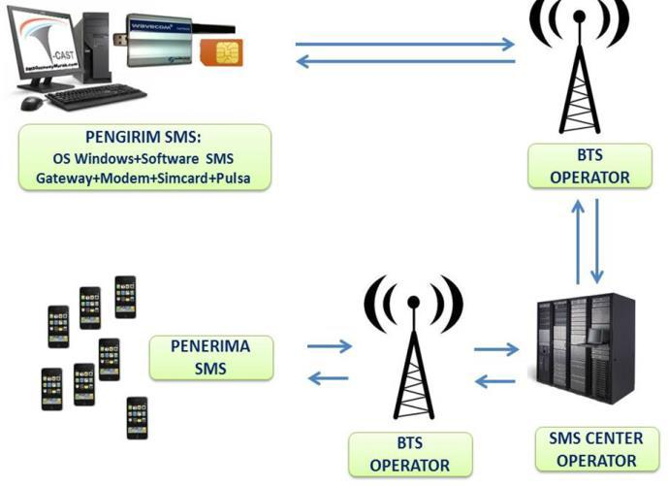

**Figure 2**. SMS Gateway mechanism [6]

Through the application that will be generated in this research, the process of delivering information for all alumni at the UPI Kampus Cibiru can be quickly carried out.

# research method

The methodology used is Rapid Application Development (RAD) [7], with stages consisting of Business Modelling, Data Modelling, Process Modelling, Application Generation and Testing and Turnover and system testing using the black box testing method. Rad has several advantages, including [ 7]:

1. Changes in system requirements that are accommodated;
2. Measured progress;
3. Shortened evaluation time due to using automation equipment;
4. Integration that is done early can make solving problems more and easier.

Figure 3 shows stages of Rapid Application Development:

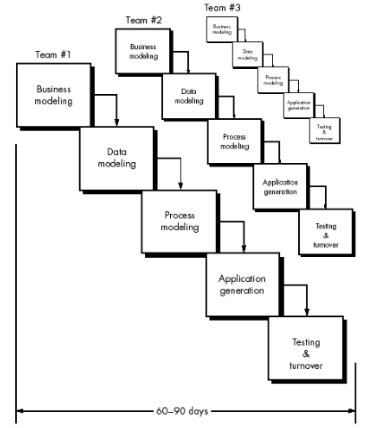

**Figure 3** Model Rapid Application Development[7]..

**Business Modelling**

Business Modeling is the initial stage of RAD. This stage is carried out to determine the identification of components related to research. The results of the identification of these components produce a system flowchart of ongoing business processes and proposed business process flowchart systems as well as Software Requirement Specification (SRS) design of the project making application. In this stage, the writer collected several literature reviews related to the SMS Gateway based tracer study system which contained job vacancies that were in line with the academic background of the UPI Kampus Cibiru alumni, with the result that the writer would get a primary data source namely job vacancies from http: // jobsdb.id/ and http://jobstreet.co.id. This is because the two sites are included in the two best job search sites in 2019 according to https://teknologi.id [8].

**Data Modelling**

The second step is Data Modeling. This stage is further analyzed from the Business Modeling stage by developing business processes that were generated in the previous stages. As for this study primary data related to the source of job vacancies for UPI Kampus Cibiru alumni, some arrangements in the application of job vacancies to be adjusted to the needs that the author needs as a primary data source for job vacancies as a teacher. Here are some settings that the authors set in the application http://jobsdb.id/ and http://jobstreet.co.id. The following settings can be seen in figures 4 and 5.

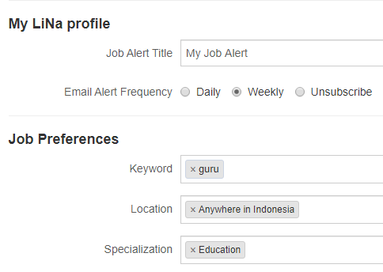

**Figure 4.** Notification settings related to job vacancies as a teacher every week from <http://jobstreet.co.id>.

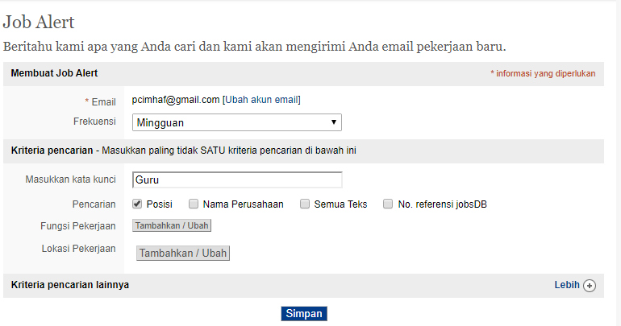

**Figure 5.** Notification settings related to job vacancies as a teacher every week from <http://jobsdb.id/>.

After the arrangement is finished, the writer will get an email every week related to job vacancies as teachers throughout Indonesia that are needed by Alumni of UPI Kampus Cibiru.

Here are some examples of incoming email notifications when the settings in the author's http://jobsdb.id/ and http://jobstreet.co.id accounts have been completed, in Figure 6.

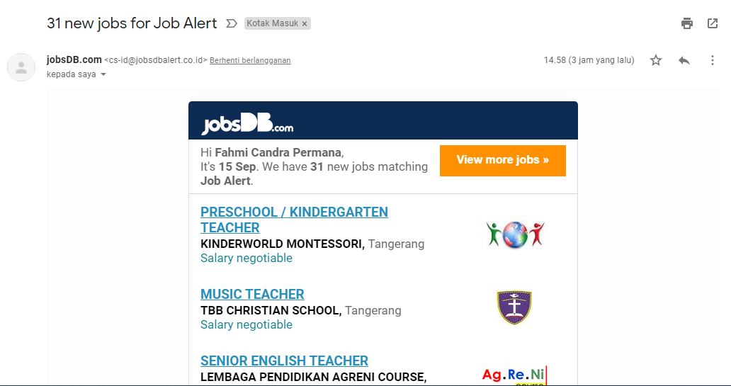

**Figure 6**. Job vacancy notification from <http://jobsdb.id/>.

In Figure 6. There is a job vacancy notification as a teacher that will be forwarded in the SMS gateway application that the author built.

**Application Generation**

The next stage is Application Generation. In this stage all the results of the Data Modeling are implemented into the programming language by designing the menu structure and designing the display to produce a beta information system that can be tested by software.

**Testing and Turnover**

The last stage is Testing and Turnover. At this stage the information system that has been generated from the Application Generation stage is tested using the black box testing method only in the functional area [11].

# result

The result of this research is an SMS gateway based application that can be used as a media for disseminating information about jobs vacancies for Alumni of UPI Kampus Cibiru. With the results of this research, it is expected that the process of disseminating information on job vacancies at the UPI Kampus Cibiru will be faster, more effective and help the tracer study process for Alumni UPI Kampus Cibiru in career development program, so this is the following application design that has been completed from this research:

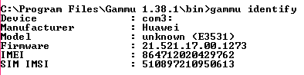

**Figure 7.** Check the Port Status of the Modem Installed on the Computer.

One of the requirements for the SMS Gateway-based application to work properly is hardware devices. The device is required to send messages from the application to the recipient. Other than that the hardware connected to the computer must be connected dy uses a modem that is connected to the computer. Figure 7 shows that the application is connected to the Sand installed on the computer. To be installed, port settings and checks are needed which show that the application is connected to the hardware that in this stuMS sender hardware. After the modem is connected the application can be used immediately, along with the initial display when the application is opened. It can be seen in Figure 8.

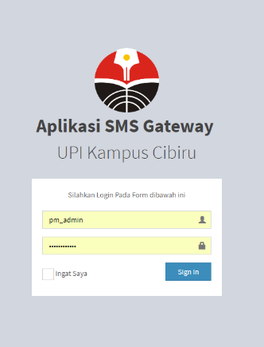

**Figure 8.** Login Page

When the application first opened, the first page that is launched is login menu. The application's login menu is needed so that only certain people can use this application, on this page only people who has a user and password can enter or login to this application.

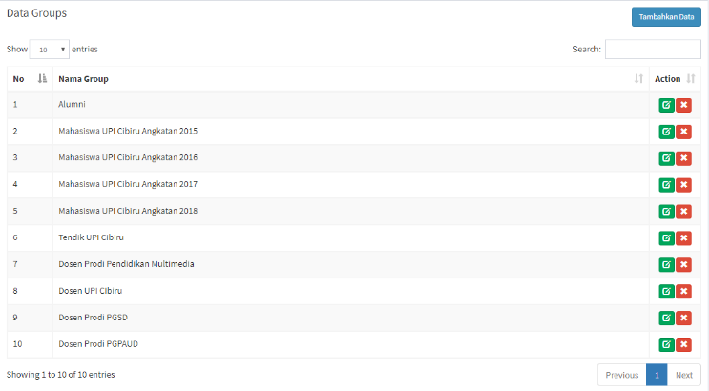

**Figure 9**. Recipients Group Classification in UPI Kampus Cibiru.

In order information can be delivered to the recipients, a special group must be formed as a method to classify academic information recipients in the UPI Kampus Cibiru environment based on the status of each recipient. The list of classifications of academic information recipients within the UPI Kampus Cibiru can be seen in Figure 9.

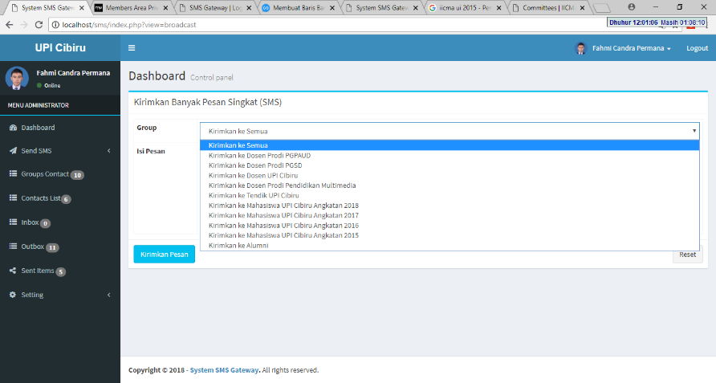

**Figure 10**. Sending Messages In Accordance With Recipient Classification.

Before writing the message to be sent, an application admin is required to choose a list of recipients of the message to be written and sent later. It can be seen in Figure 10.

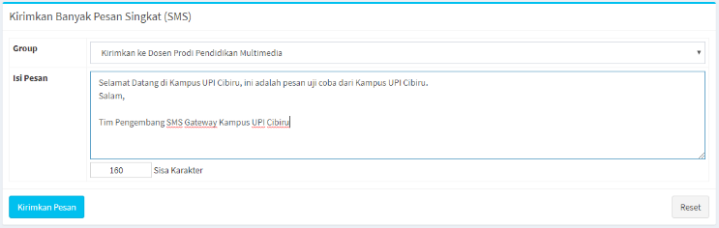

**Figure 11**. Write the contents of the message to be sent.

After selecting the list of short message recipients, the next step is to write the contents of the message to be sent, as shown in Figure 11.

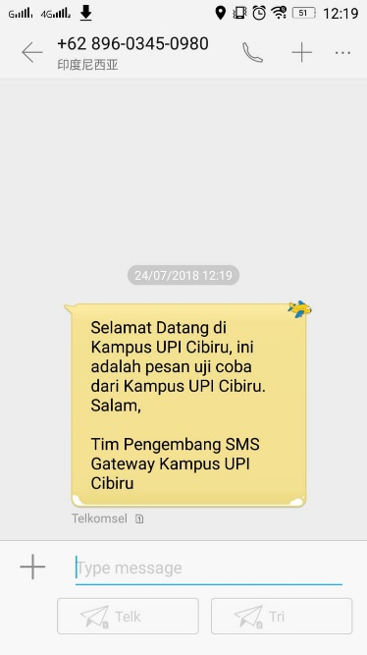

**Figure 12.** Examples of Messages Sent and Received from the Application.

After the message is sent by the application admin, the recipient will receive the message contained job vancies information from the system. Figure 12 is an example of a message that will be received by UPI Kampus Cibiru Alumni.

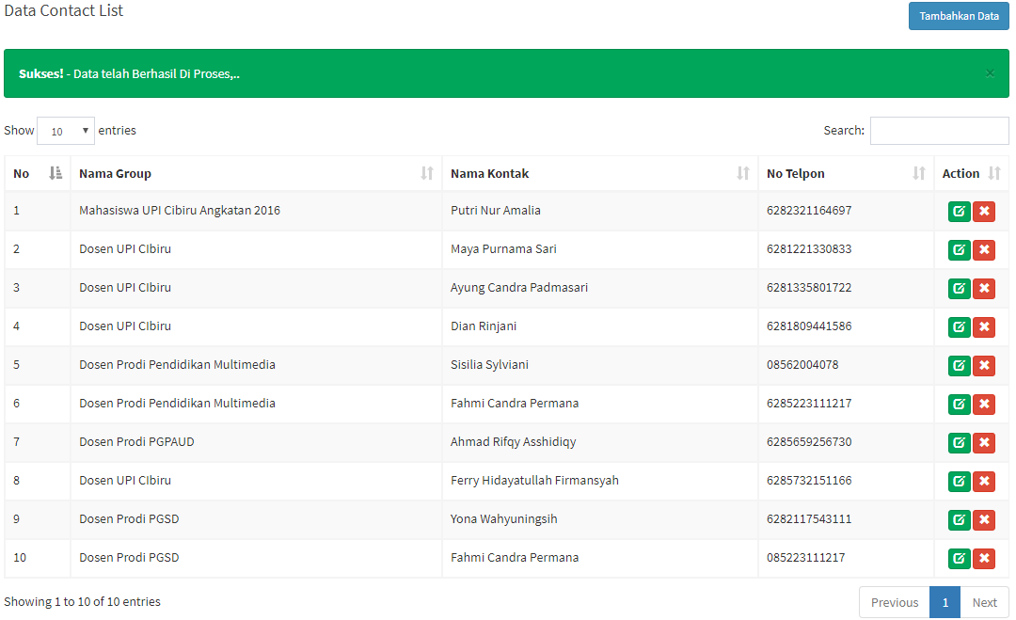

**Figure 13.** List of Recipients of Information in UPI Kampus Cibiru

One of the advantages of SMS Gateway technology, there is no limit number of recipients who will receive the message to be sent, Figure 13 shows a list of recipients of information in the UPI Kampus Cibiru, because the system that I built will be integrated with the previous system that we built, related to academic information disseminating media within the UPI Kampus Cibiru.

# conclusion

By using the HTML Programming Language, PHP, and Bootstrap as a CSS framework to facilitate designing, managing application interfaces, and MySQL as a DBMS then Gammu as a service for sending SMS by the systems, this research can built an SMS Gateway based information systems as a media for spreading information about job vacancies for UPI Kampus Cibiru Alumni to get jobs in accordance with their field of expertise.

##### Acknowledgment

##### This research was fully supported by LPPM Universitas Pendidikan Indonesia (Penelitian Pembinaan dan Afirmasi Riset Dosen tahun 2019) with contract number 293/UN40.D/PP/2019. We are thankful to our colleagues Civitas Academia UPI Kampus Cibiru who provided expertise that greatly assisted the research.

##### References

1. https://nasional.sindonews.com/read/1383165/15/revolusi-industri-40-jadi-tantangan-media-perbaiki-kualitas-jurnalis-1551442171
2. A. Nasuhadan K. Siahaan, “Analisis dan Perancangan Sistem Informasi Alumni (*Tracer study* ) Berbasis Web pada IAIN Sulthan Thaha Saifuddin Jambi,” Jurnal Manajemen Sistem Informasi, vol. 1, no. 1, pp. 18-29, 2016.
3. RENSTRA UPI Tahun 2016 – 2020
4. J. . P. Jumri, "Perancangan Sistem Monitoring Konsultasi Bimbingan Akademik Mahasiswa dengan Notifikasi Realtime Berbasis *SMS Gateway*," Informatika, pp 3455, 2012.
5. P. M. Wikma, "*SMS GATEWAY* *SMS Gateway* adalah teknologi mengirim, menerima dan bahkan mengolah sms melalui komputer dan sistem komputerisasi (software)," 2014. [Online].
6. M. Afrina, "Pengembangan Model Sistem Informasi Perpustakaan Dengan Teknologi Informasi Berbasis Wireless Aplication Protocol (WAP) pada UNSRI," Jurusan Sistem Informasi, Fasilkom Unsri, pp. 1-9, 2012.
7. R. S. Pressman, Rekayasa Perangkat Lunak, Yogyakarta: ANDI, 2012
8. <https://teknologi.id/insight/6-aplikasi-lowongan-kerja-terbaik-2019/>