Development of an Assessment Tutorial of Students’ Learning Achievements on
Vocational High School

Edy Supriyadi & Yuwono Indro Hatmojo
Faculty of Engineering, Yogyakarta State University
Email: edy_supriyadi@uny.ac.id;

Abstract—This study aims to develop a model of assessment tutorial (video) of students’ learning achievement on Vocational high school (VHSs) in the Expertise Program of Electrical Engineering. This development research used the Borg & Gall model. The video tutorial was trialed twice. Trials I were conducted at 8 vocational schools in the Special Region of Yogyakarta, and Trials II were conducted at 32 vocational high schools in Java. The results of the trials showed that the feasibility of the assessment tutorial from material, media, language, and technical aspects of the first trials is Good, with Mean = 3.48; and SD = 0.36, and in trial II also in Good category with Mean = 3.54; and SD = 0.38. The assessment tutorial developed is appropriate to improve the ability and skills of teachers in conducting an assessment of vocational student learning achievement.
Key word: video tutorial, Assessment, vocational student

Introduction
Vocational education, including Vocational High Schools (VHSs), is education aimed at preparing students to enter the workforce. VHSs graduates are expected to have a series of competencies relevant to the needs of the workforce. Therefore the implementation of education in VHSs must be relevant and of good quality. Learning is an essential component in the education process in schools. The quality of the learning process is very influential on the achievement of student learning achievement. The learning process is effective if the teacher can direct the learning activities so that students can master the subject matter in accordance with the learning objectives, including reinforcement of character. The teacher is expected to know accurately about the development progress and achievement of student learning achievement, as well as what needs to be done for further student development. This is done through an appropriate assessment process. Assessment greatly influences the effectiveness of learning [1].
Assessment is the process of gathering information about what students already know, understand, and can do in order to make the right decision regarding the next step in the educational process. Student learning achievement are used as a guide for making academic decisions about students, providing information to students, parents, teachers, or other relevant parties about student learning progress, strengths and weaknesses, to determine learning effectiveness and curriculum, and inform policy. Students and parents need evaluative information to help students be more effective in learning, and so parents can play a more appropriate role in supporting their children in learning.
The success of each learning activity can always be measured by the results of its learning. Learning activities are considered good if the learning achievement increase as expected. There is a mutual influence between learning and assessment. The learning process that has been implemented will be assessed in accordance with existing provisions. While the results of the assessment are a picture of student learning achievement. Then the merits of a learning process can be seen from the results of student learning. In other words, the level of student learning achievement symbolizes the quality of the learning processes and efforts that have been made.
The learning achievement of vocational students so far have not been adequate as expected. Based on the results of the National Examination, the average national exam score for vocational students in 2018/2019 is Mean = 46.72 [2]. Vocational Teacher Competencies are also still relatively low. Vocational Teacher Competency Test Results until 2018 obtained Mean = 57.03 [3]. The results of an evaluation by the Ministry of Education and Culture on the implementation of the Curriculum in Vocational Schools found that one of the main obstacles faced by teachers was the problem of evaluating learning achievement. The teachers do not yet have the knowledge and skills in designing assessments, developing instruments and carrying out assessments and using them to improve learning.
Improving the assessment system needs to be continued according to the development of the education system and the world of work. Weaknesses in organizing assessments include the lack of common understanding of the assessment system that every teacher should do. The implementation of assessment of learning achievement by teachers tends to differ according to the desires/knowledge of each teacher. The existing assessment system is still general in nature, not yet providing a real and operational picture of how to conduct an adequate assessment. There are several methods of assessment in learning, for example authentic assessment, portfolio, performance appraisal, but in its implementation there are no guidelines that can be made as a reference, so that teachers have their own perceptions in implementing the assessment [4]. The use of the appropriate approach to implement the assessment also needs to be done. Based on the diversity of characteristics, students are given the choice to determine how they can demonstrate the achievement of their learning achievement. A combination of techniques or assessment approaches is carried out while still leading to the achievement of learning objectives [5]. In an effort to overcome teacher problems regarding assessment, the development of tutorial of vocational student learning achievement assessment was conducted in this research. The developed video tutorial is expected to be used as a medium and/or as a learning resource for teachers in learning achievement assessments.
Educational media is a tool used as an intermediary for communication between a teacher and students in order to make communication and interaction more effective in the learning process. In the context of training, the media is used as a tool, communication intermediaries between trainers/ resource persons and participants (trainee/teachers). The research results showed that the use of video tutorials was very effective in online learning, and positively correlated to student satisfaction [6].
Video tutorials are also a clearer and more interesting learning resource for teachers to learn and implement teaching and assessment. Some of the advantages of using media/learning resources in the form of audio-visual, are clarifying the presentation of messages and information so as to facilitate and improve the process and learning achievement, increase and direct the attention of children so that it can lead to learning motivation, more direct interaction between students and their environment, and the possibility for students to learn individually according to their abilities and interests.

method
This is a research and development. The development of an assessment tutorial model refers to [7] model which is modified with the following stages. (1) Study the problem, (2) Planning the development of the model, (3) Development of the model, (4) Trial stage 1, (5) Trial stage 2, and (7) preparation of model products.
Study of the problem was carried out using interview techniques, questionnaires and document analysis, including the results of previous studies. Model development is carried out with the stages of designing the model, discussing and studying the design of the model through Forum Group Discussion (FGD). The assessment tutorial model developed was validated by experts. The results of the model development is an assessment tutorial (video) of VHS’ student learning achievement.
The instrument used for the validation and testing of the assessment model was a questionnaire, and an interview guide. The instrument developed was validated by experts. The validity of the instrument contents is determined by calculating the Aiken V coefficient index. The instrument reliability estimation is calculated using the intraclass correlation coefficient (ICC) technique.
Model trials are carried out twice. Trials I conducted in July-September 2017 were limited to teachers and principals in 8 VHSs in Yogyakarta Special Province. Trials II were conducted in August-September 2018 on teachers and principals in 42 VHSs in Java. The preparation of the final product (model) was based on an assessment of the feasibility of the model. The collected data was then analyzed in quantitative and qualitative descriptive terms.

FINDINGS

Model Developed
Based on the discussion on the design of the video tutorial assessment in FGD 1, the main contents of the model were developed. The agreed main contents of the assessment tutorial model are as follows: Introduction, Curriculum, Character, Conception of Assessment, Assessment of Learning Achievement by Teachers, Assessment of Attitude Competencies, Assessment of Knowledge Competence, and Assessment of Skill Competency, Assessment of Learning Outcomes by Schools, Closing, and Appendix . Furthermore, the development of assessment tutorial model is conducted.
The drafted model that was successfully developed was then discussed in FGD 2. The results of the discussion showed that in general the assessment model was quite adequate, but needed some improvement. Improvements include adding some material related to the conception of assessment, assessment of learning achievement in aspects of knowledge and skills, as well as examples of instruments. In the media aspect, there are a number of inputs related to video quality, video compatibility with material, animation, text, and other related matters. Appropriate input is then made improvements to the assessment video tutorial model. Some examples of captures of video tutorials on Vocational School student learning achievement assessment models are as follows:

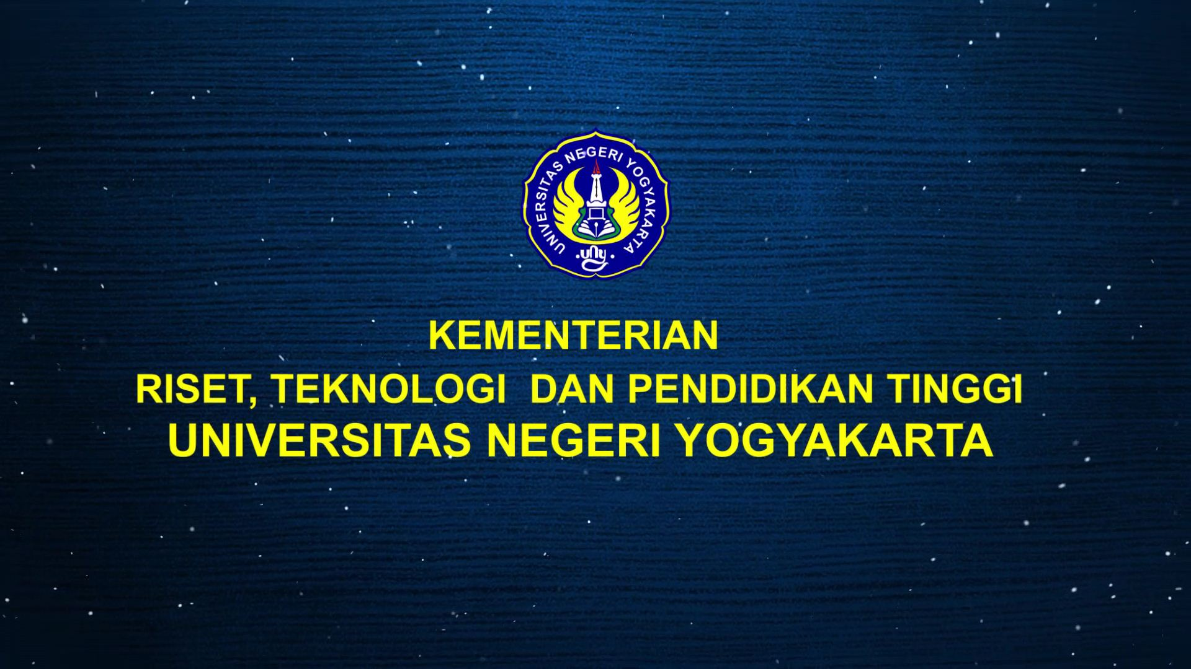

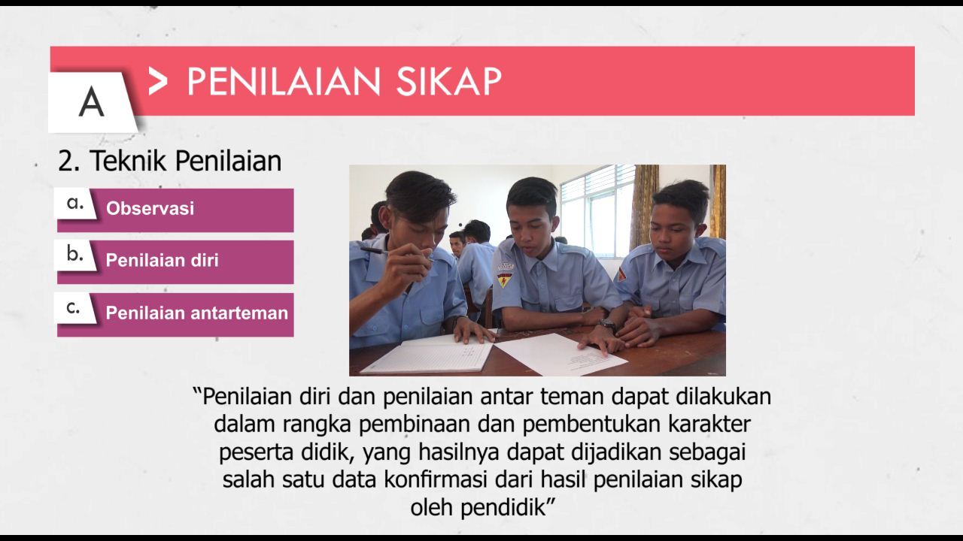

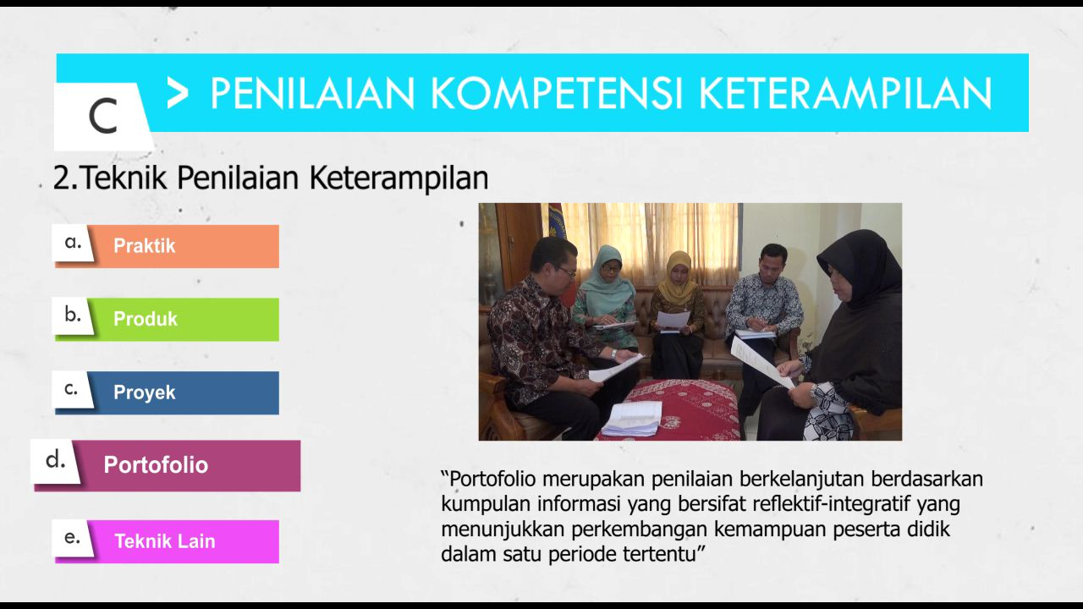

Validation by Experts
The validation of the assessment model was carried out by seven experts/practitioners, consisting of one senior teacher, one school principal, one vocational supervisor, one vocational learning expert, two learning outcome assessment experts, and one educational media expert. Validation of the assessment tutorial is conducted using an instrument. The results of the validation of the content of the model are presented in Table 1. The average value of the model content validity, Mean=3.99, is in the good category.
Table 1. The Results of Tutorial Content Validity by Experts
NO | Aspect | Mean | SD | Category
1 | Material | 4,14 | 0.44 | Very Good
2 | Media | 3,71 | 0.56 | Good
3 | Language Usage | 3,85 | 0.48 | Good
4 | Technical | 4.28 | 0.36 | Very Good
 | Average | 3,99 | 0.45 | Good

Trials I and Trials II on VHSs
The Trials I were conducted in 8 (eight) VHSs in the Special Province of Yogyakarta in July - September 2017. Trials II were conducted in 42 VHSs in Java in August - September 2018. Targets of the trials were teachers and principals. Teachers and principals were given a tutorial unit of assessment models & instruments, and are asked to read them carefully. After examining the tutorial, teachers and principals were asked to provide an assessment of the tutorial using the instrument.
The results of the Trials I and Trials II can be seen in Table 2. In general, The results of Trials I of the assessment tutorial model are classified as Very Good, and are worthy of being used as a guide in conducting the assessment of learning achievement, with Mean = 3.48 and SD 0.36. Almost the same as the results of the Trials I, the results of the Trials II are also classified as Good, with Mean=3.54 and SD=0.38. In addition to quantitative data, several input notes were obtained relating to the assessment tutorial, including aspects of sentence clarity and language correctness, accuracy of video, text and animation, terminology used, and layout of guidelines. Based on this input an improvement was made to the tutorial unit guide.
Based on the trials results of the assessment tutorial model in VHSs, in general the assessment tutorial model that were successfully developed is classified as Good and appropriate to be used in conducting the assessment of learning achievement in Vocational High Schools. The results of interviews with some teachers also revealed that they more easily understand the assessment of learning achievement by learning through tutorial video. Explanation through audio visual can make it easier for teachers to understand about assessment, both related to the concept of assessment, design of assessment, implementation of assessment, and analysis & utilization of assessment results to enhance learning. This is consistent with the results of research by [8] which revealed that the use of tutorial media in learning can increase student confidence and learning achievement. The availability of video tutorials increases students' confidence according to their abilities, and very good tools are used in learning skills [9].

Table 2. Trials Results of Assessment Tutorial on Vocational High School
No. | Component | Trial I |  |  | Trial II
No. | Component | Mean | SD |  | Mean |  | SD
A | Material
1 | Material Suitability | 3.42 | 0,52 |  | 3,57 |  | 0,53
2 | Material Coverage | 3.58 | 0,48 |  | 3,71 |  | 0,46
3 | Material Coherence | 3.37 | 0,43 |  | 3,57 |  | 0,53
4 | Material Extent | 3.35 | 0,40 |  | 3,28 |  | 0,46
5 | Material Validity | 3.56 | 0,42 |  | 3,57 |  | 0,48
6 | Material Difficulty Level | 3.79 | 0,36 |  | 3,85 |  | 0,34
B. | Presentation/ Media
1 | Completeness of the Presentation Component | 3.48 | 0,64 |  | 3,57 |  | 0,74
2 | Presentation Systematics | 3.39 | 0,38 |  | 3,65 |  | 0,37
3 | Teacher Ease in Using Media | 3.45 | 0,47 |  | 3,57 |  | 0,53
4 | Animation | 3.36 | 0,51 |  | 3,42 |  | 0,53
5 | Picture | 3.24 | 0,44 |  | 3,32 |  | 0,45
6 | Colour | 3.24 | 0,33 |  | 3,45 |  | 0,37
7 | Sound | 3.57 | 0,34 |  | 3,65 |  | 0,38
8 | Lay Out | 3.21 | 0,44 |  | 3,35 |  | 0,40
C. | Language
1 | Authenticity | 3.39 | 0,49 |  | 3,57 |  | 0,53
2 | Clearness | 3.39 | 0,38 |  | 3,85 |  | 0,37
3 | Easy to understand | 3.40 | 0,35 |  | 3,42 |  | 0,37
D. | Technical
1 | Easy to use | 3.68 | 0,26 |  | 3,45 |  | 0,24
2 | Not require Complicated Devices | 3.47 | 0,33 |  | 3,35 |  | 0,28
3 | Easily Duplicated | 3.61 | 0,34 |  | 3,45 |  | 0,30
4 | Durable | 3.42 | 0,31 |  | 3,68 |  | 0,22
 | Average | 3.48 | 0.36 |  | 3.54 |  | 0.38

In connection with the assessment tutorial model that is able to improve the ability of teachers in assessment, this is related to literacy. Assessment literacy is the knowledge and skills needed to carry out assessments of student learning achievement according to principles and ethics, and effectively utilize the processes and results of assessments to improve the achievement of student learning achievement. Teachers must have good assessment literacy so they can design assessments, develop instrument sets, carry out assessments well, and utilize assessments to support learning, so that student learning achievement can be better achieved [10].
The assessment tutorial model developed emphasizes the integration between assessment and learning. This shows that the assessment tutorial model allows teachers to carry out assessment and learning well. This means that assessment and learning should be in harmony. Assessment needs to be done before, during and after learning. The tendency so far which emphasizes only on the assessment of learning achievement at the end of learning needs to be corrected. Assessment must be directed as an integrated part of learning activities so as to support student learning activities [11]. Integration between assessment and learning is done especially from the beginning of learning to the end of learning. Continuous assessment can be conducted through observation, gathering information periodically to find out what students already know, understand, and do [12]. Through these assessments, the teacher can know what students have mastered, and what students have not yet mastered so that the teacher can adjust or improve his learning activities. If student learning achievement are not optimal, teachers can revise their learning plans, discuss materials that are not yet mastered by students, do remedies, and other efforts to improve learning activities [13].

Conclusions
The use of assessment tutorial model can improve teacher understanding of the assessment of students’ learning achievement. This is not only because of the audio visual form that makes the assessment material clearer and more interesting, but also because the teacher can learn the assessment anytime and anywhere according to the teacher's wishes. In addition, through gadgets or cell phones the teacher can easily access the video tutorial. This assessment tutorial model will be more easily accessed by teachers throughout Indonesia, if it is developed in a video format uploaded to Youtube.

Bibliography
[1] Dylan, Wiliam. (2013). Assessment: The Bridge between Teaching and Learning. Voices from the Middle. Volume 21 Number 2, December 2013. The National Council of Teachers of English. From https://www.ncte.org/library/NCTEFiles/Resources/ Journals/VM/0212-dec2013/VM0212Assessment.pdf

[2] Kementerian Pendidikan Dan Kebudayaan. (2019). Laporan Hasil Ujian Nasional. Pusat Penilaian Pendidikan. From https://puspendik.kemdikbud.go.id/hasil-un/

[3] Kementerian Pendidikan Dan Kebudayaan. (2019). Mutu Pendidikan: Strategi Pembangunan Pendidikan Yang Terintegrasi Untuk Mencapai Pemerataan Pendidikan Yang Berkualitas Dan Berkeadilan. Pusat Data Dan Statistik Pendidikan Dan Kebudayaan Setjen, Kemendikbud Jakarta, Mei 2019

[4] Sugiyono., Lastariwati, B., Budiastuti, E., & Yudianto, A. (May, 2018). Development of Authentic Assessment Instruments for Saintifical Learning in Tourism Vocational High Schools. Jurnal Pendidikan Teknologi dan Kejuruan. Volume 24, Number 1, p. 52-61. From: http://journal.uny.ac.id/index.php/jptk

[5] Montenegro, E., & Jankowski, N. A. (January, 2017). Equity and assessment: Moving towards culturally responsive assessment (Occasional Paper No. 29). Urbana, IL: University of Illinois and Indiana University, National Institute for Learning achievement Assessment (NILOA). From http://learningoutcomesassessment.org/documents/OccasionalPaper29.pdf

[6] Litao Zhong (2017). Online Teaching Effectiveness with Instructor-made Video Tutorials: A Case of Using Explain Everything Business Education Innovation Journal Volume 9 Number 1 June 2017

[7] Borg, W. R. & Gall, M. D. (1989). Educational research an introduction. New York: Longman.

[8] Van Veggel and Amory (2014), The impact of maths support tutorials on mathematics confidence and academic performance in a cohort of HE Animal Science students. PeerJ 2:e463; DOI 10.7717/peerj.463

[9] Manuela Truebano & Colin Munn (2015). An Evaluation of the Use of Video Tutorials as Supporting Tools for Teaching Laboratory Skills in Biology. Practice and Evidence of Scholarship of Teaching and Learning in Higher Education Vol. 10, No. 2, July 2015, pp. 121-135

[10] Popham, James, W. (2009). Assessment Literacy for Teachers: Faddish or Fundamental?
Theory Into Practice. 48:4–11, 2009. Copyright © The College of Education and Human Ecology, The Ohio State University. From http:/doi: 10.1080/00405840802577536

[11] Lindstrom, G., Taylor, L., and Weleschuk, A. (2017). Guiding Principles for Assessment of Student Learning. Calgary: Taylor Institute for Teaching and Learning at the University of Calgary.

[12] Plessis, J.D., Diane, P., D., Schubert, D., Habib, M., and George, E.S. (2003). Continuous Assessment: A Practical Guide for Teachers. Washington: USAID Bureau for Economic Growth, Agriculture and TradeOffice of Education

[13] Muskin, Joshua A. (2017). Continuous Assessment for Improved Teaching and Learning: A Critical Review to Inform Policy and Practice. UNESCO International Bureau of Education. From https://unesdoc.unesco.org/ark:/48223/pf0000255511

