**University Competitive Advantages Based on the Model of Fuzzy VRIO and THES**

Setyabudi Indartono, [setyabudi_indartono@uny.ac.id](mailto:setyabudi_indartono@uny.ac.id)

Sudiyatno, [sudiyatno@uny.ac.id](mailto:sudiyatno@uny.ac.id)

Universitas Negeri Yogyakarta

Ferry Wahyu Wibowo, [ferry.w@amikom.ac.id](mailto:ferry.w@amikom.ac.id)

Universitas Amikom Yogyakarta

**Abstract**

This paper proposed a novel framework model to find out university competitive advantages. The fuzzy logic used to arrange variables: valuable, rareness, inimitability, and organizable (VRIO); and times higher education supplement (THES) and in developing university strategic plan. The result of strength, weakness, opportunity, and threat (SWOT) analysis were used to be the preliminary information on the university strategic plan development. The main research methods used in this paper was developed based on a quantitative research approach. The indicators of VRIO are measured by number of capabilities evidence for valuable; length of problem-solving abilities evidence for rareness; potential competitors to replace the strength for imitability; and manageable potential strength on the functions in management for organizable. The main attention on the university strategic plan are in area teaching, international outlook, research, citations, and industry income as used in THES.

**Keywords**: Competitive Advantages, Framework, Fuzzy, VRIO, THES.

**1. INTRODUCTION**

Strategic planning is an important issue to prepare success for an educational institution. Hence, the strategic planning approaches are required to create their competitive advantage. Scholars and practitioner develop various model of strategic plans based on the result of analysis of strength, weakness, opportunity, and threat (SWOT). Empirically the valuable, rareness, inimitability, and organizable (VRIO) is found effective in creating competitive advantages. Further the times higher education supplement (THES) is used to indicate the quality of educational institutional achievements. Thus, the integrated and sequences of the utilization of SWOT, VRIO and THES is believed to be an effective way to evaluate and develop the university strategic plan. Hence this model is developed by using materials from the analysis results of strength, weakness, opportunity, and threat (SWOT) to prepare the university strategic plan1. The inclusion of VRIO on the model revise weaknesses and limitations of SWOT on strategic plan processes. This model has also been aligned with the university’s vision and mission so the programs and activities could be considered by the side of the management structure to build the university strategic plan2. The strategic planning is a process that is done by organizations to decide the strategies to decide in allocating the resources to obtain this strategy. There are several institutions that haven’t done a strategic planning and others don’t have appropriate tools in developing the strategic plan based on the competitive advantage. The instruments could be made in order to get the model of the advantage competitive for strategic management3. The analysis of the strategic management needs should be done in the institution business model due to the changing management4,5. The strategic planning is the activity initialized from the innovation and shifting the institutions to support and make a change of innovations. From the analysis and making a planning could be recommended some excellent services in the institutions so it is very important thing to do in the strategic management6. This paper aims at building an assessment for university strategic plan based on fuzzy logic, VRIO, and THES. This assessment is used to make a framework for making a strategic plan to evaluate the competitive advantage condition from the university.

**2. RELATED WORKS**

Many fuzzy models have been implemented in the competitive advantages of the institutions or productions. Determining competitive advantage weights and lean attribute impacts with some criteria have been applied through fuzzy logic. This approach could assist stakeholders to decide the policy in getting a new perspective7. In the business environment could also use the Fuzzy logic in proposing a holistic model in making decisions between two areas i.e. quality and strategic management8. This model could be an integrated decision model due to the advantage competitive in the quality management and services9. Developing a framework in the competitive advantages could be based on resource and theory of dynamic capability. This framework could implement Fuzzy logic to be applied in analyzing data10. In this paper presents applying a Fuzzy logic in the model of VRIO-THES. The criteria of THES are used to model the competitive advantages of the university.

**3. METHODOLOGY**

This paper implemented a VRIO-THES framework that covers a content validation. The fuzzy VRIO-THES framework module is initially made by considering processes and justifications of SWOT analysis and appropriate with the THES standard.

3.1 SWOT and VRIO-THES Model

Some questions that can affect the university in making a strategic plan from the SWOT that was changed into VRIO-

THES model namely:

Could the university exploit an opportunity and/or facing an external threat with its resources?

Is the uniqueness of control in the university due to the resources or capabilities of the university relative few?

Could the university resources or capabilities difficult to imitate and what is the significant cost to the university to develop, obtain, and duplicate the resources or capabilities?

Is the university ready and capable to exploit the resources or capabilities?

The resources used in THES-VRIO approach are internal resources from SWOT. If this positive potential is in the internal, then it will be the strength and chosen to get its factors to get an unusable strength and if it is a negative potential will be weakness and chosen to avoid it to get an unusable strength. But if the resources are external then if the potential is a positive it will be an opportunity and it needs to be exploited to get an unusable strength and valuable strength and if it is a negative potential it will be grouped into a threat and it needs to be chosen how to neutralize and exploit it to get an unusable strength and valuable strength. From a valuable strength then it will be assessed related to a rareness, inimitability, and organizable by sorting unusable strength from each of these points to get a sustainable strength. The sustainable strength used to develop competitive strategies statements i.e. optimize teaching strength strategies, optimize research strength strategies, optimize citation strength strategies, optimize innovation strength strategies, and optimize international outlook strength strategies. In this context, the teaching point is the learning environment; the research point consists of volume, income, and reputation of the university’s research; the citation point shows the influence of the research; the innovation can attract the income from industries; and the international outlook. If the five strength strategies have sufficient resources, the competitive advantage could be evaluated to obtain a smart goal setting to develop competitive program and effective activities. The THES-VRIO model from the SWOT materials can be shown in Figure 1.

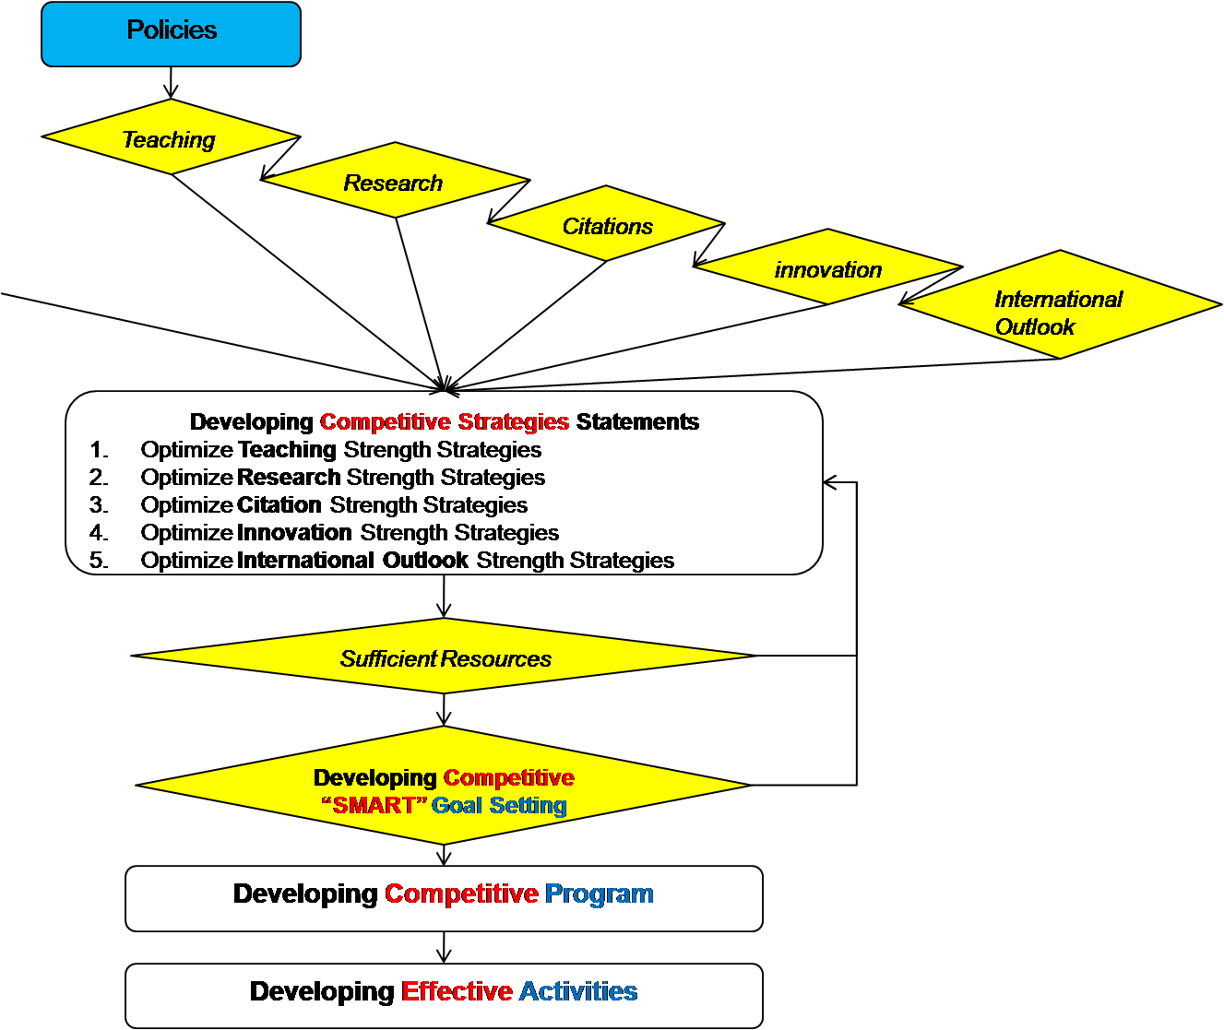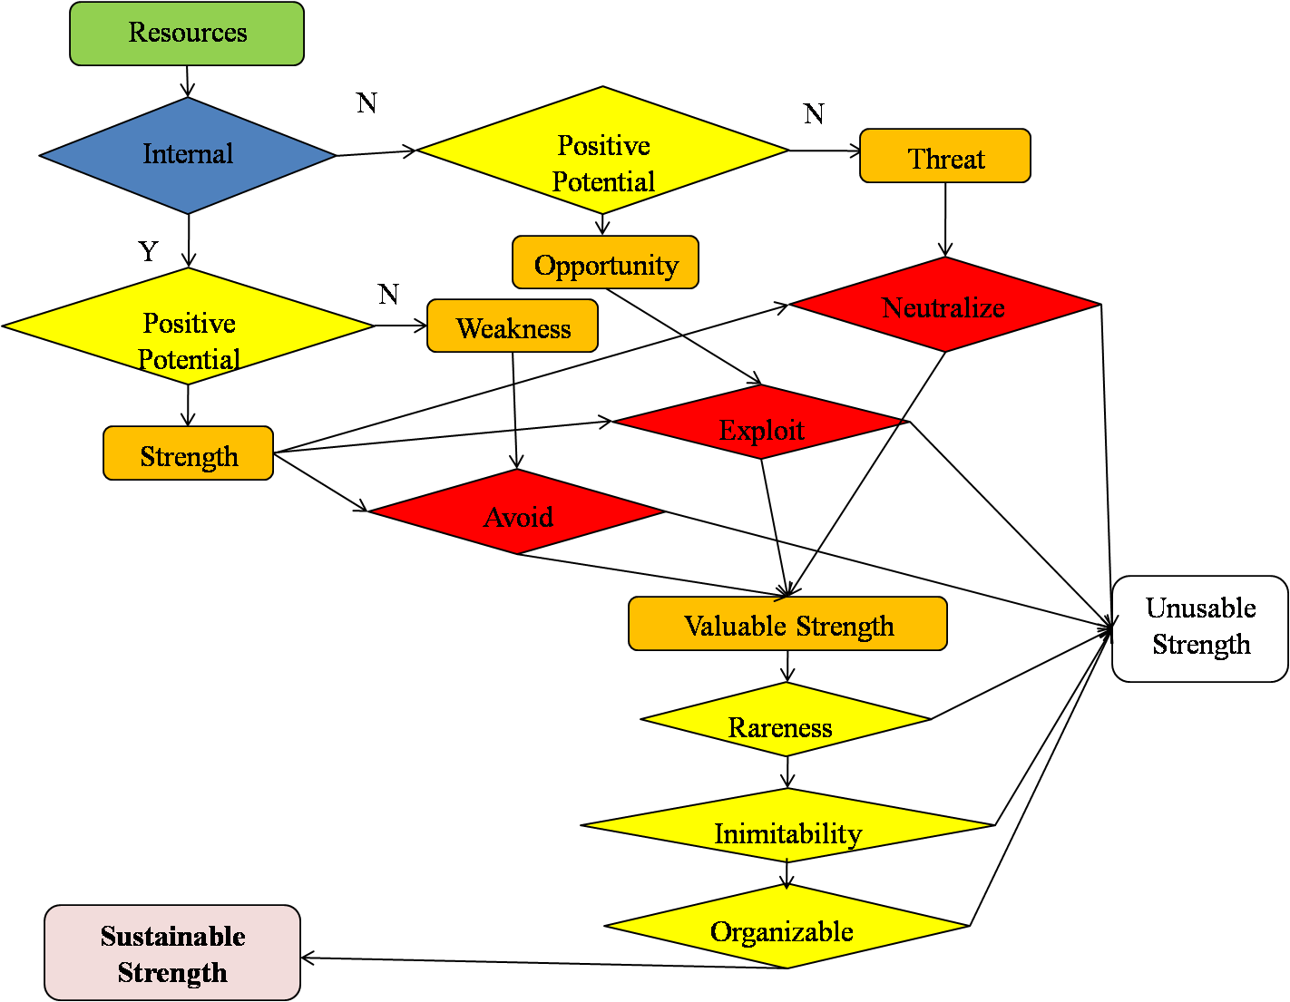

Fig. 1 THES-VRIO model from SWOT

3.2 VRIO-THES Evaluation Analysis

Some forms of evaluation for VRIO analysis obtained from SWOT analysis that can be generated and observed as some areas as written follows:

1. Valuable

The examples in this valuable case are strength of the institution. This evaluation could be expanded more to get the value of the university. The evaluation of this valuable point can be shown in Table 1.

Table.1. Value

|  |  |  |  |  |
| --- | --- | --- | --- | --- |
| Strength | exploit opportunity | experience | neutralize threat | experiences |
| 1.  2.  3. |  |  |  |  |

2. Rare

The evaluation of this rarity point can be shown in Table 2.

Table.2. Rarity

|  |  |  |
| --- | --- | --- |
| Strength | EXPERIENCE | RARITY |
| 1.  2.  3. |  |  |

3. Inimitability

The evaluation of this inimitability point can be shown in Table 3.

Table.3. Inimitable

|  |  |  |
| --- | --- | --- |
| Strength | EXPERIENCE | INIMITABLE |
| 1.  2.  3. |  |  |

4. Organizable

The evaluation of this inimitability can be shown in Table 4.

Table.4. Organizable

|  |  |  |
| --- | --- | --- |
| Strength | EXPERIENCE | ORGANIZABLE |
| 1.  2.  3. |  |  |

In this paper, the competitive implications used consist of a competitive disadvantage, competitive parity, temporary competitive advantage, and sustained competitive advantage1.

For the THES parameters, there are two components for analyzing model i.e. performance categories and weightings. The table for this can be shown in Table 5.

Table.5. THES Analysis

|  |  |  |
| --- | --- | --- |
| No | Performance categories | weightings |
| 1. | Teaching – the learning environment | Reputational survey – teaching (15%) |
| Ph.D. awards per academic (6%) |
| Undergraduates admitted per academic (4.5%) |
| Income per academic (2.25%) |
| Ph.D. awards/bachelor’s awards (2.25%) |
| 2. | International outlook – staff and students | Ratio of international to domestic staff (3%) |
| Ratio of international to domestic students (2%) |
| 3. | Research – volume, income, and reputation | Reputational survey – research (19.5%) |
|  |  | Research income (scaled) (5.25%) |
|  |  | Papers per academic and research staff (4.5%) |
|  |  | Public research income/total research income (0.75%) |
| 4. | Citations – research influence | Citation impact (normalized average citations per paper) (32.5%) |
| 5 | Industry income - innovation | Research income from industry (per academic staff) (2.5%) |

4. RESULTS AND DISCUSSION

The VRIO model criteria and points could be made using Fuzzy in the implementation as shown below,

1. Valuable

The criteria, in this case, should be changing Weakness (W), capturing Opportunity (O), and neutralizing Threat (T). There are four points and criteria respectively in making a Fuzzy logic i.e.:

1 - Unable

2 - Only 1 capability

3 - Only 2 capabilities

4 - 3 or more is achieved

So the fuzzy logic for the valuable criteria can be shown in Figure 2.

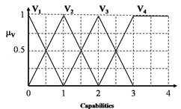

Fig. 2 Fuzzy logic for valuable

The functions of Fuzzy member for the valuable criteria can be shown in formula below:

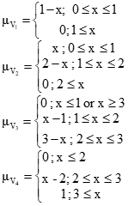

2. Rareness

The criteria, in this case, are seen it is very mature or not mature. There are four points and criteria respectively in making a Fuzzy logic i.e.:

1 - Haven’t shown evidence of ability to solve problem

2 - Able to solve problems for the last 3 years

3 - Able to solve problems for the last 5 years

4 - Able to solve problems for the last 10 years

So the fuzzy logic for the rarity can be shown in Figure 3.

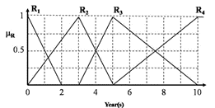

Fig. 3 Fuzzy logic for rarity

The functions of Fuzzy member for the rarity criteria can be shown in formula below:

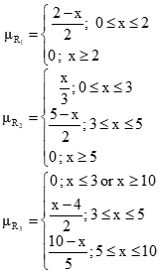

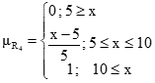

3. Inimitability

The criteria, in this case, are uniqueness and/or substitution. There are four points and criteria respectively in making a Fuzzy logic i.e.:

1 - More than 5 competitors are able to replace the strength within 10 years

2 - There are only less than 3 competitors who can imitate/replace the strength within 10 years

3 - Only 1 competitor can replicate/replace the strength within 10 years

4 - No competitor can replicate/replace the strength within 10 years

So the fuzzy logic for the inimitable can be shown in Figure 4.

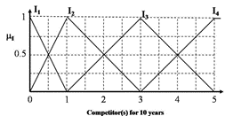

Fig. 4 Fuzzy logic for inimitability

The functions of Fuzzy member for the inimatibility criteria can be shown in formula below:

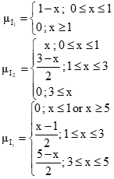

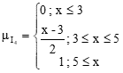

4. Organizable

The criteria, in this case, are organizable. There are four points and criteria respectively in making a Fuzzy logic i.e.:

1 - Strength owned isn’t able to support functions in management effectively and efficiently

2 - Strength owned is able to support certain functions in management effectively and efficiently

3 - Strength owned is able to support most of the functions in management effectively and efficiently

4 - Strength owned is able to support all kinds of functions in management effectively and efficiently

So the fuzzy logic for the organizable can be shown in Figure 5.

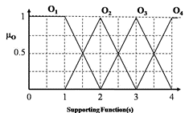

Fig. 5 Fuzzy logic for organizable

The functions of Fuzzy member for the organizable criteria can be shown in formula below:

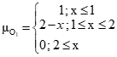

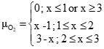

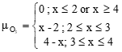

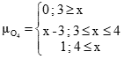

5. Competitive Implications

The criteria for the competitive implications are a competitive disadvantage (D), competitive parity (P), temporary competitive advantage (T), and sustained competitive advantage (S). So the fuzzy logic for this can be shown in Figure 6.

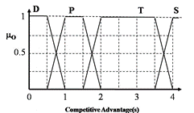

Fig. 6 Fuzzy logic for competitive advantage

5. CONCLUSIONS

This paper has proposed a novel framework model of Fuzzy VRIO-THES. The analysis model based on VRIO and also points and weightings from THES framework have been made. The evaluation and analysis are very important to clustering the problems from the SWOT analysis that has been obtained. In this paper has also been categorized into member functions of the Fuzzy logic. The future work will be an application of the Fuzzy VRIO-THES in developing a university strategic plan.

ACKNOWLEDGMENTS

This work was supported by a fundamental research grant no. 143737 from the Ministry of Research, Technology and Higher Education of the Republic of Indonesia.

**REFERENCES**

Sudiyatno, S. Indartono, F. W. Wibowo. VRIO and THES Based Development of University Competitive Advantage Model in Formulating University Strategic Plan, INFORMATION.

F. W. Wibowo. Implementation of Strategic Alignment Framework for Developing information Technology of RFID in XYZ Private University, Advanced Science Letters.

Suyatmi, F. W. Wibowo. Research Instrument Testing for Strategic Management of Information Technology Private University of XYZ, INFORMATION, 19 (9(B))(2016), 4025-4032.

M. I. Purwanto, F. W. Wibowo. Analysis of XYZ Information Technology University Employees Welfare in Islamic Perspective, Advanced Science Letters, 23 (5)(2017), 4981-4985.

Suyatmi, F. W. Wibowo. Regression and Correlation Analysis for Strategic Management of Information Technology Private University of XYZ, Asian Journal of Information Technology, 15 (15)(2016), 2559-2563.

F. W. Wibowo, A. Dahlan. Excellent Services for Digital Government Services of XYZ Department in Yogyakarta.

E. Roghanian, M. Alipour. A Fuzzy Model for Achieving Lean Attributes for Competitive Advantages using AHP-QFD-PROMETHEE, Journal of Industrial Engineering International, (2014), 10:68.

E. T. Luthfi, F. W. Wibowo. Loan Payment Prediction Using Adaptive Neuro Fuzzy Inference System, International Journal of Simulation Systems, Science & Technology, 18 (4)(2017), 9.1-9.6, DOI: 10.5013/IJSSST.a.18.04.09

J. Vaziri, M. A. Beheshtinia. A Holistic Fuzzy Approach To Create Competitive Advantage Via Quality Management In Services Industry (Case Study: Life-Insurance Services), Management Decision, 54 (8)(2016), 2035-2062, [DOI: 10.1108/MD-11-2015-0535](https://doi.org/10.1108/MD-11-2015-0535)

M. Hemmati, D. Feiz, M. R. Jalilvand, I. Kholghi. Development of Fuzzy Two-Stage DEA Model For Competitive Advantage Based On RBV And Strategic Agility As A Dynamic Capability, Journal of Modelling in Management, 11 (1)(2016), 288-308, [DOI: 10.1108/JM2-12-2013-0067](https://doi.org/10.1108/JM2-12-2013-0067)