The Development of Terbang Papat and Larung Sesaji Local Wisdom-Based Physics Learning Module to Increase the Senior High School Students’ Physics Representation Ability in Realizing Nature Of Sciences

Warsono  Departement of Physics Education:Yogyakarta State University  Yogyakarta, Indonesia  warsono@uny.ac.id | Supahar  Departement of Physics Education:Yogyakarta State University  Yogyakarta, Indonesia  supahar@uny.ac.id
Ahdika Setiyadi  Departement of Physics Education:Yogyakarta State University  Yogyakarta, Indonesia  Adika.setiyadi.2017@student.uny.ac.id | Danis Alif Oktavia  Departement of Physics Education:Yogyakarta State University  Yogyakarta, Indonesia  danisalifoktavia.2017@student.uny.ac.id

Abstract- This study aims to determine the feasibility level of local wisdom-based physics learning module in high school physics learning and determine the effectiveness of local wisdom-based physics learning module in increasing the students' representation ability in high school physics learning. This research is research and development with a 4-D development model (Define, Design, Develop, Disseminate). The research design used was a pretest-posttest control group design. The research subjects were students of class X MIPA in Kebumen City, Central Java and students of class XI MIPA in Kudus, Central Java. The research instrument consisted of material and media assessment validation sheets as well as tests of physics representation abilities (verbal and vector). The data analysis technique used is the General Linear Model (GLM) with a significance level of 0.05 and a standard scale. The results obtained show that the module developed is feasible and effective to be used in high school physics learning activities to improve students' physics (verbal and vector) representation abilities based on Mean Difference values.
Keyword- learning media, physics representation, local wisdom, high school physics learning

Introduction
Learning is the process of changing the understanding of concept of a science. The process of changing the understanding of the concept in question is an integral part of the transfer process, the level of understanding, the ability to predict, solve problems, and the process of translating knowledge [1]. Learning is said to be successful if students are able to understand the concept of the material well [2].
Physics is the study of natural phenomena in everyday life. The process of learning physics is often considered complicated because there are many mathematical equations. References [3] suggest that misunderstanding in understanding the concept of physics is a major difficulty of physics. The relationship between technology and physics material in everyday life is considered not having any relation by the students. This makes students not interested to study physics because students have difficulty in understanding physics.
The abstract and difficult learning process has an impact on students' understanding of concepts and problem solving. The ability to solve problems is important in achieving learning objectives [4]. References [5] conclude that students will change their perception that physics is considered difficult and they are more interested if the learning process is carried out by innovating methods or strategies with problem solving. Multiple representation in problem solving, including verbal, diagram/ picture, mathematics/symbolic, and graphic.
Rapid technology development makes learning activities more dynamic. Learning activities that require representation ability can be integrated with technology such as learning module that are designed interactively. Interactive physics learning module are able to provide meaningful learning. The teacher can easily connect prior knowledge or remind students of important information with hyperlinks [6]. Some representations in physics such as graphics, animation, video, and narration are part of the learning module which is a link for abstract concepts [6] [7] [8].
Meaningful learning can also be realized by applying learning based on local wisdom (9). The application of local wisdom can create a pleasant atmosphere of teaching and learning. This happens because students feel their experiences in daily life become closer to learning [10]. Local wisdom taken is terbang papat from Kudus Regency and larung sesaji from Kebumen Regency. Terbang papat is an Islamic cultural art in the form of musical instruments and used as a medium for the propagation of Islam. By definition, larung sesaji, which means offerings, can be said to be a tradition carried out by fishermen or coastal sea communities as expressing gratitude that has been blessed in the form of a fish harvest by throwing offerings into the ocean [11].
Based on the description that has been explained, it can be concluded that there is a need for the development of physics learning module based on terbang papat and larung sesaji local wisdom to improve the physics representation ability of high school students in realizing the nature of sciences.

Research Method
This study used research and development method using a 4-D model developed by Thiagajaran in 1974 (Arifin, 2012: 245) which is presented in Figure 1. The research was conducted in 2 months in the even semester of 2018/2019 academic year at class X MIPA in Kebumen, Central Java and class XI MIPA in Kudus, Central Java.
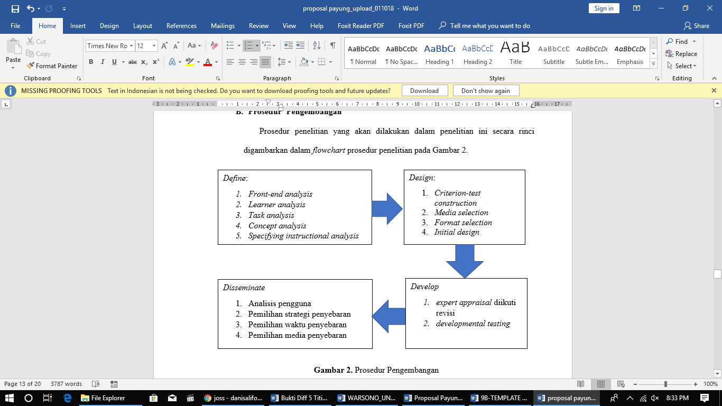
Figure 1. Research Method
The product test design in this study included three stages, namely, validation of experts consisting of material experts. Furthermore, a limited test was conducted to determine the quality of the product based on aspects of learning and product appearance from the assessment of students. Then, a field test was conducted to find out the improvement of representation ability. The product test design stages are presented in Figure 2.
Figure 2. The Product Test Design Stages

The research procedures in this study were described in the research procedure flowchart in Figure 3
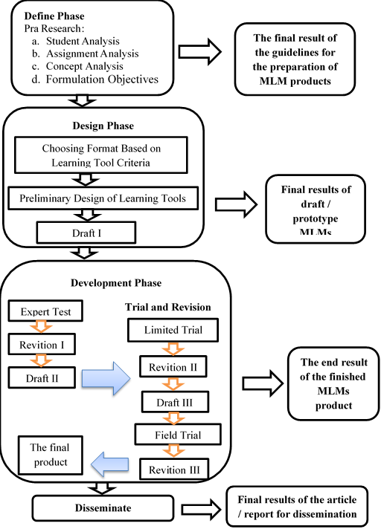
Figure 3. Research Procedure
The design of this study was the Pretest-Posttest Control Group Design presented in Table 1. The instruments used in this study were a test of verbal and vector representation abilities of 10 items and student questionnaire responses.
Table 1. Research Design.
Group | Pretest |  | Treatment | Postest
Group | Y₁ | Y₂ | Treatment | Y₁ | Y₂
Experiment | T₁ | T₁ | X₁ | T₂ | T₂
Contrast 1 | T₁ | T₁ | X₂ | T₂ | T₂
Contrast 2 | T₁ | T₁ | X₃ | T₂ | T₂
Keterangan:
T1 : Pretest.
T2 : Posttest
Y1 : Verbal Representation
Y2 : Vector Representation
X1 : Using MLM local wisdom
X2 : Using local wisdom PPT
X3 : Using textbook
The assessment of local wisdom-based module feasibility used a standard scale as in Table 2
Table 2. Five Scale Standard Assessment Criteria
Range Score | Category
 | Very Good
 | Good
 | Fair
 | Poor
 | Very Poor

The Analysis of the increasing ability of physical representations (verbal and vector) used the General Linear Model (GLM) based on the output value of Mean Difference (MD) and Partial Eta Squared.

Research result and Discussion
The module developed is based on the local wisdom of terbang papat and larung sesaji. Multimedia Learning Module that was made consists of the front cover, a list of menus consisting of material, developer profiles, instructions for use, references, competencies and exercises. The module developed was in the form of an android application that can be accessed offline via a smartphone. The module has animation-based problem exercises and problem descriptions to find out the level of problem-solving ability. The display of the module based on the local wisdom of terbang papat and larung sesaji is presented in Figure 4. The results of the expert and media expert assessment of the module are presented in Table 3 and Table 4.
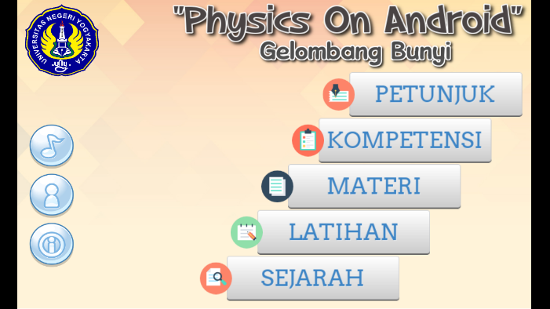
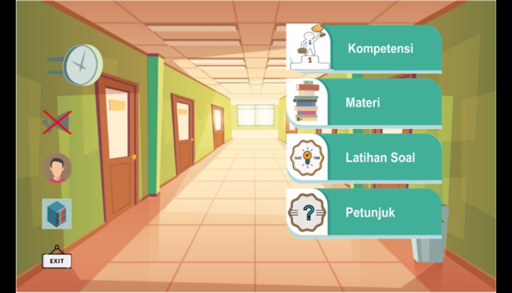
Figure 3. Display of products MLMs
The results of the material analysis and media expert judgment on Multimedia Learning Modules are presented in Table 3 and Table 4.
Table 3. Analysis Material Aspects
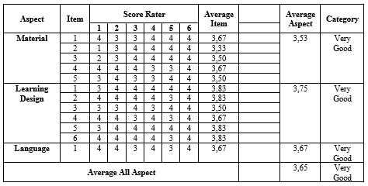
Table 3 shows the results of the module assessment analysis on material aspects, learning design aspects and language aspects. The assessment results obtained are quantitative data with a score of 1 to 4. This data were then converted and analyzed using a five-scale assessment category as in Table 2. The module evaluation based on material sub-aspects in Table 3 obtained an average value of 3.52 which was classified in the very good category. The learning design sub-aspect obtained a mean value of 3.75 which was classified in the excellent category. The sub-aspect of language in the assessment of module obtained a mean value of 3.67 and was classified in the very good category. The scores provided by the validator were included with suggestions for improvement. The validator suggested the researcher improve the physical quantities used to match the actual events in everyday life and improving the arrangement of sentences to make it more effective and easier to understand. Overall analysis of the material, learning design and language sub-aspects obtained a mean value of 3.65 and showed that the modules developed were in the excellent category. These results prove that terbang papat and larung sesaji local wisdom-based module developed is suitable for use in learning activities in terms of the material aspects.
Table 4. Analysis learning design and language aspects
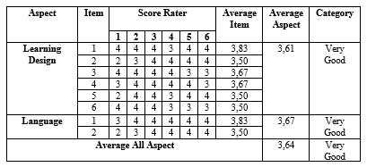
Table 4 shows the results of the module assessment analysis on aspects of learning design and aspects of language. The assessment results obtained are quantitative data with a score of 1 to 4. The data was then converted and analyzed using a five-scale assessment category as in Table 2. The module assessment based on the sub-aspects of learning design obtained a mean value of 3.61 which is classified in the very good category. The sub-aspect of language in the assessment module obtained a mean value of 3.67 and was classified in the very good category. The scores provided by the validator were included with suggestions for improvement. Suggestions for improving the display module include improving the location of the navigation buttons and examples of local wisdom in accordance with the concept of the material. The validator also suggested the researcher add target information and physical material contained in the module. Overall analysis of the learning and language design sub-aspects obtained a mean value of 3.64 and showed that the modules developed were included in the excellent category. These results prove that terbang papat and larung sesaji local wisdom-based module developed is suitable for use in learning activities in terms of media aspects.
Table 5 Analysis eligibility of students
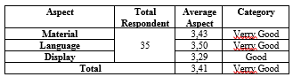
Table 5 shows the results of the module assessment analysis according to the eligibility assessed by students. The assessment results obtained were quantitative data with a score of 1 to 4. These data were then converted and analyzed using a five-scale assessment category as in Table 2. The product module evaluation is based on sub-aspects of material/learning, language and appearance which each got a score of 3.43, 3.50 and 3.29. The overall analysis obtained a mean value of 3.41. The assessment provided is included with suggestions for improvement. It was suggested that the researcher add the exercises and examples of questions into the module. This result proves that terbang papat and larung sesaji local wisdom-based module developed is suitable for use in learning activities. The results of implementing modules in learning activities to improve verbal and vector representation skills are presented in Tables 6, 7 and 8.
The results of the implementation of the Multimedia Learning Modules in learning activities to improve the representation ability of physics are presented in Table 6.
Tabel 6. Pairwise Comparisons Verbal Representation
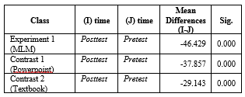
Mean difference (MD) is obtained from the reduction of the mean of pretest scores against the posttest scores. The increasingly negative MD scores in Table 6 prove that there was a significant increase in students' verbal representation abilities. The results of pairwise comparisons in Table 6 prove that the class that uses terbang papat local wisdom-based module showed improved scores which were better than the class using PPT and ordinary modules by obtaining an MD of -46.442.
Tabel 7. Pairwise Comparisons Vector Representation
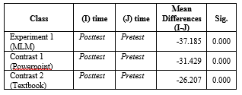
Mean difference (MD) is obtained from the reduction of the mean of pretest scores against the posttest scores. The increasingly negative MD scores in Table 7 prove that there was a significant increase in students' vector representation abilities. The results of pairwise comparisons in Table 6 prove that the class that uses larung sesaji local wisdom-based module showed improved scores which were better than the class using PPT and ordinary modules by obtaining an MD of -37.185.
Additional information about the effective contribution of the use of terbang papat and larung sesaji local wisdom-based modules in learning activities as a means to improve students' verbal and vector representation skills can be seen from the results of the Multivariate Test of Hotelling Trace type test in GLM based on the partial eta squared values in Table 8.
Tabel 8. Multivariate Test
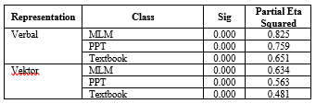

Table 8 shows the values of the effective contribution of terbang papat and larung sesaji local wisdom-based module in improving students' verbal and vector representation skills which were 82.5% and 63.4%. The results of the analysis in Table 9 conclude that the local wisdom-based module provides the highest effective contribution in improving students' verbal and vector representation skills.

Conclusion
The conclusion of this research is that terbang papat and larung sesaji local wisdom-based module is suitable for use in learning activities based on the assessment of material experts and media experts with very good categories. The local wisdom-based module developed can improve the representation ability of students with effective contributions in learning activities by 82.5% in increasing verbal representation and 63.4% in improving vector representation.

Acknowledgment
The Directorate of Research and Community Service for Research and Community Service funding in Higher Education Edition XII 2018 through the Research Postgraduate Team for this research.

References
- Holme, T. A., Luxford, C. J., & Brandriet, A. (2015b). Defining conceptual understanding in general chemistry. Journal of Chemical Education, 92(9), 1477–1483. https://doi.org/10.1021/acs.jchemed.5b00218
- Georgiou, H., & Sharma, M. D. (2015). Does using active learning in thermodynamics lectures improve students’ conceptual understanding and learning experiences? European Journal of Physics, 36(1), 015020. https://doi.org/10.1088/0143-0807/36/1/015020
- Docktor, J. L., & Mestre, J. P. (2014). Synthesis of discipline-based education research in physics, 020119, 1–58. https://doi.org/10.1103/PhysRevSTPER.10.020119
- Merriënboer, J. J. G. Van. (2013). Computers & education perspectives on problem solving and instruction. Computers & Education, 64, 153–160. https://doi.org/10.1016/j.compedu.2012.11.025
- Taale, K. D. (2011). Improving physics problem solving skills of students of Somanya senior high secondary technical school in the Yilo Krobo District of Eastern Region of Ghana. Journal of Education and Practice, 2(6), 8–21. Retrieved from http://www.iiste.org/Journals/index.php/JEP/article/view/522/408
- Sadaghiani, H. R. (2011). Using multimedia learning modules in a hybrid-online course in electricity and magnetism. Physical Review Special Topics - Physics Education Research, 7(1). https://doi.org/10.1103/PhysRevSTPER.7.010102
- Hill, M., Sharma, M. ., & Johnston, H. (2015). How online learning modules can improve the representational fl uency and conceptual understanding of university physics students. https://doi.org/10.1088/0143-0807/36/4/045019
- Sadaghiani, H. R. (2012). Controlled study on the effectiveness of multimedia learning modules for teaching mechanics. Physical Review Special Topics - Physics Education Research, 8(1). https://doi.org/10.1103/PhysRevSTPER.8.010103
- Zuhdan, K. P. (2013). Pembelajaran sains berbasis kearifan lokal, (September), 1–14
- Dewi, I. N., Poedjiastoeti, S., & Prahani, B. K. (2017). Elsii learning model based local wisdom to improve students’ problem solving skills and scientific communication, 5(1), 107–118
- Sawiji. A, Maulidiyah & Munir. M. 2015. Petik laut dalam tinjauan sains dan islam. Al-Ard: Jurnal Teknik Lingkungan, 2(2)

