The Development of Physics Learning Media Based on Local Wisdom Belogo and Traditional Rowing Contest to Improve the Physics Representative Ability of High School Students in Realizing Learning Outcomes
Warsono  Departement of Physics Education:Yogyakarta State University  Yogyakarta, Indonesia  warsono@uny.ac.id | Supahar  Departement of Physics Education:Yogyakarta State University  Yogyakarta, Indonesia  supahar@uny.ac.id
Rio Sandhika Darma  Departement of Physics Education:Yogyakarta State University  Yogyakarta, Indonesia  Riodarma58.2017@student.uny.ac.id | Puji Iman Nursuhud  Departement of Physics Education:Yogyakarta State University  Yogyakarta, Indonesia  Nursuhudpujiiman_007.2017@student.uny.ac.id

Abstract- This research aims to develop and find out the effectiveness of Multimedia Learning Modules (MLMs) in improving students’ (diagram and physical) representations of physics. This research is research and development with a 4-D development model (Define, Design, Develop, and Disseminate). The research design used is a pretest-posttest control group design. The research subjects are 10th-grade MIPA students in Samarinda City, East Kalimantan and Batang Regency, Central Java. The research instrument consists of ability tests of representations (diagram and physical) of physics. The data analysis technique used is the General Linear Model (GLM) with a significance level of 0.05 and a standard scale. The results of the research are that MLMs that are implemented properly and effectively are used in high school physics learning activities to improve students’ physics (diagram and physical) ability based on Mean Difference values.
Keyword- learning media, physics representation, local wisdom, high school physics learning

Introduction
The 21st century physics learning is highly closely related to technological development. The rapid development of technology makes learning activities more dynamic. Learning activities that require representation ability can be integrated with technologies such as interactive multimedia. The application of interactive multimedia has a positive impact as a support for learning to improve students’ understanding of concepts [1]. Concurring with this, Ramganesh [2] states that interactive multimedia can also be used to improve problem-solving abilities. In addition, the involvement of multimedia in learning activities can also improve learning achievement, positive attitudes and student motivation compared to conventional learning [3] [4]. This indicates that the development of learning is in line with the development of technology so that there is a need of media that can be used to facilitate the delivery of material concepts. Monotonous learning is bound to text modules and common daily examples in explaining physics concepts, making students look bored in each session [5]. That is why the development of Multimedia Learning Modules based on local wisdom is suitable and in accordance with the needs of students and teachers so it should be developed in helping the learning process [6].
Multimedia is a combination of several techniques and formats, namely: first, technical devices as a carrier of information (computers, networks, display of information, etc.), second, signs/information in the form of representations (text, images, sounds), and third, recipients of information (in the form of sight and hearing) [10]. Submission of information is the focus of the use of multimedia with the aim of being easily accessible, easily used repeatedly and can be used by each individual [3] [10]. One form of interactive multimedia is multimedia learning modules (MLMs). MLMs are introduced to students as an introduction before learning activities begin, so students become more prepared and motivated to participate in learning [7] [9]. MLMs are used as a solution to overcome problems in the use of textbooks that are less effective, where some students do not read books carefully and retrieve more information that is not important [8] [9] [7]. MLMs that are applied in learning activities can make learning more meaningful. The teacher can easily connect prior knowledge or remind students of important information using hyperlinks [11]. However, students need not be afraid if learning takes place too quickly because it can be controlled with the existing navigation buttons [9]. Some representations in physics such as graphics, animation, video, and narration are part of MLMs which become a link for abstract concepts [8] [9] [10].
Physics learning in addition to understanding the concept of vectors also requires an understanding of diagrams. The research results of Purchase [13] and Harjanti [14] state that the use of diagrams is very necessary to explain and understand phenomena from various kinds of multidisciplinary sciences. Physics is the study of natural phenomena which are divided into several parts including kinematics and dynamics [15]. Some concepts of physics related to kinematics and dynamics include force, motion, momentum and energy [15]. These materials must be understood and mastered by students because they relate in everyday life. However, in reality, students still have difficulty understanding materials related to the concepts of kinematics and dynamics. This is because these materials use diagrams as a means of representation in their learning [16]. Nieminen and Viiri [17] and Ardi [12] research results show that some students still have difficulty in drawing free diagrams. In fact, diagrams are a means of representing the concepts of physics related to the concepts of kinematics and dynamics. This explanation concludes that in addition to vector representations, diagrams also have important influences in learning physics concepts.
In accordance with the situation at the time of learning, that students feel confusion in cognitive activities, especially representing physical activities that in the learning process only connects to physical phenomena, concepts, symptoms, objects, data and context or processes in physics [18]. This supports the use of representation during the physics learning process, which can improve students' understanding of concepts and can provide more meaningful learning [19]. Franco [20] argues that representing the concept of physics into physical phenomena makes students able to process strategies, encapsulate learning into text, and understand the changes in concepts that happen consistently. Thus, representations of physics can represent students' thinking about deep concepts of physics when compared to the ability of verbal and picture representations [21]. Therefore, students can understand the concepts of physics that are needed not just memorizing the equation

Research Method
This research includes research and development using the 4-D models developed by Thiagajar in 1974 [22] presented in Figure 1. Two months of research in the even semester of 2018/2019 MIPA X classes in Samarinda, East Kalimantan and Batang, Central Java.
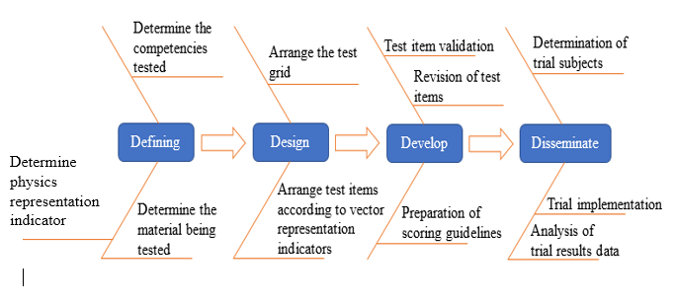
Figure 1. Research Method
Field testing was carried out to obtain a conclusion whether the product developed can improve the representation (diagrams and physical) ability of physics. Field testing (broad scale) was conducted at randomly selected schools from all MIPA X classes in Samarinda, East Kalimantan and Batang, Central Java.
The product development procedure used the Borg and Gall (R&D) development model above. The picture below shows the research procedure that was carried out:
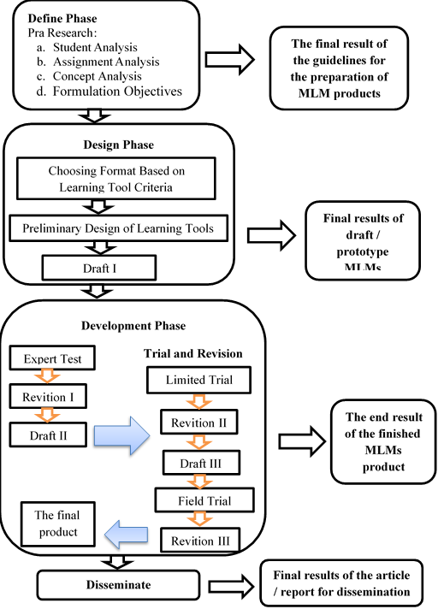
Figure 2. Procedure Research
The design of this research uses the Pretest-Posttest Control Group Design presented in Table 1. The instrument used in this research is a test of the ability to represent diagrams and vectors of 10 items and questionnaire responses of students.
Table 1. Research Design.
Group | Pretest |  | Treatment | Postest
Group | Y₁ | Y₂ | Treatment | Y₁ | Y₂
Experiment | T₁ | T₁ | X₁ | T₂ | T₂
Contrast 1 | T₁ | T₁ | X₂ | T₂ | T₂
Contrast 2 | T₁ | T₁ | X₃ | T₂ | T₂
Keterangan:
T1 : Pretest.
T2 : Posttest
Y1 : Diagram Representation
Y2 : Physical Representation
X1 : Using MLM local wisdom
X2 : Using local wisdom PPT
X3 : Using textbook
The feasibility assessment of Multimedia Learning Modules uses a standard scale as in Table 2.
Table 2. Five Scale Standard Assessment Criteria
Range Score | Category
 | Very Good
 | Good
 | Fair
 | Poor
 | Very Poor
The analysis of the increasing of representation (diagrams and physical) ability of physics using the General Linear Model (GLM) based on the output value of Mean Difference (MD) and Partial Eta Squared.

Research result and Discussion
Multimedia Learning Modules that are developed based on the Belogo local wisdom and traditional rowing competition. The Multimedia Learning Modules consist of a start page, a title page, instructions for use, a main menu, a material menu that contains a video introduction to Belogo and a traditional rowing competition with material content: momentum, impulse and the law of conservation of momentum, example problems, practice questions, references and developer profiles. Multimedia Learning Modules developed in the form of an android application can be accessed offline via a smartphone. Multimedia Learning Modules have exercises based on animation and problem descriptions to find out the level of problem solving ability and students’ understanding of the physics concepts of momentum and impulse material. Display of Multimedia Learning Module products based on the Belogo local wisdom and traditional rowing competitions are presented in Figure 4.
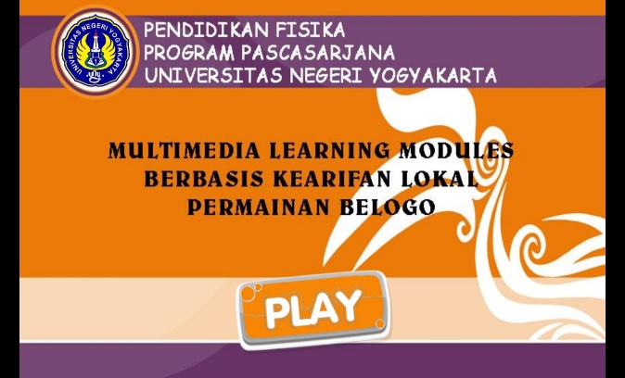
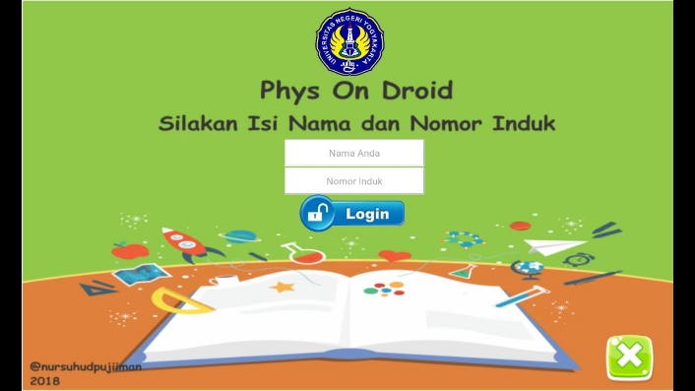
Figure 3. Display of products MLMs
The results of the material analysis and media expert judgment on Multimedia Learning Modules are presented in Table 3 and Table 4.
Table 3. Analysis material aspects
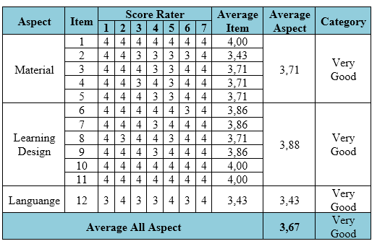
Table 3 shows the results of the Multimedia Learning Modules (MLMs) assessment analysis according to material aspects, learning design aspects and language aspects. The assessment results obtained are quantitative data with a score of 1 to 4. This data is then converted and analyzed using the five scale rating category as in Table 2. The evaluation of MLM products based on the material sub-aspects in Table 3 using a scale 5 assessment category obtains an average value of 3.71, which is classified as a very good category. Ratings provided by the validator are included with suggestions for improvement. Suggestions for improvement given by the validator include the researchers improving the physical quantity units used to match the actual events in daily life such as the speed unit m/s replaced by km/hour. The learning design sub-aspect obtains a mean value of 3.88 and is classified as an excellent category. Suggestions for improvement given by the validator are that researchers are asked to improve mathematical equations related to the concept of impulses so that they are more easily understood. The sub-aspect of language in evaluating MLM products has a mean value of 3.43 and is classified as a very good category. Suggestions for improvement given by the validator are that the researcher is asked to improve the sentence related to the concept of momentum and impulse to make it more effective and easy to understand. The overall analysis of the material aspects, learning design and language obtains a mean value of 3.67 and shows that the developed MLMs are included in the excellent category. These results prove that MLMs based on the Belogo local wisdom and the traditional rowing competition developed are suitable for use in learning activities.
Table 4. Analysis media aspects
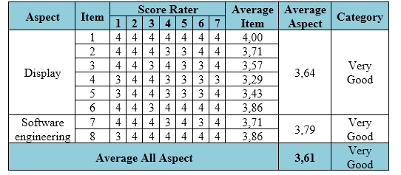
Table 4 shows the results of the Multimedia Learning Modules (MLMs) assessment analysis according to aspects of software display and engineering. The assessment results obtained are quantitative data with a score of 1 to 4. This data is then converted and analyzed using the 5 scale rating category as in Table 2. The evaluation of MLM products based on the display sub-aspects in Table 4 using a scale 5 assessment category obtains an average value of 3.64, which is classified as a very good category. Ratings provided by the validator are included with suggestions for improvement. Suggestions for improvement provided by the validator include researchers to reproduce multimedia that is relevant to learning activities and local wisdom content to be integrated into learning media. In addition, the developed MLMs must be facilitated by representative media and tricks. Suggestions for improvements to the display of MLMs include improvements to the background, navigation buttons and animated content in accordance with the concept of the material. The software engineering sub-aspect obtains a mean value of 3.79 and is classified as a very good category. Suggestions for improvement given by the validator are that researchers are asked to increase multimedia content related to the concept of material that can be integrated into MLMs. The overall analysis of the display aspects and software engineering obtains a mean value of 3.61 and shows that the developed MLMs are included in the excellent category. These results prove that MLMs based on the Belogo local wisdom and the traditional rowing competition developed are already suitable for use in learning activities.
Table 5 Analysis eligibility of students
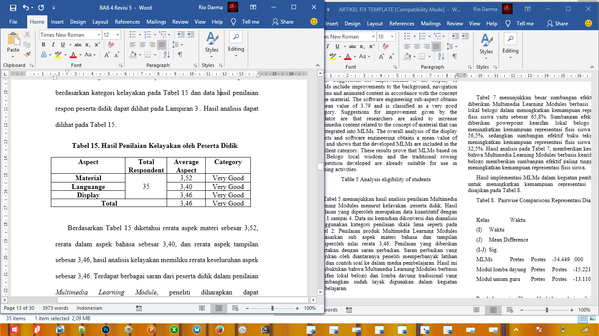
Table 5 shows the results of the Multimedia Learning Modules assessment analysis according to the eligibility of students. The assessment results obtained are quantitative data with a score of 1 to 4. This data is then converted and analyzed using the five scale rating category as in Table 2. The product assessment of Multimedia Learning Modules based on sub-aspects of language and display material obtains a mean value of 3.46. The assessment provided is included with suggestions for improvement. Suggestions for improvement given by researchers include increasing the practice of questions and examples of problems into the learning media. These results prove that the Multimedia Learning Modules based on the Belogo local wisdom and the traditional rowing competition developed are appropriate for use in learning activities.
The results of the implementation of the Multimedia Learning Modules in learning activities to improve the representation ability of physics are presented in Table 6.
Tabel 6. Pairwise Comparisons Physical Representation
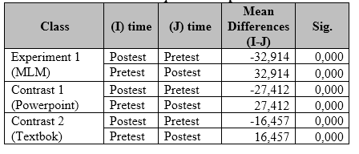
Significant changes are proved from the Mean Difference value of -32.914 for the MLM class, -27.412 for the power point class and -16.457 for the textbook class. Mean difference (MD) is obtained from the reduction in the average pretest score against the posttest score. The increasingly negative MD scores in Table 6 prove that there is a significant increase in students’ representation ability of physics based on pretest and posttest scores. The results of output pairwise comparisons in Table 6 prove that the MLM class based on the Belogo game local wisdom gives an increase in scores better than the power point and textbook classes by obtaining an MD of -32.914.
Additional information regarding the effective contribution of the use of Multimedia Learning Modules based on the Belogo local wisdom, power point and textbooks in learning activities as a means to improve students’ representation ability of physics can be seen from the results of the Multivariate Test analysis on GLM based on partial eta squared values in Table 7.
Tabel 7. Multivariate Test
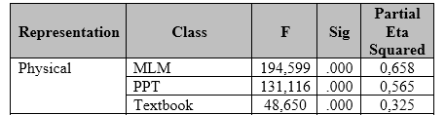
Table 7 shows the large effective contribution made by Multimedia Learning Modules based on the Belogo local wisdom in improving students’ representation abilities of physics by 65.8%. The effective contribution given by the Belogo local wisdom in improving students’ representation ability of physics is 56.5%, while the effective contribution of textbooks in improving students’ representation ability of physics is 32.5%. The results of the analysis in Table 7, give the conclusion that Multimedia Learning Modules based on the Belogo local wisdom provide the highest effective contribution in improving students’ representation ability of physics.
The results of the implementation of MLMs in learning activities to improve the ability of diagram representation are presented in Table 8..
Tabel 8. Pairwise Comparisons Diagram Representation
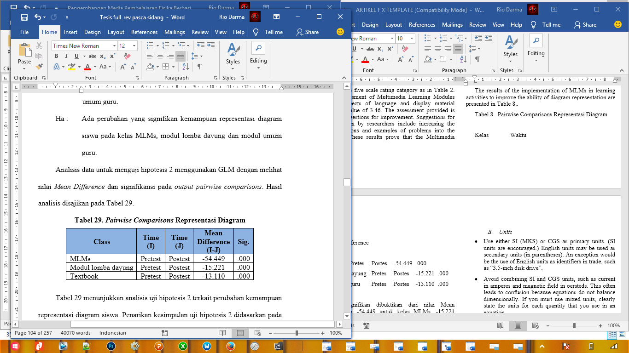
Significant changes are proved from the Mean Difference value of -54.449 for the MLMs class, -15.221 for the rowing race module class and -13.110 for the general module teacher class. Mean difference (MD) is obtained from the reduction in the average pretest score against the posttest score. The increasingly negative MD scores in Table 8 prove that there is a significant increase in the ability of the students to represent the diagram based on the pretest and posttest scores. The results of output pairwise comparisons in Table 8 prove that the MLMs class based on local wisdom of traditional rowing competitions give improved scores better than the rowing module class and general teacher module by obtaining an MD of -54,449. This is in line with Sadaghiani's research (2012) stating that MLMs are introduced to students as an introduction before learning activities begin, so students become more prepared and motivated to participate in learning.
Additional information regarding the effective contribution of using MLMs based on local wisdom in traditional rowing competitions, rowing race modules and general teacher modules in learning activities as a means to improve student diagram representation ability can be seen from the results of the Multivariate Test analysis on GLM based on partial eta squared values in Table 9.
Tabel 9. Multivariate Test Diagram Representation
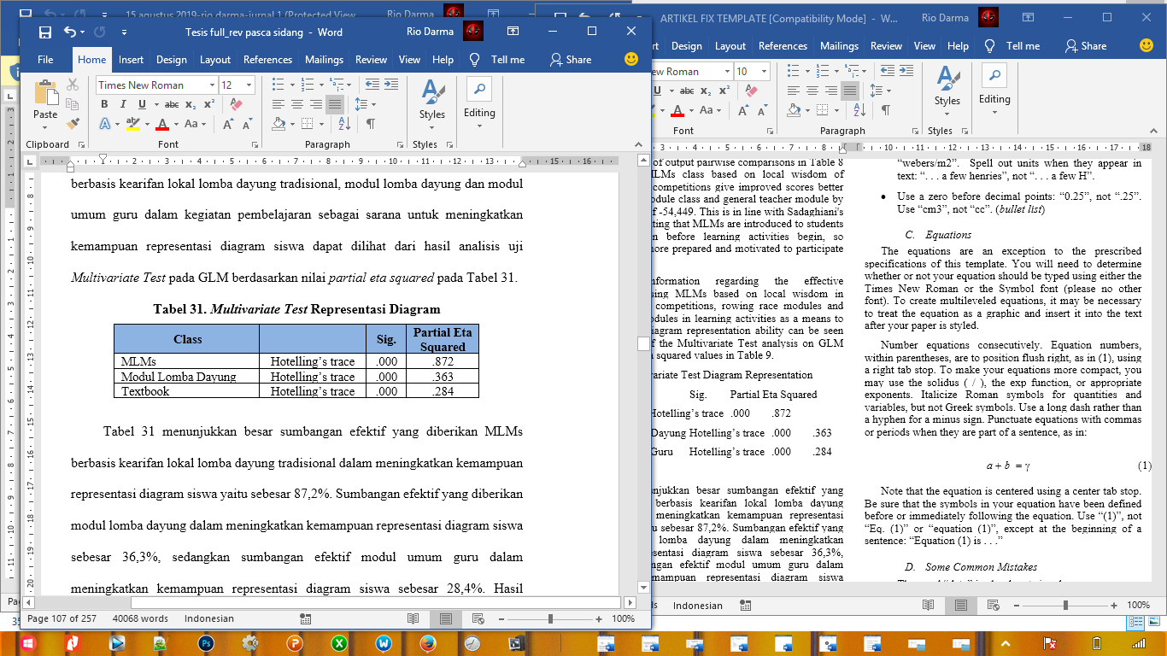
Table 9 shows the effective contribution made by MLMs based on local wisdom of traditional rowing competition in increasing the student diagram representation ability that is equal to 87.2%. The effective contribution made by the rowing competition modules in increasing the student diagram representation ability is 36.3%, while the effective contribution of the teacher general modules in increasing the student diagram representation ability is 28.4%. The results of the analysis in Table 9 conclude that Multimedia Learning Modules (MLMs) based on local wisdom of traditional rowing competitions provide the highest effective contribution in increasing the ability to represent students’ diagrams.

Conclusion
The conclusions in this research are (1) products of Multimedia Learning Modules (MLMs) based on the Belogo local wisdom and traditional rowing competitions are suitable for use in learning activities based on the assessment of material experts and media experts with excellent categories, (2) MLMs based on the Belogo local wisdom and traditional rowing competitions developed can improve the ability representations of diagrams and physics for students at 10th grade MIPA in Samarinda, East Kalimantan and Batang, Central Java, and (3) The effective contribution made by MLMs in learning activities is 87.2% in increasing diagrammatic representation and 65.8% in increasing the representation of physics.

Acknowledgment
The Directorate of Research and Community Service for Research and Community Service funding in Higher Education Edition XII 2018 through the Research Postgraduate Team for this research.

References
- Andarini, H. D., Swasty, W., Hidayat, D., & Media, A. L. (2016). Designing the interactive multimedia learning for elementary students grade 1 st -3 rd a case of plants ( Natural Science Subject ). Fourth International Conference on Information and Communication Technologies, 4(c), 1–5.
- Ramganesh, E. (2012). Effect of self-regulatory strategies with interactive multimedia on problem solving ability of higher secondary students in physics. Shodh Sanchayan, 3(2), 1–5.
- Leow, M. F., & Neo, M. (2014). Interactive multimedia learning : innovating classroom education in a Malaysian University, The Turkish Online Journal of Educational Technology, 13(2), 99–110.
- Li, Y. W., Mai, N., & Tse-Kian, N. (2014). Impact of learner-centred teaching environment with the use of multimedia-mediated learning modules in improving learning experience. Jurnal Teknologi (Sciences and Engineering), 68(2), 65–71.
- Delima, E., Warsono, Supahar, and Jumadi (2018). The importance of multimedia learning modules (mlms) based on local wisdom as an instructional media of 21st century physics learning. IOP Conf. Series: Journal of Physics: Conf. Series 1097 (2018) 012018. 1-7
- Putry, A A., Warsono, Supahar, and Jumadi (2018). Students and Teachers’ Necessity toward Multimedia Learning Module (MLMs) Based on Benthik Local Wisdom to Provide Students’ Physics Initial Knowledge. IOP Conf. Series: Journal of Physics: Conf. Series 1097 (2018) 012014.
- Chen, Z., Stelzer, T., & Gladding, G. (2010). Using multimedia modules to better prepare students for introductory physics lecture. Physical Review Special Topics - Physics Education Research, 6(1), 1–5.
- Hill, M., Sharma, M. D., & Johnston, H. (2015). How online learning modules can improve the representational fluency and conceptual understanding of university physics students. European Journal of Physics, 36(4), 45019
- Sadaghiani, H. R. (2012). Controlled study on the effectiveness of multimedia learning modules for teaching mechanics. Physical Review Special Topics - Physics Education Research, 8(1), 1–7
- Schnotz, W., & Lowe, R. (2003). External and internal representations in multimedia learning. Learning and Instruction, 13, 117–123.
- Sadaghiani, H. R. (2011). Using multimedia learning modules in a hybrid-online course in electricity and magnetism. Physical Review Special Topics - Physics Education Research, 7(1), 1–7
- Ardi, F. L. (2017). Pengembangan perangkat pembelajaran fisika berbasis kearifan lokal (andong) berbantuan android untuk meningkatkan kemampuan representasi diagram dan representasi vektor. Tesis, tidak diterbitkan, Universitas Negeri Yogyakarta, Yogyakarta.
- Purchase, H. C. (2014). Journal of Visual Languages and Computing Twelve years of diagrams research. Journal of Visual Language and Computing, 25(2), 57–75.
- Harjanti, J.R, Supahar, Warsono, Jumadi (2019). Quality Analysis of Test for Diagrams and Mathematical Representation Ability of High School Student in Physics Using Partial Credit Model. Proceedings of the 3rd International Conference on Current Issues in Education (ICCIE 2018).
- Docktor, J. L., & Mestre, J. P. (2014). Synthesis of discipline-based education research in physics. Physical Review Special Topics - Physics Education Research, 10(2), 1–58
- Manalo, E., Uesaka, Y., Pérez-kriz, S., & Fukaya, T. (2013). Science and engineering students ’ use of diagrams during note taking versus explanation, Educational Studies, 39(1), 37–41.
- Nieminen, P., & Viiri, J. (2013). Does using a visual-representation tool foster students ’ ability to identify forces and construct free-body diagrams, Physical Review Special Topics - Physics Education Research, 010104, 1–11
- Abdurrahman et al. (2011) ‘Implementasi Pembelajaran Berbasis Multi Representasi untuk Peningkatan Penguasaan Konsep Fisika Kuantum’, Cakrawala Pendidikan, 30(1), pp. 30–45.
- Kurnaz, M.A, & Arslan, G. L. A. M. (2014). Effectiveness of Multiple Representations for Learning Energy Concepts : Case of Turkey, 116, 627-632.
- Franco, G. M. et al. (2012) ‘Examining the influences of epistemic beliefs and knowledge representations on cognitive processing and conceptual change when learning physics’, Learning and Instruction, 22(1), pp. 62–77.
- Leigh, Gregor. (2004). Developing Multi-representational Problem Solving Skills in Large, Mixed-ability Physics Classes (University of Cape Town Department of Physics: Thesis).
- Arifin, Zainal. (2012). Penelitian Pendidikan Metode dan Paradigma Baru. Bandung: Remaja Rosda Karya..

