**Lecturers’ Performance in Learning According to Students’ Perception**

Trie Hartiti Retnowati

*Graduate Program*

*Universitas Negeri Yogyakarta*

Yogyakarta, Indonesia

trie_hr@uny.ac.id

Djemari Mardapi

*Graduate Program*

*Universitas Negeri Yogyakarta*

Yogyakarta, Indonesia

djemari@uny.ac.id

Badrun Kartowagiran

*Graduate Program*

*Universitas Negeri Yogyakarta*

Yogyakarta, Indonesia

kartowagiran@uny.ac.id

Eka Ary Wibawa

*Faculty of Economic*

*Universitas Negeri Yogyakarta*

Yogyakarta, Indonesia

eka_arywibawa@uny.ac.id

**Abstract –** This research presents the information of lecturers’ performance in the learning process according to students’ perception. The data provided consist of the lecturers’ ability in conducting preliminary stage of the learning in the course activity during the course process and the assessment done by the lecturers. The purpose of this research is to see the quality of lecturers’ performance in conducting learning. The subjects population of this research were students from 43 majors in UNY. The samples used in this research were 1.380 students. The data about the lecturers’ performance were obtained through questionnaires given to the students. The validity verification of the instrument construct was done by using factor analysis technique Confirmatory Factor Analysis (CFA), while its reliability estimation used Cronbach Alpha technique. The technique of data analysis used was statistics descriptive quantitative. The research results show that the lecturers’ performance in the preliminary stage of learning activity is in excellent category with score 89,00. In the learning process stage is included into good category with score 77,00. And in the learning assessment is included into good category with score 78,25. Overall, the lecturers’ performance is included into good category for each faculty. However, there are some aspects that need to be improved such as the lecturers’ performance in the learning process and the assessment.

**Keywords –** Lecturers’ Performance, Learning, Students’ Perception

1. **INTRODUCTION**

As an education institution, university is an institution that has important role in producing intellectual resource that expected can contribute in the improvement of human resource quality. One matter that influences the quality and organizational sustainability capacity, in this matter, university is lecturer performance (Suryaman, 2018). Law no 14 of 2005 concerning Teacher and Lecturer states that lecturers are professional educators and scientists with their main job to transform, develop, and distribute sciences, technology, and rat through education research, and service to society. So broad and complex the job of a lecturer, to be a lecturer, a person must have high ability in accordance with these limits. Here lies the importance of lecturer roles in a tertiary institution.

Competency of learners is determined by RPS and next by learning process. The learning quality is determined by lecturer performance, that are skills and motivation. Bungai & Perdana (2018) stated that lecturer is an important component in resource system in high education. Considered lecturer performance is very important in improving high education quality, the lecturers of colleges are expected to have good performance. Therefore, need to maintain lecturer performance quality in college.

The success of education institution can be seen by the Lecturer Performance (Narasuci et all, 2018). Trisnaningsih (2011) explained that lecturer performance is ability to conduct job or duty that owned by lecturers in finishing the job. Performance can be interpreted as work presentation, work implementation, work achievement, and work result. If lecturer performance can be maintained well, then the result obtained is still in good quality. To realize this condition need a continuous assessment towards lecturer performance to get updated information about condition of lecturer performance. The purpose is if there is decline of lecturer performance, will be find out immediately and can give the right action. This is in line with the result of research by Peleyeju & Ojebiyi (2013) which recommend that management must guarantee lecturer performance assessment overall and continuously i order to improve lecturer quality and management quality in college.

Activity conducted in evaluation of lecturer performance is not only assessment of lecturer performance. This needs to be reassured to make evaluation of lecturer performance not only used to describe performance of each lecturer but also used for guiding of lecturer performance thoroughly and continuously. The research of Asrori (2011) found that with the existence of lecturer performance assessment system, can give positive impact in order to improve the report accountability and lecturer performance evaluation.

Different with evaluation, assessment is a systematic activity to collect, analyze, and provide information accurately and beneficial for interpreting the learner learning success.. Chappuis et al. (2012) explains that assessment is a process of collecting information about learners learning for the improvement of learning. Wright & Stones (1992) writes *“assessment provides an accounting of how much student learn in school and what resources are expended on achieving those learning outcome*”. Assessment can explain how far learners learn in school and what resources are needed to achieve the result of that learning. Thus, assessment is an interpretation to information or score of measurement result and the result is used for individuals.

Information needed in assessment and evaluation can be collected through measurement and non-measurement. Gronlund (1985) stated *“measurements process of obtaining of numerical description of the degree to which an individual possesses a particular characteristic”*. Keeves and Masters (1999) also stated that measurement is giving number (numerical quantity) to objects or events according to rules. In line with other experts, Nunnally (1978) also explains that measurement consists of rules to give number to object in certain manner so that it can present quantitatively the nature of the objects.

The measurement can be conducted through test and without test. According to experts, testing is a process of numbering or quantification of cognitive and psychomotor potential using tools designed specifically. Examination for learners is a quantification process of learning achievement in certain field through test. Measuring the table length and someone body height is quantification of an object without test. Meanwhile, evaluation is interpretation to data one of which is measurement result score which its implication is used by a group of people or program, for example the score of lecturer performance in college is 8,7, which us above minimum score to be said as good, then it can be said that program of lecturer performance guidance in that collage is successful.

Earl, Hargreaves, & Schmidt (2002) explained their research result that: (1) educator is more pleasant to use authentic assessment because the questions used do not need to be tried first, (2) by authentic assessment, can build collaborative understanding between educators, learners, and parents because authentic assessment assess each activity of learners and sometimes involves parents. Furthermore, Marzano et all, (2011) explains that based on reflection in learning is conducted by *planning and preparing*. Based on planning and preparing, finally the learner conduct learning called *classroom strategies and behaviors*. The implementation of learning is an important component that really determines the learning achievement of learners. Marzano, Frontier, Livinnhston even explain that the more learners conduct something the the high learning achievement of learner.

The main problem that must be solved in this research is how student perspective in assessing lecturer performance in learning. Learning performance has three main aspects to be assessed that are: learning planning, learning process, and assessment. It is expected to be able to load the *output* of College performance so that it can result positive *feedback* for the quality improvement of College especially in UNY as *World Class University*. If lecturer performance in learning becomes main indicator of assessment, then student achievement output will become proof that performance of knowledge transfer and value transfer is effective to conduct.

1. **RESEARCH METHOD**

This research includes in type of quantitative descriptive method with purpose to describe lecturer performance in learning. Lecturer performance in this research can be seen according to student perception. The instrument used for data collection is questionnaire given to students to find out lecturer performance according to student perspective.

Subject population this research are students of 43 majors in UNY. The samples used in this research are 1.380 students. The analysis technique used in this research is quantitative statistic technique. Descriptive statistics used are *mean, median, modus, maximum, minimum*, deviation standard, and *varian*s. Score of lecturer performance is transformed into score with scale 100 to ease the data analysis. After analysis of descriptive statistic was conducted, the next stage is categorizing the score with category as follows.

**Table 1. Categorization of Lecturers’ Performance**

|  |  |
| --- | --- |
| Score | Category |
| above 80 s.d. 100 | Excellent |
| above 70 s.d. 85 | Good |
| above 55 s.d. 70 | Fair |
| above 40 s.d. 55 | Poor |
| 25 s.d. 40 | Bad |

1. **RESULT OF RESEARCH AND DISCUSSION**
2. *Lecturer Performance According to Student Perception*

Lecturer perception in this research is seen based on student perception. Lecturer performance measured is divided into three stages according to learning process in class which are introduction, process stage, and assessment stage. The result of lecturer performance in those three stages according to students is explained in Table 2.

**Table 2. Students’ Assessment towards Lecturers’ Performance**

|  |  |
| --- | --- |
| **Stages** | **Average** |
| Apperception | 89,00 |
| Process | 77,00 |
| Assessment | 78,25 |

Table 2 shows the average of lecturer performance according to student perspective in three learning stages. Based on Table 2 it can be seen that the average score of lecturer performance in introduction stage is 89,00, process stage is 77,00 and assessment stage is 78,25. Lecturer performance in introduction stage is included in very good category, the in the process stage and assessment stage are included in good category.

Next the average score of lecturer performance in each stage of learning according to student perspective needs to be seen. Each learning stage contains of several aspects that must be conducted by lecturer. Each aspect need to be seen if the lecturer performance is included in good category or not. Lecturer performance will be maximum if all components are conducted well. Lecturer performance will be optimal if all components are conducted well. The result of this research suppor the research conducted by Harisantoso (2012) which stated that lecturer performance thoroughly in pedagogic and professional competency is good.

1. Lecturer Performance in Learning Introduction Stage

Introduction stage is skill to open learning in college activities is an activity conducted by lecturers to create condition where students are ready physically and mentally so that their attention are focused on material to be learned. In the beginning of college, no all students have mental readiness and interest to learn and follow the college activities. Therefore, skill to open learning is a success key from all process of college activities. The introduction stage in assessment of lecturer performance includes six aspects. Lecturer performance in all aspects in introduction stage is explained in Figure 1.

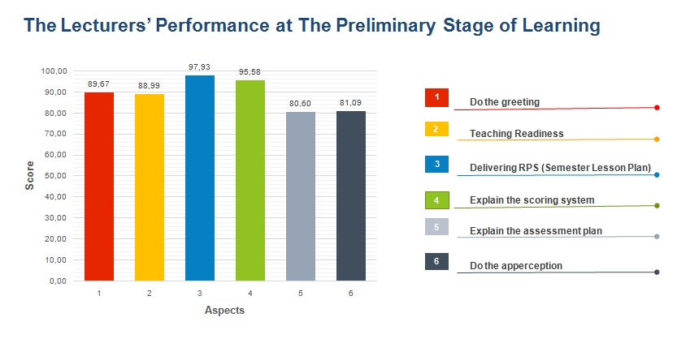

**Figure 1. Lecturers’ Performance in The Preliminary Stage of Learning**

If seen from Figure 1, it is known that the average of lecturer performance for all aspects in introduction stage is in lowest range of 80,60 and highest 97,93. Meaning that lecturer performance if seen from all aspects in introduction stage is included in category very good with score more than 80. The result of this research is in line with research conducted by Harisantoso (2012) about evaluation of lecturer performance. The result of research shows that lecturer intensity in preparing lecture (introduction stage) is included in category vary good, which is in score 86,3%.

1. Lecturer Performance in Learning Process

Based on Figure 2, if seen from each aspect in process stages of lecture, lecturer performance in general is in good category. If reviewed more, there are two aspects which have score less than 60, which are aspects no 12 and 17. Aspect no 12 is aspect about the use of *blended learning* in lecture. This aspect has score 62,63. This means that many lecturers still do not use *blended learning* in lecture process. Beside aspect no 12, aspect no 17 which is the use of *youtube* or *blog* as supporting tool for lecture activities is still low. This shows by score 56,70. Which is aspect with lowest in lecturer performance of lecture stage.

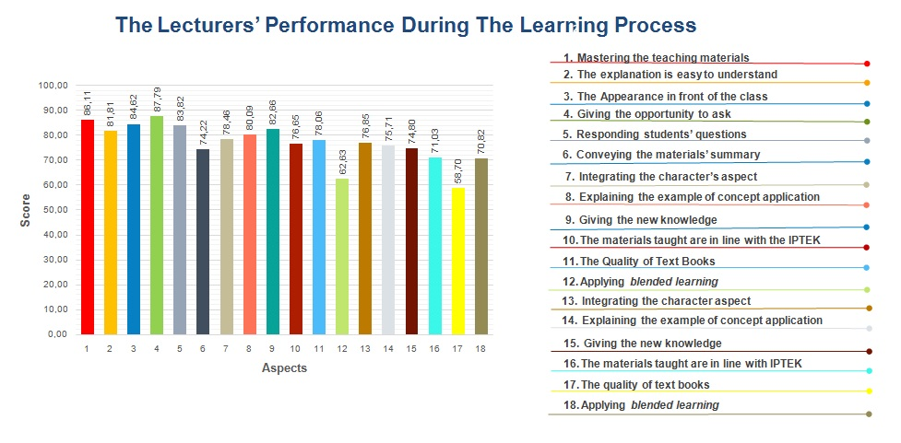

**Figure 2. Lecturer Performance in Learning Process**

1. Lecturer Performance in Learning Assessment

Assessment is an important stage in lecture activities. Through assessment conducted by lecturer, the level of student ability after lecture process will be found. The research result will give information about student weaknesses and it will be consideration of lecturer to conduct improvement of next lecture activities. In addition, assessment/evaluation conducted by lecturer can motivate student to be more intense in learning. Therefore, it is important by lecturer to conduct assessment activity in learning. This will be presented lecturer performance for assessment stage in Figure 3.

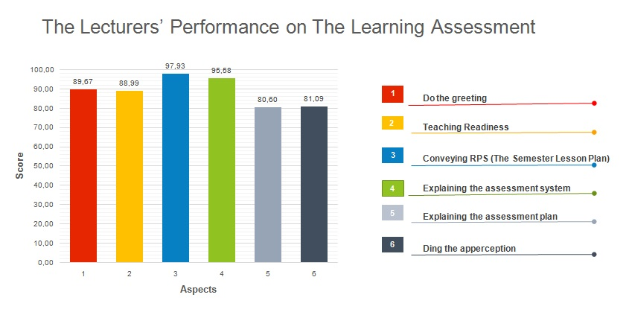

**Figure 3. Lecturer Performance in Learning Assessment**

Based on Figure 2 it can be seen that in stage of assessment, lecturer performance is seen from six aspects. If seen thoroughly in Table 1, lecturer performance in assessment stage is good which is in score 78, 25. But if reviewed more in each aspect, there are two aspect included in category adequate because it has score below 70. The aspect that is still included in category adequate is aspect no 3 which is correct and return the task to students, also aspect no 5 which is discuss the test result with students.

Figure 3 shows that according to students, there are many lecturers who give task to students but the task that has been conducted are not corrected and returned to students. In addition, many lecturers did not discuss the result of test along with the students. According to Reeves (2010) assessment also can be used for the improvement of learning process. Therefore, needs to conduct improvement in aspect which is still included in adequate category.

1. *Lecturer Performance in Each Faculty*

Figure 4 explains the UNY lecturers performance seen based on each faculty for each aspect. Based on figure 4 it can be known that overall UNY lecturers performance for each faculty is included in good category. This can be seen from score obtained for each aspect, in introduction, process, and assessment. All aspects in all faculties have score more than 70.

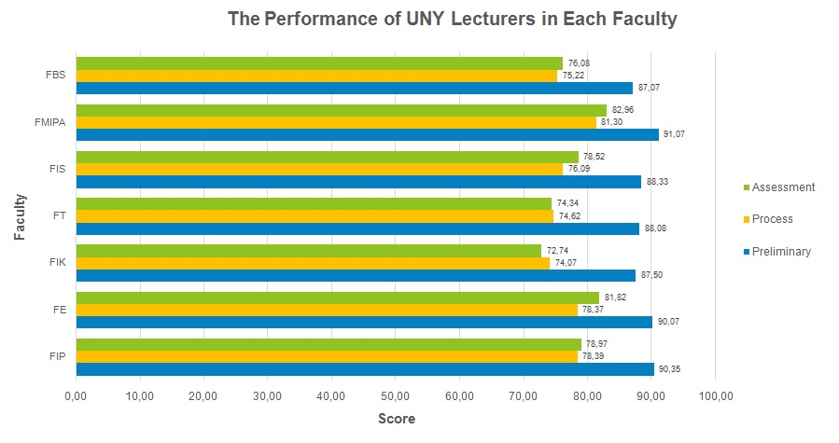

**Figure 4. UNY Lecturers’ Performance in Each Faculty**

If reviewed further, lecturer performance between one faculty and another has varied score. This means, lecturer performance between one faculty another has few differences. From figure 4 it can be seen that faculty with highest lecturer performance is FMIPA. The highest score is achieved for three aspects. Otherwise, faculty with lowest lecturer performance score is FIK.

The difference of lecturer performance can be caused by several factors. The result of research conducted by Hadiantini et all (2017) showed that several factors which influence lecturer performance such as work motivation, education, work satisfaction, supervisory perception, age and work period. Hamid (2013) explains in his research that lecturer ability in science and skill owned in conducting tridarma college contributes towards lecturer performance improvement. The differences of lecturer performance between faculties can be caused by those factors.

1. **CONCLUSION AND SUGGESTION**

Analysis of lecturer performance in conducting learning in Yogyakarta State University gives illustration that lecturer performance in general included in good category. Lecturer performance in lecture in this matter is divided into three stages that are introduction, process and learning assessment. Nevertheless, there are still some aspects that need improvement to maintain the quality of lecture performance.

Based on conclusion, it can be formulated some suggestion for improvement of lecturer performance in learning. In then stage of learning process, need to improve the use of *blended learning* to support lecture activities. In addition, still need to conduct learning variations such as the use of youtube and blog. For assessment stage, lecturer needs to correct and return the task to students also discuss the examination questions along with students. Assessment of lecturer performance needs to be conducted continuously to maintain education quality.

**REFERENCES**

1. Bungai, J. & Perdana, I. (2018). Evaluation of Performance Leturer on Implementing Tridharma College. *Indonesian Journal of Educational.* 5(1), 174-182.
2. Chappuis, J., R. Stiggins, S. Chappuis, & J. Arter. (2012). *Classroom Assessment for Student Learning: Doing It Right—Using It Well​, 2nd Ed*. Upper Saddle River, NJ: Pearson Education, p. 5.
3. Earl, L., Hargreaves, A., & Schmidt, M. (2002). Perspective on Reform. *American Educational Research Journal*, Spring 2002, Vol. 39. No. 1.
4. Gronlund, N.E. (1985). *Measurement and evaluation in teaching*. New York: Macmillan Publising Co.
5. Hamid, S. (2013). Lecturers’ performance and technology at private higher education in South Sulawesi Indonesia. *Procedia-Social and Behavioral Sciences*, *83*, 580-584.
6. Harisantoso, J. (2012). Pengukuran kinerja dosen melalui EKD (Evaluasi Kinerja Dosen) STKIP PGRI Situbondo berdasarkan persepsi mahasiswa. *Sainteks*, *9*(2)
7. Keeves & Masters. (1999). *Advances in Measurement in Educational Research and Assessment*. New York: Pergamon Press.
8. Marzano, R.J., Frontier, T., Livinnhston, D. (2011). *Effective supervision*. Alexandria: ASCD.
9. Narasuci, W., Setiawan, M., Noermijati. (2018). *Effect of Work Environment on Lecturer Performance Mediated by Motivation and Job Satisfactio. Journal of Applied Management (JAM). 16(4),645-653.*
10. Nunnally, J.C. (1964). ***Educational mmeasuremment and evaluation*. New York:** McGraw-Hill.
11. Peleyeju, J.O. &Ojebiyi, O.A. (2013). Lecturers’ Performance Appraisal and Total Quality Management of Public Universities in South-Western Nigeria. *British Journal of Education.* Vol.1, No.2, pp.41-47, December 2013.
12. Suryaman. (2018). Indonesian Private University Lecturer Performance Improvement Model to Improve a Sustainable Organization Performance. *International Journal of Higher Education*, Vol.7, No.1, 59-68.
13. Undang-undang Republik Indonesia Nomor 14 Tahun 2005 tentang Guru dan Dosen.
14. Trisnaningsih, S. 2011. Faktor-Faktor yang mempengaruhi Lecturer Performance Akutansi. *Jurnal Akutansi dan Auditing*, 8(1), 1–94.
15. Wright, B. D., & Stone, M. H. (1992). *Best test design.* Chicago: Mesa Press.