**Noise Reduction of Simplified Phonocardiograph Through Flexural Tube Adjustment**

Sumarna, Dyah K. Agustika, Agus Purwanto, Juli Astono

*Department of Physics Education, Faculty of Mathematics and Natural Science, Universitas Negeri Yogyakarta, Jl. Colombo No.1, Karang Malang, Caturtunggal, Sleman, DIY 55281 Indonesia, sumarna@uny.ac.id*

This study aims to determine the length of the felxural tube phonocardiograph device for noise reduction from heart sound record data. Human. Phonocardiograph, which is a simplification of the phonocardiograph in the chest part (in whole) in the chest; pipe; condenser mic; pre-amp; PC. The data is then processed using the fast fourier transform (FFT) method to change the time domain to a domain that can be used with baseline data. Data processed by FFT PCG that uses a flexible tube as a filter are compared to those that use filters to influence the noise reduction. In terms of the length of the felxural tube there is a significant frequency obtained. The results of heart rate comparison through PCG with filters and without filters, then PCG with a flexible tube length of 1000 cm is the most optimal result in the FFT baseline.

Keywords: Phonocardiograph, flexural tube, FFT, noise reduction.

1. Introduction

Phonocardiography is a graphic display that shows the sound of the heart, where the sound of the heart is monitored through the surface of the human skin and a tool for obtaining Phonocardiography data is called the Phonocardiograph (PCG) [1], [2]. Phonocardiography can be an invasive and non-invasive sensor where non-invasive sensing shows a graph of heart rate and vibration of the skin surface, which is the effect of changes in pressure from the blood vessel system [2].

There are several other heart rate testing equipment besides PCG in the medical environment, the most widely of which are electrocardiogram and echocardiogram [3]. The electrocardiogram takes a long time to process the patient's diagnosis and is a method that requires expensive fees while the echocardiogram cannot provide an effective outcome for all patients. For this reason, a technological development is carried out using an automated auscultation system through computer assistance that greatly helps physiscian in identifying heart sounds and obtaining more reliable and objective diagnostic results [4].

In terms of detecting heart abnormalities, auscultation (PCG or stethoscope) is still the main diagnostic tool for interpreting heart murmurs and is an important way of making decisions to analyze echocardiography [5]. The electronic stethoscope (combined with PC and software), as a modern concept for PCG, may gain importance for clinical purposes, so lately this method is widely used also for teaching and training purposes and for research [6]. Even though ECG is a popular method of detecting cardiores-piratory functions through cardiac electrical activity, heart defects produce more vibromechanical indicators than electrical [7].

The method of using a PCG or stethoscope (auscultation) by listening to the sound emitted from the heart is the most common initial step followed by the method of echocardiography when the auscultatory findings are abnormal [8]. Heart sounds are like the opening or closing of a valve, vibrations due to blood turbulence may exist besides the heart sound [9]–[11]. The first and second heart sounds can be detected in some cases [12].

A normal cardiac cycle contains two major audible sounds: the first heart sound (S1) or systole and the second heart sound (S2) or diastole named as Fundamental Heart Sounds (FHS), where the remaining two sounds S3 and S4 are generally not audible [1],[13]. The example of determination of S1 and S2 and charateristics of heart beat sound for normal patient and patient with murmur depicted in figure 1 below

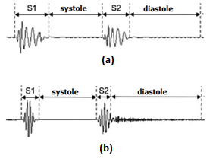

Fig 1. The heart sounds obtained from PCG signals of (a) normal patient; and (b) patient with murmur [4], [14].

To obtain accurate information on PCG, a set of frequency filters is signaled, each of them emphasizes a higher frequency component (by using high pass or band-pass filters). that does not compromise the quality of the recorded signals that impact the length of the stethoscope [6], [15]. The purpose of this study was to analyze the different frequency spectrum based on FFT analysis from a simplified PCG tool using various lengths of flexural tube so that researchers could establish the right length to be applied to simplified PCG by finding the least noise frequency.

Previous studies from Sumarna et al. which has been written in "The Improvement of Phonocardiograph Signal (PCG) Representation Through the Electronic Stethoscope" shows that the frequency of PCG output is different for PCG with and without filters, in this case the filters are plastic hoses of various sizes. This study aims to discuss the effects of using hose filters on PCG output output [16].

2. Subject & methods

The simplified PCG equipment used in this study uses a simple electronic circuit using a 9 volt voltage source. The circuit was then tested on the subject to be able to take the heartbeat sound. Heart record data obtained in the form of amplitude of sound against the time domain. To get the data accuracy, four random pieces of systole-diastole were taken, each with a time of 0.8 seconds.

Repeatability of the output signal has to be determined to make sure that the system is reliable and this is undertaken by measuring the frequency response of the heart beat signals of the same person in different time by using Fast Fourier Transform (FFT) [16].

The mathematical definition of the FFT is given below:

(1)

$$X\left(f\right)=\int{x\left(t\right)e^{-j2πft}dt}$$

.

where t and f are respectively the time and frequency that defines the spectrum of s(t) which consists of components at all frequencies over the range for which it is non zero; x(t) are the time domain signal; and X(f) are the the Fourier coefficients which are large when a signal contains a frequency component around the frequency f [17], [18].

From the fourth time domain data that has been converted into the frequency domain, defined five dominant frequency to then be used as baseline data. The next step is to compare the baseline data with the results of the FFT sound record also using PCG with a filter in the form of flexural tube with a length of 1000 cm; 3350 cm; 750 cm; and 500 cm.

The FFT data of cardiac record experiments using PCG with filters were then analyzed using two sequences to find the most optimum length of flexural tube, namely: (1) determining the value of the experimental frequency that was closest to the frequency of dominant frequencies; and (2) determine the greatest experiment in reducing noise.

3. Results

From the data of four trials using the same sample of people, it was seen that the heartbeat sound pattern using a simplified PCG without using the filter shown in figure 2 shows that the patterns of S1 and S2 (systolic and diastolic) did not show any heart abnormalities. This data is used as baseline data for characterizing domain frequencies using FFT with and without filters. The character of frequency domain data from the results of sound wavelet synthesis using FFT can be seen in figure 4 where the five main frequency sequences that often appear are 49.80 ± 0.20 Hz (1st sequence); 450.48 ± 0.51 (2nd sequence), 1249.75 ± 21.84 Hz (3rd sequence); 2452.75 ± 0.50 Hz (4th sequence); and 2752.75 ± 0.50 Hz (5th sequence).

These frequencies indicate a unique character for a person's heart rate or as the identity of one's heart sound to distinguish from the identity of someone else's heart sound. There is a major obstacle to PCG without using a filter (in the form of flexural tube), which is the difficulty in operating heart detection for female patients. The filter is also needed to get data quickly and easily. Figure 4 shows the results of FFT using filters with several lengths of flexural tube used as baseline data to compare FFT analysis using filters.

In PCG using a filter length of 1000 cm it is clear that the dominant peaks of frequency are filtered through flexural tube . The five sequences of frequency are still visible in each experiment except in the experiment using 3350 cm flexural tube length where the 5th sequnce frequency is not visible. From figure 3, it can be seen that there is a filtering process for noise frequencies to get the dominant native frequency in the sound of someone's sistole and diastole. This can be seen from the higher peaks of the baseline data frequency sequence.

|  |  |
| --- | --- |
| C:\Users\X200C\Downloads\Bunda\Gambar untuk Jurnal PPT 2\Gambar untuk Jurnal PPT 2\abnnox5.bmp | C:\Users\X200C\Downloads\Bunda\Gambar untuk Jurnal PPT 2\Gambar untuk Jurnal PPT 2\fftabnnoy6.bmp |
| Figure (2) The pattern of S1 and S2 in time series from normal Figure (3) The FFT pattern of normal heart rate using PCG  heartbeat uses unfiltered PCG [16] without filters [16] | |

|  |  |
| --- | --- |
| C:\Users\X200C\Downloads\Bunda\Gambar untuk Jurnal PPT 2\Gambar untuk Jurnal PPT 2\fftabn10.bmp  (a) | C:\Users\X200C\Downloads\Bunda\Gambar untuk Jurnal PPT 2\Gambar untuk Jurnal PPT 2\ftabn335.bmp  (b) |
| C:\Users\X200C\Downloads\Bunda\Gambar untuk Jurnal PPT 2\Gambar untuk Jurnal PPT 2\fftabn76.bmp  (c) | C:\Users\X200C\Downloads\Bunda\Gambar untuk Jurnal PPT 2\Gambar untuk Jurnal PPT 2\fftabn5m.bmp  (d) |
| Figure 4. The FFT pattern of normal heart rate using PCG with filters with different lengths of flexural tube: (a) 1000 cm; (b) 3350 cm; (c) 750 cm; and (d) 500 cm [16] | |

4. Discussion / conclusions

To determine the most optimal length of PCG flexural tube, the dominant frequency value comparison between the FFT baseline data and the four trials using different lengths of flexural tube (figure 5) must be done. In addition to the frequency value comparison approach with other data, the second approach is to use the analysis of the number and height of the dominant peaks achieved from the filter process.

The column column value in the baseline FFT is the mean value (from 4 times the baseline data experiment) with the addition of the standard deviation value. The comparative results show that the experiment using 1000 cm of flexural tube is the one closest to the FFT baseline value where there are three frequency sequence values that fall into the mean ± standard deviation (SD) value of the baseline data which is at the first sequnce (49.33 Hz), 4th (2453.00 Hz) and 5th (2753.00 Hz). Whereas other experiments have only a maximum of one frequency that is suitable, that is, an experiment using a length of 750 at the second sequnce (450.70 Hz).

In addition, experiments with the length of 1000 cm flexural tube also showed greater reduced noise. This can be seen from the apparent difference between the high frequency peak peaks with the highest noise and the least number of dominant peaks when compared to other experiments. Thus it was concluded that PCG by using a flexural tube length of 1000 cm was the most optimum noise filter process.

Further research is needed regarding the additional technology applied to this PCG, for example by adding metal corrugate pipes. Fei Xue and Beibei Sun [19] have confirmed that the application of corrugated pipes in reactive mufflers significantly improves the noise reduction frequency range and the muffler with corrugated pipes have a better ability to lower the regenerative noise in low frequency than the muffler with insertion pipes. To obtain data that is more reliable, it is also necessary to conduct experiments using the same method with several subjects in the form of people indicated to have heart abnormalities. In addition, long stretches of flexural tube also need to be widened.

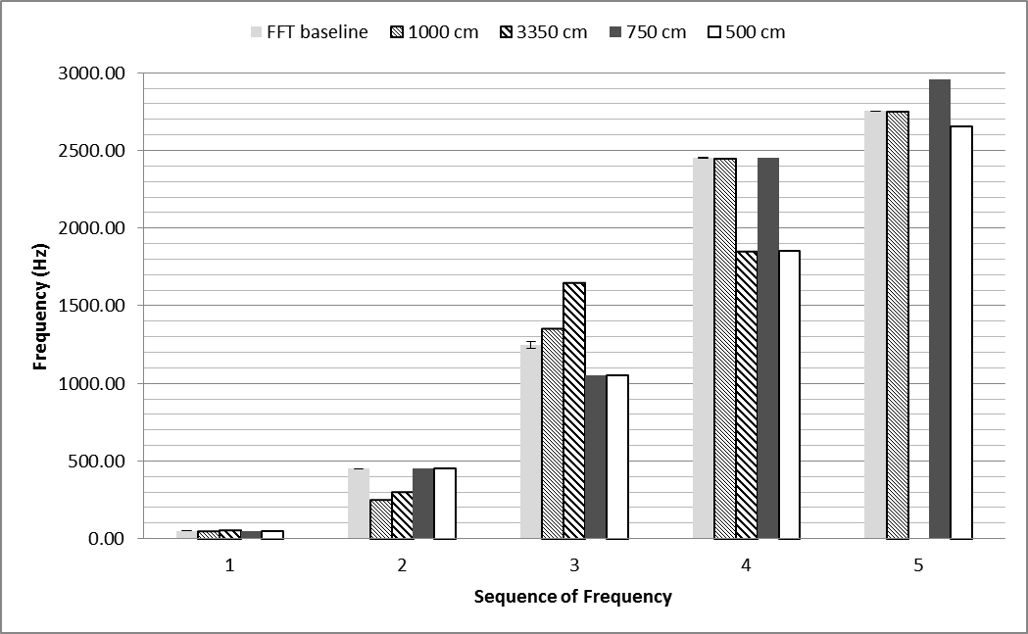

Figure 5. Pola FFT dari detak jantung normal menggunakan PCG tanpa filter

7. Conclusion

This study has revealed a new thing that the length of the filter in the form of flexural tube that impacts the reduction of noise frequency peaks of the sound of a normal heartbeat using the PCG. The researcher also concluded that the PCG filter with a length of 1000 cm was the most optimum in terms of noise reduction.

References

[1] G. V. H. Prasad, R. D. Bhavani, T. M. Ragni, and V. S. Rani, “Improved Classification of Phonocardiography Signal Using Optimised Feature Selection,” *Indian J. Sci. Technol.*, vol. 10, no. September, pp. 1–7, 2017.

[2] R. Bernatik, “Sensing and Processing of Phonocardiographic Signal,” *IFAC Program. Deices Syst.*, pp. 407–410, 2003.

[3] C. Kall, M. Herm, C. Ara, C. Requel, and A. Bachur, “Analysis of cardiac exams : electrocardiogram and echocardiogram use In Duchenne muscular dystrophies,” *Fisioter. Mov*, vol. 27, no. 3, pp. 429–436, 2014.

[4] A. Arslan and O. Yildiz, “Automated Auscultative Diagnosis System for Evaluation of Phonocardiogram Signals Associated with Heart Murmur Diseases,” *GU J Sci.*, vol. 31, no. 1, pp. 112–124, 2018.

[5] C. H. Attenhofer Jost *et al.*, “Echocardiography in the evaluation of systolic murmurs of unknown cause,” *Am. J. Med.*, vol. 108, no. 8, pp. 614–620, 2000.

[6] V. U. Brussel, “Phonocardiography,” in *Encyclopedia of Medical Devices and Instrumentation*, 2nd ed., J. G. Webster, Ed. John Wiley & Sons, Inc., 2006, pp. 278–290.

[7] A. T. Dao, “Wireless laptop-based phonocardiograph and diagnosis,” *PeerJ*, pp. 1–16, 2015.

[8] M. Ali Akbari *et al.*, “Digital Subtraction Phonocardiography (DSP) applied to the detection and characterization of heart murmurs,” *Biomed. Eng. Online*, vol. 10, pp. 1–14, 2011.

[9] Z. Zhidong, Z. Zhijin, and C. Yuquan, “Time-frequency analysis of heart sound based on HHT,” in *Int. Conf. Communications, Circuits and Systems*, 2005.

[10] T. Reed, N. Reed, and P. Fritzson, “Heart sound analysis for symptom detection and computer aided diagnosis,” *Simul. Model. Pract. Theory*, vol. 12, no. May, pp. 129–146, 2004.

[11] S. Kärki, M. Kääriäinen, and J. Lekkala, “Measurement of heart sounds with EMFi transducer,” in *Proceedings of the 29th Annual International*, 2007, pp. 1683–1686.

[12] T. Chen, L. Xiang, and M. Zhang, “Recognition of heart sound based on distribution of choi-williams,” *Rev. Bras. Eng. Biomed.*, vol. 31, no. 3, pp. 189–195, 2015.

[13] S. Debbal and F. Bereksi-Reguig, “Graphic representation and analysis of the PCG signal using the continuous wavelet transform,” *Internet J. Bioeng.*, vol. 2, no. 2, pp. 1–7, 2006.

[14] C. Kwak and O. . Kwon, “Cardiac disorder classification by heart sound signals using murmur likelihood and hidden Markov model state likelihood,” *IET signal Process.*, vol. 38, no. 2, pp. 263–280, 2012.

[15] S. R. Thiyagaraja *et al.*, “A novel heart-mobile interface for detection and classification of heart sounds,” *Biomed. Signal Process. Control*, vol. 45, pp. 313–324, 2018.

[16] J. Astono, A. Purwanto, and D. K. Agustika, “The Improvement of Phonocardiograph Signal ( PCG ) Representation Through the Electronic Stethoscope,” no. September, pp. 19–21, 2017.

[17] S. M. Debbal, “Computerized Heart Sounds Analysis,” in *Computerized Heart Sounds Analysis, Discrete Wavelet Transforms - Biomedical Applications*, H. Olkkonen, Ed. inTech, 2011, pp. 63–89.

[18] S. M. Debbal and F. Berekesi-Reguig, “The fast fourier transform and the continuous wavelet transform analysis of the normal and pathologicals phonocardiogram signals,” *Sci. Technol.*, vol. 17, no. June, pp. 81–86, 2002.

[19] F. Xue and B. Sun, “Experimental study on the comprehensive performance of the application of U-shaped corrugated pipes into reactive mufflers,” *Appl. Acoust.*, vol. 141, no. July, pp. 362–370, 2018.