Effectiveness of Physics Blended Learning with Moodle toward Student’s Problem Solving
Skills and ICT Literacy

Jumadi
Postgraduate Program
Yogyakarta State University
Yogyakarta, Indonesia
jumadi@uny.ac.id
Ratna Sari
Postgraduate Program
Yogyakarta State University
Yogyakarta, Indonesia
ratnasari2912.rs@gmail.com
Ariswan
Postgraduate Program
Yogyakarta State University
Yogyakarta, Indonesia
ariswan@uny.ac.id
Rahmi Putri Z
Postgraduate Program
Yogyakarta State University
Yogyakarta, Indonesia
rahmiputriz09@gmail.com

Abstract—The development of technology urge innovations in education field. One of innovations is blended learning. In blended learning, face-to-face and online learning are integrated. The aim of this research is to find out the effectiveness of physics blended learning with moodle, especially toward senior high school student’s problem solving skills and ICT literacy. The type of this research is quasy experimental with pre-test and post-test design. The students who participated in this research were 64 students of class X MIPA in SMA Negeri 1 Sungai Penuh and 69 students of class X MIPA in SMA Negeri 1 Sambas. The tests that used in this research are an essay test about the problem solving skills and multiple choice test about the ICT literacy. The data analyzed by using N-gain formula. The result is physics blended learning with moodle effective to improve the student’s problem solving skills and ICT literacy in medium level. The benefit of this research is give out positive description toward blended learning and utilization of moodle in physics learning. Furthermore, the result also can be a contribution in reference about blended learning with moodle.
Keywords—blended learning, ICT literacy, moodle, problem solving skills

AN INTRODUCTION
The development of technology urge innovations in education field. In other words, the learning must be integrate with technology. One of innovations is blended learning. Today, many senior high schools, colleges, and universities have implement blended learning. The blended learning is a concept of learning that integrate face-to-face learning and technology that called e-learning [1], [2], [3]. The benefit of blended learning is blended learning can improve student’s motivation [3].
In implementation of blended learning, there is an important part is called e-learning. E-learning is many in demand because it can support the concept of lifelong learning. So, the knowledge are increasingly becoming very important. E-learning is expected can give a great contribution in blended learning and lifelong learning [4].
E-learning can be provided using various platforms such as learning management system (LMS). One of form of learning management system (LMS) is moodle. Many students give positive feedback toward moodle as a platform of blended learning [3]. An implementation of blended learning with moodle give many chances to many teachers and students to discuss in a group online and self-examination. The teachers also can provide learning materials using moodle to help student’s learning development.
In the 21th century, there are several skills that must be mastered by students. They are (1) life and career skills, (2) learning and innovation skills, and (3) information, media, and technology skills. The skills is showed in Figure I.

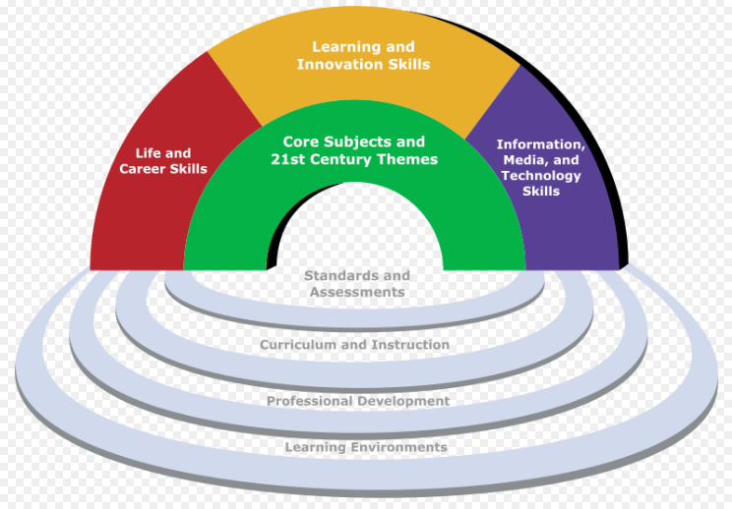
Figure I. The 21 th century skills [5]

Based on the 21th century skills, in physics learning, problem solving skills and information, communication, and technology (ICT) literacy become important skills that must be mastered by students. The problem solving skills is one factor that affect student’s outcomes in physics learning [6]. The ICT literacy is one factor that affect the students in using ICT tools [7].
The problem solving activity can be helped by using ICT tools. The ICT tools can help students in an investigation process [8]. Through ICT tools, teachers can take many chances to work in different condition from traditional learning [8].
The student’s problem solving skills can be improved by integrate ICT aspect in learning activity [9]. Many references, animations, and videos about learning materials can be delivered to students using ICT tools [9]. One of example in physics learning is abstract concept can be presented by using ICT tools. The student’s problem solving skills also can be improved by giving chances to students to take many exercise.
The research is funded by the Ministry of Research, Technology, and Higher Education.
In case ICT tools, the students must be have ICT literacy. The ICT literacy is a skill to define, to access, to manage, to integrate, to create, and to communicate about information and digital technology [7]. The ICT literacy become an important things because it can support physics learning.
The using of moodle as an e-learning media in blended learning is expected can improve the student’s problem solving skills and ICT literacy. Based on literature review, an integrated learning between face-to-face learning and e-learning can improve the student’s participation, motivation, competency, and learning quality [10].
Based on literature review, blended learning more effective than face-to-face learning in science process skills aspect [11]. An implementation of blended learning can be done by combining 75% face-to-face learning and 25% online learning [12].
This research aimed to find out the effectiveness of blended learning with moodle toward two aspect in physics learning. The first aspect is about the student’s problem solving skills. The second aspect is about the student’s ICT literacy.

THE METHOD OF RESEARCH

The Type of Research
The type of this research is quasy experimental. The design of this research is pre-test post-test control group design. The design is showed in Figure II.
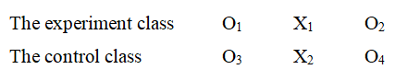
Figure II. The design of research

The information:
O₁ = pre-test about problem solving skills and ICT literacy in experiment class
O₂ = post-test about problem solving skills and ICT literacy in experiment class
O₃ = pre-test about problem solving skills and ICT literacy in control class
O₄ = post-test about problem solving skills and ICT literacy in control class
X₁ = physics blended learning with moodle
X₂ = physics conventional learning

The Sample of Research
The sample of this research consist of four class X MIPA. Two class X MIPA in SMA Negeri 1 Sungai Penuh as a sample research in an implementation of physics blended learning with moodle toward the student’s problem solving skills. The number of student that participated are 64 students with details 31 students of experimental class and 33 students of control class. Two class X MIPA in SMA Negeri 1 Sambas as a sample research in an implementation of physics blended learning with moodle toward the student’s ICT literacy. The number of student that participated are 69 students with details 34 students of experimental class and 35 students of control class.

A Collection and An Analysis of Data
The data is collected by using an essay test about problem solving skills and a multiple choice test about ICT literacy. The data is analyzed by using N-gain formula [13]. The level criteria about N-gain score is showed in Table I.
Table I. The level criteria about N-gain score
N-gain score | The level criteria
N-gain score < 0,30 | Low
0,30 < N-gain score < 0,70 | Medium
N-gain score > 0,70 | High

THE RESULTS OF RESEARCH AND DISCUSSION
The first activity in this research is giving pre-test to all of students, include the students in experimental class and control class. After giving pre-test, physics blended learning is implemented in experimental class in SMA Negeri 1 Sungai Penuh and SMA Negeri 1 Sambas. The stages of physics blended learning is showed in Table II.
Table II. The stages of physics blended learning
Stage | Implementation | Condition
Observe | The students observe learning materials using moodle. | Online
Ask | The students write a question based on learning materials that have observed using moodle. After write a question using moodle, a learning is doing in the classroom. The teacher take several question and ask students to solve it. | Online and  face-to-face
Collect the data | The students collect the data through variety of learning resources such as physics books and/or from internet about learning materials, then find out an answer of questions. | Online and  face-to-face
Analyze the data | The students analyze the data that have collected through expand of learning resources. | Online and  face-to-face
Communicate | The students communicate an analysis result in front of the classroom and make a conclusion with teacher. | Face-to-face

There are two moodles that is used in this research. The moodle that is used in SMA Negeri 1 Sungai Penuh is showed in Figure III and Figure IV. Whereas, the moodle that is used in SMA Negeri 1 Sambas is showed in Figure V and Figure VI.
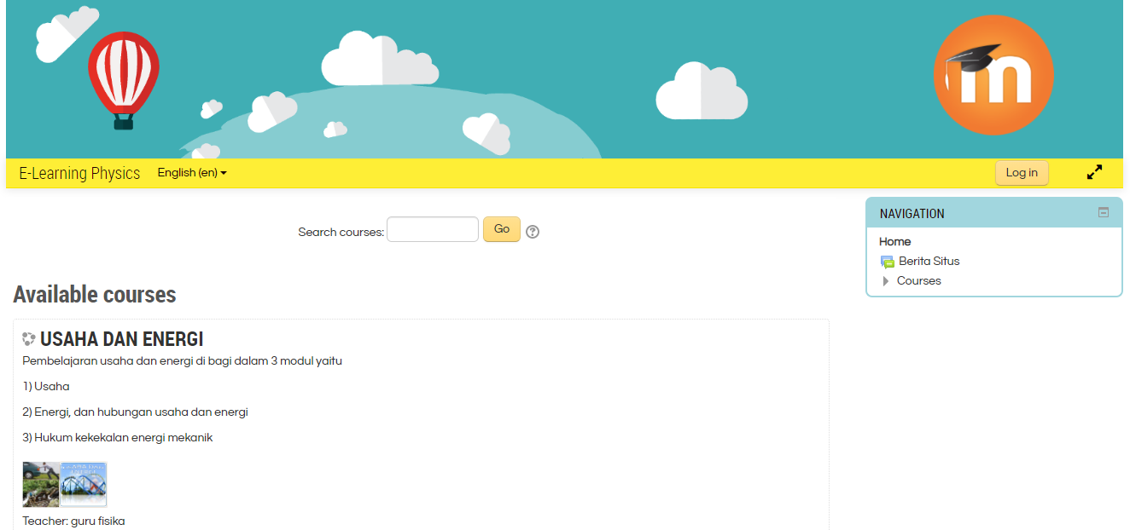
Figure III. The moodle in SMA Negeri 1 Sungai Penuh

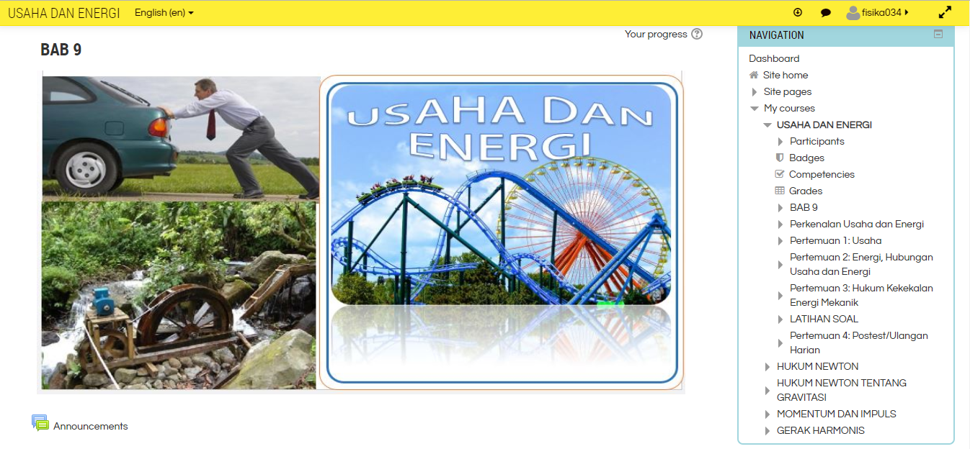
Figure IV. The moodle in SMA Negeri 1 Sungai Penuh

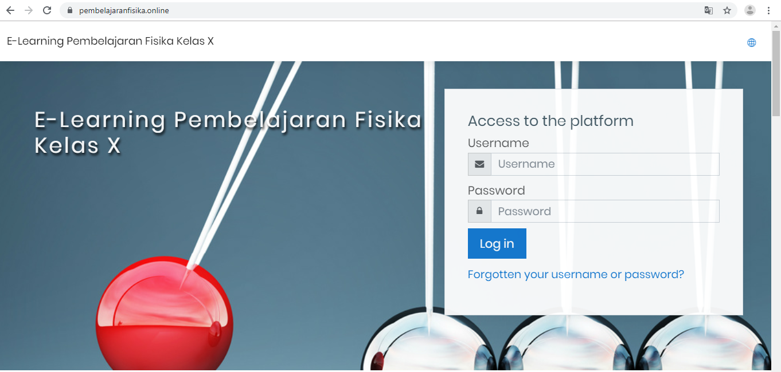
Figure V. The moodle in SMA Negeri 1 Sambas

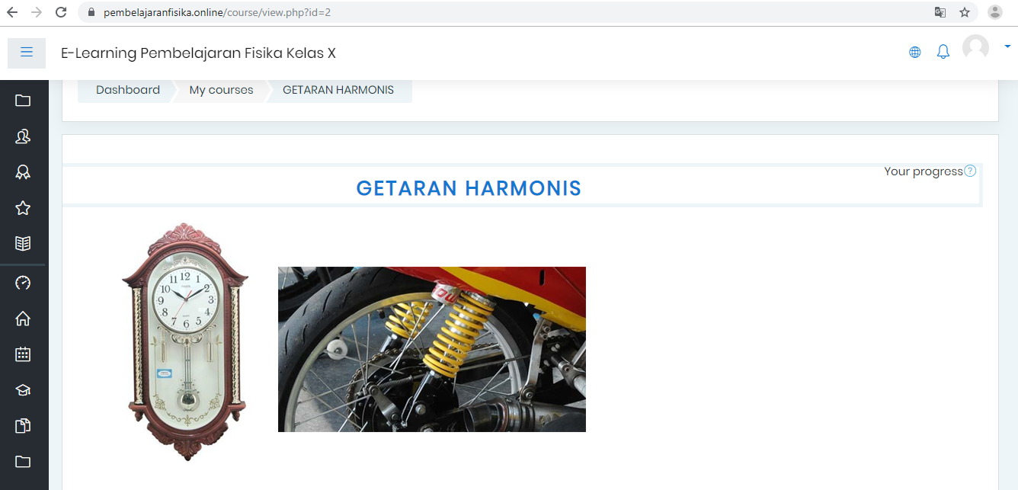
Figure VI. The moodle in SMA Negeri 1 Sambas

After an implementation of physics blended learning, the students take a post-test to determine learning improvement. Based on the pre-test and post-test results, the data is analyzed to determine N-gain score. The results of pre-test and post-test about the student’s problem solving skills is showed in Table III.
Table III. The result of test about the student’s problem solving skills
Class | Pre-test score | Post-test score
Experimental class | 41,45 | 64,35
Control class | 32,73 | 64,85

The N-gain score from experimental and control class about the student’s problem solving skills is showed in Table IV.
Table IV. The N-gain score of the student’s problem solving skills
Class | N-gain score | Level
Experimental class | 0,36 | Medium
Control class | 0,47 | Medium

Based on Table IV, N-gain score of experimental class is smaller than N-gain score of control class. However, the level criteria of N-gain score between that class is equal in the medium category.
As if it is in terms of average value of pre-test and post-test average value can be seen that average pretest score in experimental class is greater than control class. This shows that preparation in experimental class is better than control class. However, an implementation of learning to blended learning has not been able to improve the problem solving skills of students is higher than control class. These results can be seen from the posttest learners experimental class that differ only slightly with control class.
Based on the data obtained, it is known that learning has not reached the level of blended learning is very effective to increase problem-solving skills. This can be caused by challenges in the use of e-learning. As for some of challenges include: (1) some disadvantaged learners in use of e-learning that is not motivated in use [14], (2) some learners are not accustomed to using e-learning so as not to know benefits of using e-learning and feel that use of e-learning only consumes time [15] or increase burden of their learning.
Therefore, based on some of the difficulties or challenges in use of blended learning, then learners need to habituation and a longer time in use of e-learning prior to assessment. The implementation of research needs to be done at least more than 6 months to see an increase in the skills of learners and get better results.
Apart from difficulties or challenges that have to be resolved, the benefits of learning blended learning can be seen from the pretest of students in the control class higher. Through learning blended learning, teachers have provided materials that can be studied learners before going to class, then the material discussed together in the classroom [16]. This may be reason why learning blended learning can establish initial concept of learners in the experimental class is better.
The result of pre-test and post-test about the student’s ICT literacy is showed in Table V.
Table V. The result of test about the student’s ICT literacy
Class | Pre-test score | Post-test score
Experimental class | 61,76 | 76,26
Control class | 50,39 | 72,22

The N-gain score from experimental and control class about the student’s ICT literacy is showed in Table VI.
Table VI. The N-gain score of the student’s ICT literacy
Class | N-gain score | Level
Experimental class | 0,37 | Medium
Control class | 0,44 | Medium

Based on research that has been done, the next researcher can do some things so that learning blended learning can work better as follows: (1) first explain to students concept of learning blended learning; (2) teaches how to use e-learning to learner can; (3) willing and patient in helping and supporting learners who asked about use of e-learning; (4) fill out the e-learning content in an interesting and arrange them neatly so that learners are interested in using it; (5) the teacher should use e-learning in a sustainable manner, so as to obtain learning outcomes better blended learning.

The conclusion of the research
The result is physics blended learning with moodle effective to improve the student’s problem solving skills and ICT literacy in medium level. The benefit of this research is give out the positive description toward blended learning and utilization of moodle in physics learning. Furthermore, the result also can be a contribution in reference about blended learning with moodle.

Acknowledgment
The research is funded by the Ministry of Research, Technology, and Higher Education.

References
- López-Pérez, M. V., Pérez-López, M.C., & Rodríguez-Ariza, L. Blended learning in higher education: Students’ perceptions and their relation to outcomes. Computers & Education, 2011, 56: 818–826. doi:10.1016/j.compedu.2010.10.023
- Umek, L., Aristovnik, A., Tomazevic, N., & Kerzic, D. Analysis of selected aspects of students’ performance and satisfaction in a moodle-based e-learning system environment. Eurasia Journal of Mathematics, Science & Technology Education, 11(6), 1495-1505, 2015. doi: 10.12973/eurasia.2015.1408a
- Lin, Y., Tseng, C., Chiang, P. The effect of blended learning in mathematics course. EURASIA Journal of Mathematics Science and Technology Education, 13(3):741-770, 2017. DOI: 10.12973/eurasia.2017.00641a
- Baris, M. F. Future of e-learning: perspective of european teachers. Eurasia Journal of Mathematics, Science & Technology Education, 11(2), 421-429, 2015. doi: 10.12973/eurasia.2015.1361a
- Harahap, F., Nasution, N. E. A., & Manurung, B. (2019). The Effect of Blended Learning on Student's Learning Achievement and Science Process Skills in Plant Tissue Culture Course. International Journal of Instruction, 12(1), 521-538. https://doi.org/10.29333/iji.2019.12134a
- Markawi, N. 2011. Pengaruh Keterampilan Proses Sains, Penalaran, dan Pemecahan Masalah Terhadap Hasil Belajar Fisika. Jurnal Formatif, Vol 3(1): 11-25. ISSN: 2088-351X
- Nova-Corti, I., Varela-Candamio, L., & Ramil-Diaz, M. 2013. E-learning and Face to face Mixed Methodology: Ecaluating Effectiveness of E-learning and Perceived Satisfaction for a Microeconomic Course Using the Moodle Platform. Computers in Human Behavior. 29(2013): 410-415. http://dx.doi.org/10.1016/j.chb.2012.06.006
- Psycharis, S., Chalatzoglidis, G., & Kalogiannakis, M. (2013). Moodle as a Learning Environment in Promoting Conceptual Understanding for Secondary School Students. Eurasia Journal of Mathematics, Science & Technology Education, 9(1), 11-21. DOI: 10.12973/eurasia.2013.912a
- Dwi, I.M., Arif, H., Sentot, K. 2013. Pengaruh Strategi Problem Based Learning Berbasis Ict Terhadap Pemahaman Konsep Dan Kemampuan Pemecahan Masalah Fisika. Jurnal Pendidikan Fisika Indonesia 9: 8-17. ISSN: 1693-1246
- Nova-Corti, I., Varela-Candamio, L., & Ramil-Diaz, M. 2013. E-learning and Face to face Mixed Methodology: Ecaluating Effectiveness of E-learning and Perceived Satisfaction for a Microeconomic Course Using the Moodle Platform. Computers in Human Behavior. 29(2013): 410-415. http://dx.doi.org/10.1016/j.chb.2012.06.006
- Cetin, A., & Ozdemir, O. F. (2018). Mode-Method Interaction: The Role of Teaching Methods on The Effect of Instructional Modes on Achievements, Science Process Skills, and Attitudes Towards Physics. EURASIA Journal of Mathematics, Science and Technology Education, 2018, 14(5), 1815-1826. https://doi.org/10.29333/ejmste/85217
- Means, B., Toyama, Y., Murphy, R., Baki, M. (2013). The effectiveness of online and blended learning: a meta-analysis of the empirical literature. Teachers College Record Volume 115, 030303, March 2013, 1-47.
- Umek, L., Aristovnik, A., Tomazevic, N., & Kerzic, D. Analysis of selected aspects of students’ performance and satisfaction in a moodle-based e-learning system environment. Eurasia Journal of Mathematics, Science & Technology Education, 11(6), 1495-1505, 2015. doi: 10.12973/eurasia.2015.1408a
- Adams, A., Liyanagunawardena, T., Rassool, N. & Williams, S. (2013), Use of open educational resources in higher education. British J. of Educ. Tech., 44(5), 149-50
- Bonk, C., Lee, M., Reeves, T., & Reynolds, T. (2015). MOOCs and open education around the world. England: Taylor & Francis.
- Harahap, F., Nasution, N. E. A., & Manurung, B. (2019). The Effect of Blended Learning on Student's Learning Achievement and Science Process Skills in Plant Tissue Culture Course. International Journal of Instruction, 12(1), 521-538. https://doi.org/10.29333/iji.2019.12134a

