DEVELOPMENT OF PHYSICS COMIC BASED ON LOCAL WISDOM ASSISTED BY ANDROID TO IMPROVE THE CAPABILITY OF HOTS AND PHYSICAL, DIAGRAM AND MATHEMATIC REPRESENTATIONS

Kuswanto, Heru
Physics Education, Graduate Program
Universitas Negeri Yogyakarta
DI Yogyakarta, Indonesia
herukus61@uny.ac.id

Ramadhan, Rahmad Hudan
Physics Education, Graduate Program
Universitas Negeri Yogyakarta
DI Yogyakarta, Indonesia
hudanrr@gmail.com

Wardani, Ratna
Physics Education, Graduate Program
Universitas Negeri Yogyakarta
DI Yogyakarta, Indonesia
ratna@uny.ac.id

Ratnaningtyas, Latifah
Physics Education, Graduate Program
Universitas Negeri Yogyakarta
DI Yogyakarta, Indonesia
el.ratnaningtyaz23@gmail.com

Abstract — This research focuses on producing media of physics comic based on local wisdom (Long Bumbung and Nglarak Blarak) assisted by android to improve the ability of physical representation, diagrams, and, mathematical, HOTS.
This study aims to: (1) produce learning products in the form of physics media comics of local wisdom (Long Bumbung and Nglarak Blarak) assisted by android that are suitable for use in learning physics; (2) measure the increase in the ability of physical representation, diagrams, and, mathematically, HOTS high school students.
This research included development research (R&D) with a 4D development model, namely Define, Design, Develop, Disseminate. The research design was an experiment using pretest-posttest design. The research instruments in the form of tests and non-tests were validated by expert lecturers (material and media), physics teachers, and colleagues before being used to be valid. The data analysis technique used was descriptive qualitative with standard gain, MANOVA statistical test with SPSS. The results showed that learning physics by using physics media comics with local wisdom assisted by android was appropriate to be used in learning based on assessments by experts, physics teachers and colleagues in the excellent category. Products that were developed effectively could improve the ability of physical representations, diagrams, and, mathematical, HOTS experimental and control classes based on statistical test values.
Keywords— Physics Comics, Physical Representations, Diagrams; Mathematical; HOTS Local Wisdom, Long Bumbung; Nglarak Blarak

Introduction (Heading 1)
The problem that often arises in the world of education is that technological development is not in line with the use of IT for learning and addiction to smart phones. Most students still use smartphones to play games and social media. The use of media as a learning aid is considered not maximally applied because it takes a long time so it is rarely used. To that end, teachers make media innovations in the form of comics. Comics that are developed will make students access a lot of information after reading comics.
Another problem arises in the low ability to think high level (HOTS) and the ability to multiple representations, in the form of physics, diagrams and mathematics in learning physics. In addition, Indonesia, which is rich in local culture, is less integrated into learning. The purpose of this study is to develop learning media based on local wisdom through mobile leraning to improve high-level thinking skills (HOTS) and multiple representations.
The majority of students are at a low cognitive level in the form of remembering, defining, and solving problems through mathematical equations [1]. Some students have problems in formulating mathematical and conceptual concepts [2]. In fact, physics is closely related to facts, concepts, laws and theories that are commonly found in everyday life. A study presents scientific reasoning is quite low [3]. The study of teacher skills from aspects of teacher HOTS assessment shows the weakest aspect [4]. In learning physics, students have difficulty representing concepts in free diagrams [5] [6] [4] [3]. Students have difficulty reading / interpreting diagrams and proof of mathematical formulas [7]. Therefore it is important for teachers to implement learning that can hone the ability of multiple representations or HOTS.
Cases that are often found show that technological development has not been comparable with the use of IT [8] [9] [10] [5] [4] [11]. Smartphones make it easy for humans to obtain and find information quickly and accurately. However, on the other hand the negative impacts of addiction [12] [8] [5]. Comics became the opiate of students, especially Asian [7] [13] [12] [11] [10] [9] [8]. Smartphone addicted students have difficulty in learning [9]. The intensity of the use of smartphones is mostly for playing games and social media [8] [8] [9], to the indirect impact of decreasing thinking productivity [9]. Thus, there needs to be innovations for teachers to be more familiar and observant of the use of IT in learning.
This research is a research and development (R&D) with 4-D (Four-D Models) by the Lesson. The sample consists of a control class and an experimental class. The data collection method is done by using a written test technique consisting of a pretest and posttest. The data of this study are assessments and suggestions for improving the learning tools of the validator, HOTS, the ability of physical representation, diagrams, mathematical and HOTS of students. Research data captured through questionnaires, tests, and observations. Data analysis uses qualitative and quantitative analysis to revise and determine the quality of the learning tools developed. Data analysis was performed with a multivariate statistical test using SPSS software.
This research was designed with the TPACK approach, which is a framework for designing innovative learning models by combining aspects of technology, pedagogy and material / content. The role of education in creating interactive learning is considered necessary without shifting the value of local knowledge which is currently largely forgotten. This study combines smartphones and comics by integrating them into local wisdom, long bumbung and nglarak blarak, to improve high-level thinking skills (HOTS) and physical representations, diagrams, and mathematical.
Learning is closely related to the use of teaching materials or learning media. Contextual and comprehensive teaching media become very good for studying physics. Physics comics as a learning media are expected to be able to provide stimuli for students to respond and think more deeply through events that contain clarity of physics material and examples of questions relating to local wisdom. Physics comics as a learning medium are developed to facilitate students in solving problems and encourage students to analyze problems more deeply. The use of local wisdom makes learning attractive for students to have real experience according to the application of physics.
Physics Comics media products contain physics material that is equipped with examples of questions and practice questions. Teaching materials are arranged based on related physics concepts and events on local wisdom long bumbung and nglarak blarak. Physics comics also integrate deep questions in each story plot. Physics comics also present a combination of concepts in visual or written form to stimulate students in developing their representational abilities.
Comics developed with the android system can be read through mobile devices having positive sides such as flexibility of use [14] [1] [7] [6] [15] [16] [17] [13]. The development of comics gave a positive contribution in learning physics of Newton's Laws through the simplification of concepts and images [17] [16]. In addition, comics contribute to the ease of learning in sound material [15] [14]. Comics should be used as a good learning medium, by entering several aspects that support the achievement of learning objectives.
The role of educators in creating interactive learning without shifting local knowledge has been largely forgotten [18] [4] [2]. The use of local wisdom makes students have real experience [19]. So learning with a local wisdom approach can bring contextual learning and at the same time promote cultural values.

LITERATURE REVIEW
- Pembelajaran Fisika
TPACK (Technological, Pedagogical, and Content Knowledge) is a framework for designing innovative learning models by combining aspects of technology, pedagogy and material / content. The TPACK framework has seven constructs in which the three main sources of teacher ICT integration knowledge are (1) technological knowledge (TK) - knowledge of technological tools; (2) pedagogical knowledge (PK) - knowledge of teaching methods; and (3) content knowledge (CK) - knowledge of subject matter [20]. This approach is used in research to help students hone their representation and HOTS.
Students must be helped to get HOTS, either through conventional teaching or self-instructional [20]. Improving HOTS of students can be used several strategies including giving questions to students, guiding students in problem solving, guiding students in decision making, inviting students to generate ideas and activities, and giving tasks in the form of open ended questions.
Understanding, studying, adjusting, adapting, translating, and reconstructing local wisdom (local wisdom) for the purposes of learning future scholars can provide a key understanding of the values contained therein [21]. Therefore, contextual learning can promote the local culture.

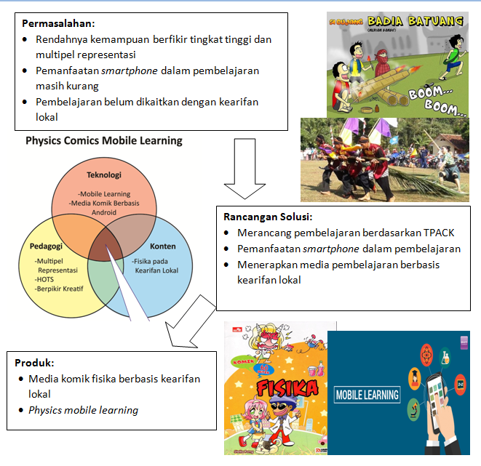
Figure 1. Research framework

- Learning with Smartphone
Mobile learning (m-learning) opens wider learning opportunities. This learning can be done anytime and anywhere by students [22]. In addition, mobile learning can improve the quality of one's learning life by providing access to information content / learning content without regard to social status, residence, and culture [23]. This positive side must be teachers to improve learning, such as the use of the latest technology.
Smartphones make it easier for teachers to teach. The use of instructional media in the learning process can arouse interest, motivation, and stimulation of learning activities, even bring psychological influence on students. Mobile learning media provides various learning application programs in the form of learning applications that can be accessed by everyone [24]. This makes learning physics better, in the sense of learning to be more relaxed and open.

- Physics Comics
Comics can be used for learning media [25]. Comics as a media are proven to be able to convey incoming messages in a clear, coherent, and pleasant way. Comics as a media have the potential to become teaching material [26]. Unlike textbooks, stories and comics allow many perspectives, visually and verbally, and apply the beginning, end, climax moments, and focal points, as well as the complexity of complex stories, textbooks, virtual reality simulations [27]. With this comic can provide treatment about the phenomenon of physics, with the Manaruh various phenomena up to completion and explanation of the problem.
The purpose of comics is to promote fundamental understanding of the subject through independent learning among students [28]. Comics as a source of learning need to be effective on themes and content in dialogue questions [29]. In learning students think that comic strips are fun and informative. Comics can help understand information and remember "key" messages [30]. Comic books that feature humor, narrative, and visual representation are considered as potential media for science communication [31]. A combination of comic offerings in the form of physical phenomena, problem solving, and comic drawings, and students ' interest in combatants can be used well as learning media.

- Local wisdom
Local wisdom is reflected in the culture that characterizes the region. Local wisdom will facilitate the development of science [32]. One of its uses is local wisdom as a link between scientific theories and regional conditions [33], so that knowledge can be accessed by the public. Learning with local wisdom gives students the opportunity to think and express ideas in understanding a physical concept [34]. Using local wisdom as a model of science learning has the effect of building contextual learning, stimulating students to learn more about the environment around their homes [32]. So that the learning approach with local culture can lead students to acquire two meanings of learning at the same time, physics and culture.
Bamboo cannon are one of the traditional Malay traditional games that were popular in its era and are almost known throughout the archipelago. Various regions recognize the game of bamboo cannons with different names. In Java, especially around Yogyakarta and Central Java, bamboo cannons are commonly known as "Long Bumbung". Also in other places this game is known by the name of bamboo rifles, fireworks, and others. Furthermore, this long bumbung game is usually played by boys when celebrating religious / customary holidays and enlivening the month of Ramadan (fasting) ahead of the feast. some tools and materials needed to play Bamboo Cannon, including bamboo cannon; kerosene is used for combustion; funnel used to put kerosene into the ignition hole, oil lamp or candle as a source of fire, a trigger, can be used from pieces of wood wrapped with cloth; and matches.
The blarak nglarak game first emerged from the Menoreh hilly region where the community in general was active in tapping coconut palm juice. Nglarak Blarak, abbreviated as Nglabrak, in Javanese Nglarak means to drag and Blarak means coconut leaf midrib, so Nglarak Blarak means to drag the palm leaf midrib. From there then developed a game that uses the basic ingredients of a coconut leaf midrib. To preserve local culture, players wear cultural-themed clothing, such as reog, jathilan, new kuthu, sorjan clothing which are the hallmarks of Yogyakarta. The equipment used is a blarak for carriages made from coconut leaves, sepet derived from the skin of coconut fruit, uthik derived from the trunk of a coconut tree, as well as roofs and baskets that are easily obtained in everyday life.

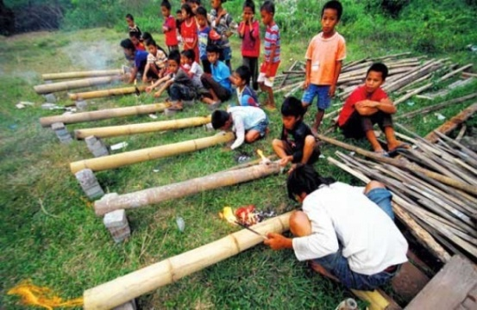
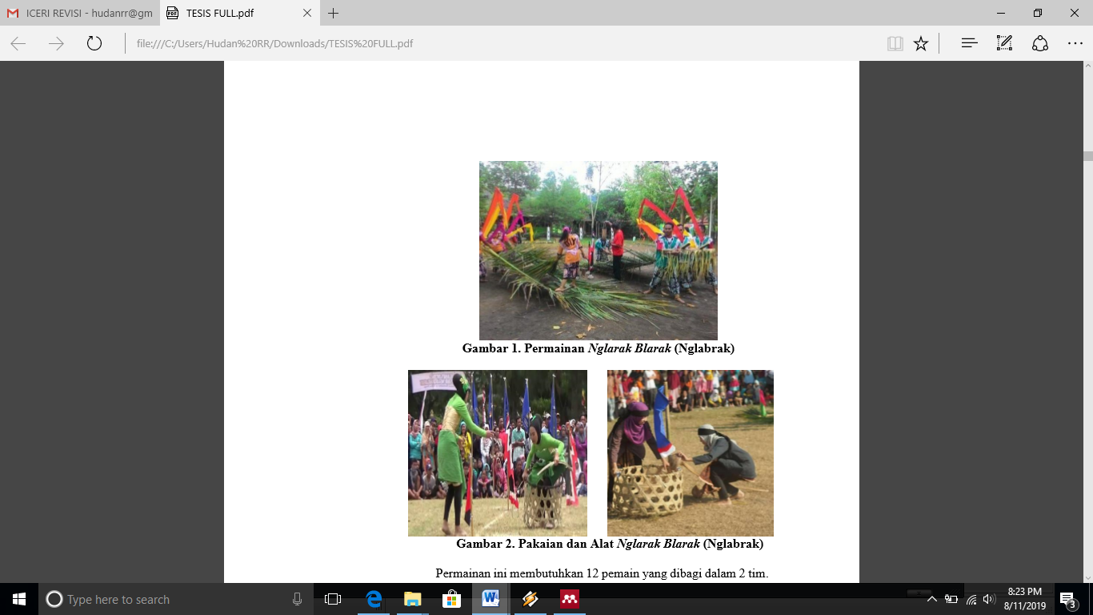
Figure 2. Long Bumbung (top) and game
Nglarak Blarak (bottom)

Physics concepts in long bumbung and blarak games are presented in Table 1 and Table 2, respectively.

Table 1. Physics Concepts of Long Bumbung Game
Activities | Theory
Positioning the bamboo cannon in a tilted state of between 10 to 30 degrees with the base of the cannon on the lower surface. | Fluid  Kerosene fluid follows the nature of the fluid, which occupies space. So that kerosene will cover the base of the long roof.
- Dipping the tip of the trigger bar into the trigger hole and then ignite the tip of the trigger bar with fire.  - Warming up the oil by inserting the fiery trigger bar into the Heat/Thermophysical trigger pit. | Heat / Thermophysical  Combustion is the sequence of chemical reactions between fuels with oxidants accompanied by heat production. This combustion process is usually accompanied by light in the form of fire or fluorescent. Here are the 3 main requirements that must be met are:  - Fuel combustion  - Oxidizer  - Heat source
A mixture of kerosene vapor and oxygen will explode when ignited by Thermophysics | Thermophysics  Ideal Gas and Real Gas  Definition and Nature of Gas; Pressure on Gas; Gas Equation; and Energy in Gas; Particle Movement Speed.
Detontion
Detonation is a chemical-physical process or commonly known as a combustion process that has a very high reaction speed. This reaction process will produce a very large temperature and gas so that it will build a very large force expansion. The detonation process begins with a very high reaction speed (around 3000 - 7500 m / s) that spreads heat pressure throughout the gas reaction blasting zone in the form of shock wave (shock compression wave) and the process of energy liberation ends with the expansion of the reaction.
Igniting the long roof by dipping the tip of the trigger bar into the trigger hole then igniting the tip of the trigger bar with fire | Shock wave  Shock waves occur from a very fast flow of waves because of a sudden increase in pressure, density, and temperature at the same time. Shock waves occur in a short time followed by the development of waves (reduced pressure) with increasing time. The process of the shock wave begins with the accumulation of air (pressurized) quickly which then produces a shock wave in this process in the form of a bang that will sound as an explosion.
The long bumbum was heard as the explosion | Sound Wave cannon  The process of booming longbumbung can be related to the sound concept including: sound characteristics; sound fast; sound symptoms; sound intensity; and the level of sound intensity.

Table 2. Physics Concept Game Nglarak Blarak
Variabel | Treatment of Newton’s Kinematic Material and Law
Variabel | Newton's Law I | Newton's Law II | Newton's Law III
Diagram | Diagram Presented the basket phenomenon in a state of silence it will continue to remain silent and if at first it moves it will maintain its position of movement | Presented two phenomena of a balanced state by giving opposing forces of the same magnitude but opposite directions  Two phenomena are presented: Basket driven by the player compared to the train drawn by 3 male players | Presented phenomenon Sepet hits the pole.
Diagram | Presented two pushing phenomena conducted Sepet against him and Sepet against Basket |  | Presented footprints of players when running
Diagram | Presented two phenomena of a balanced state by giving opposing forces of the same magnitude but opposite directions | Expressed force analysis on Basket pushed by players and the train drawn by 3 male players. | Expressed opposite force analysis on Sepet, hitting the pole (reaction-action force)
Diagram |  |  | Expression analysis is performed on the player's footprint when running (reaction style of action)
Diagram | Presented an explanation when the jockey boarded the blarak train by holding a few blarak leaves aiming not to snap backwards. | Presented an explanation of the relationship between force, mass and acceleration. | Disajikan perumusan hukum III Newton
Diagram | Presented as a state of equilibrium as a condition for the application of Newton's first law |  | Presented an explanantion of the reaction force on the player’s footprints while running.
Mathematical |  | presented the physical quantities of mass and acceleration to drive the blarak train
Mathematical | Presented requirements for the entry into force of Newton's first law | Expressed the formulation of Newton's II law equation
Mathematical |  | Presented completion in determining the magnitude of the force to move the blarak train

METHODOLOGY
This study used the type of Research and Development (R&D) by Thiagajar in 1974 [33] with a 4-D development model consisting of four main stages: (1) Define; (2) Design; (3) Develope; and (4) Disseminate. The steps in product development with the 4D model included:
a) Define: Defining and setting general conditions in learning through analysis of needs, curriculum, conditions of students and their knowledge related to the local wisdom used. This stage was carried out through interviews, observations, and preliminary surveys.
b) Design: Designing comics developed in accordance with the results of the analysis at the Define stage. Researchers made the design of the initial product design or prototype through assigning material and making media component specifications.
c) Develop: Developing physics-based comic media offline using the SIGIL application which could be displayed using a smartphone with the help of the Reasily Reader application. At this stage, comic media were tested through validation by experts, physics teachers and colleagues, limited tests, extensive field tests to get comic media products that were suitable for use in learning.
d) Disseminate: Disseminating widely available comic media.

The type of data to be obtained was qualitative and quantitative data. Qualitative data were in the form of survey data, while quantitative data were obtained from product feasibility assessments, scores on mathematical representation abilities and cognitive abilities of students, such as high order thingking skills and creative thingking skills.
Data collection techniques used non-test instruments and test instruments. Non-test instruments consisted of questionnaires and survey observation sheets, questionnaires and product assessment sheets, attitude observation sheets, self-assessment questionnaires, student questionnaire responses, and peer assessment questionnaires. The test instrument used in this study was a matter of description to assess the ability of physical representation, diagrams, mathematical and high order thinking skills.
A qualitative data analysis technique was used to analyze the results of the survey need assessment. While quantitative analysis was used to determine product viability, and product effectiveness. Analysis of this data was done by calculating the value of the pretest and posttest statistical analysis of MANOVA, inferentially done by multivariate analysis with the help of the SPSS computer program.
The research was conducted in Yogyakarta Province, namely in Sleman Regency with long-distance local wisdom to improve physical representation and HOTS abilities, and Kulon Progo District with local wisdom Nglarak Blarak to improve diagrammatic and mathematical representation capabilities.

RESULT AND DISCUSSION
- Komik Physics Comics of Long Bumbum Local Wisdom in improving the ability of Physical Representation and HOTS
The feasibility assessment of physics comic media products obtained an average value of 4.28, which was in the very good category, as seen in Table 2.
Table 2. Results of Limited Trial Assessment
Media Products Phase I
Material |  | Media | Average
Physics Reppresentation | HOTS | Questionnaire | Average
4,40 | 3,98 | 4,45 | 4,28
Good | Good | Very good | Good

The effectiveness of the product can be seen from the results of the test statistics in Table 3. It is known that the significance value <0.05, then there was a significant increase between the pretest-posttest scores of physical representation ability in each group. In the physical representation ability test, the mean difference (MD) value in the experimental class and the control class was -47,361; and -41,176.
Based on the MD value from the pretest to the posttest which was negative in each group, it is known that the average posttest score was higher than the mean pretest score. So it can be concluded that there was a significant improvement between the pretest-posttest scores of the physical representation ability of each group.
Table 3 shows that the significance value was <0.05, there was a significant increase between HOTS pretest-posttest scores in each group. In the HOTS ability test, the mean difference (MD) value in the experimental class and the control class was -66,111; and -60,735.
Based on the MD value from the pretest to the posttest which was negative in each group, it is known that the average posttest score was higher than the mean pretest score. So it can be concluded that there was a significant increase between the HOTS pretest-posttest scores for each group.
The effective contribution of the use of physics comics based on local wisdom long bumbung, and discussion learning on the physical representation ability and HOTS of students was obtained from the results of the Multivariate test type Hotelling's Trace on GLM.
Table 4 shows tha the effective contribution made by long bumbung based on the local wisdom comics in improving students' physical representation ability was by 91% and HOTS was by 95.4%. The amount of discussion learning contribution in increasing the physical representation ability of students was by 87.8% and HOTS was by 94.3%. Therefore it can be concluded that the physics comics based on local wisdom long bumbung provided the greatest effective contribution in increasing the physical representation ability of students and HOTS if versus the use of discussion learning.

- Nglarak Blarak Local Wisdom Physics Comic in increasing the ability of Physical Representation and HOTS
The assessment of Nglarak Blarak's local wisdom physics comics product that had been revised based on suggestions, comments and validator responses showed that the comic media products were netted to obtain quality value products. The results were obtained by the assessment of learning media products as seen in Table 5.
The Manova test was carried out using the SPSS 21 software used was the Hotteling’s Trace test. Hotteling’s Trace multivariate test results are presented in Table 6.
In table 33 sign value of 0.000 was less than = 0.05, meaning that H0 was rejected. So, by using a significance level = 0.05, there was a significant difference in the average increase in the ability of diagrammatic and mathematical representation between students taught by using the local wisdom comics physics media Nglarak Blarak assisted by android and the media usually used by teachers.
To see how much influence the use of Ngalark Blarak's local wisdom comic media products on android helps to increase the ability of diagrammatic and mathematical representation, the results were seen using an effect size. The results of Cohen's calculation are presented in Table 7.
Based on the analysis of the effect size, Cohen's f value was obtained for each variable of 0.158 and 0.296 with the interpretation of medium effect size and large effect size on each variable. That was when the product was developed, the local wisdom comic media Nglarak Blarak assisted by android gave a big influence on the ability of diagrammatic and mathematical representation. In other words, it is concluded that the local wisdom comic media product of Nglarak Blarak assisted by android effectively increased the ability of diagrammatic and mathematical representation.
- The Final Product
The product of physics comics based on local wisdom long bumbung produced is presented in Figure 3 (a), (b), (c), and (d). Whereas physics comics products based on local wisdom produced by Blarak are presented in Figure 2 (e), (f), (g), and (h).
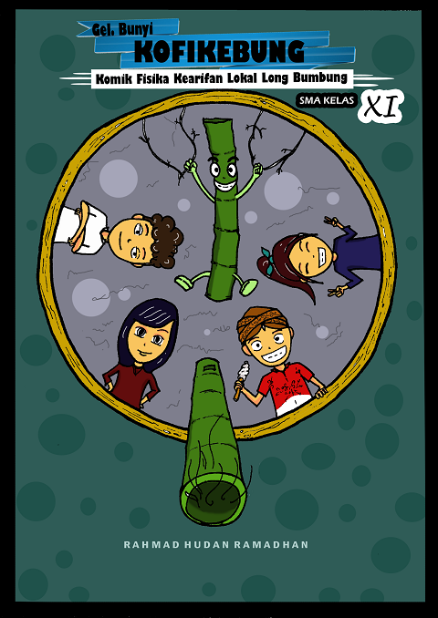 | 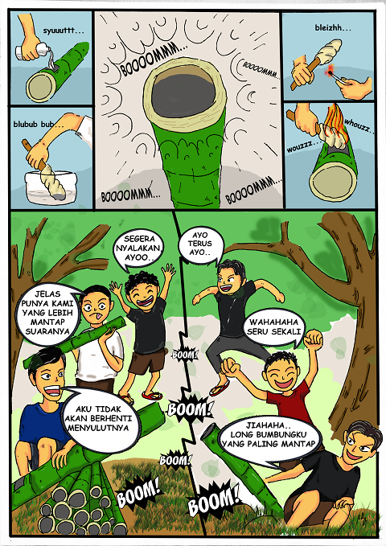
(a) | (b)
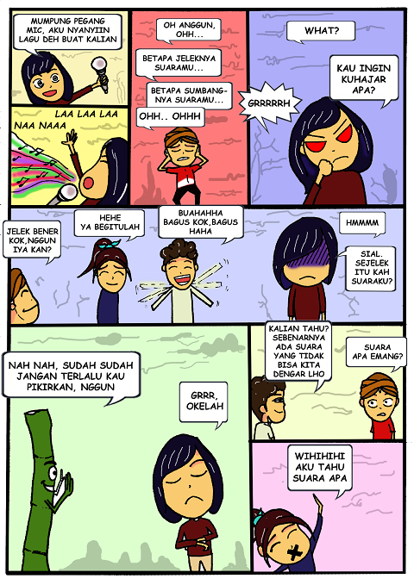 | 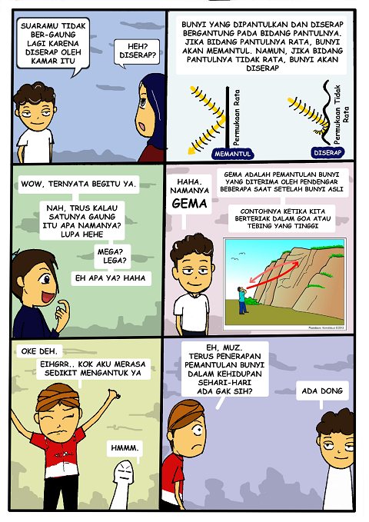
(c) | (d)
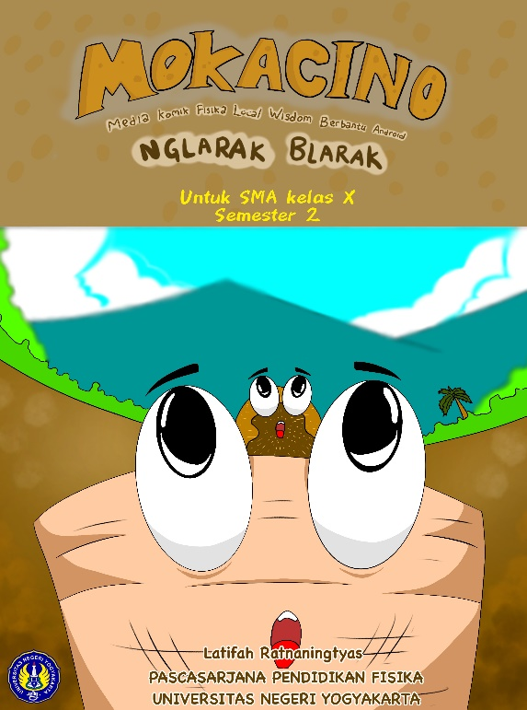 | 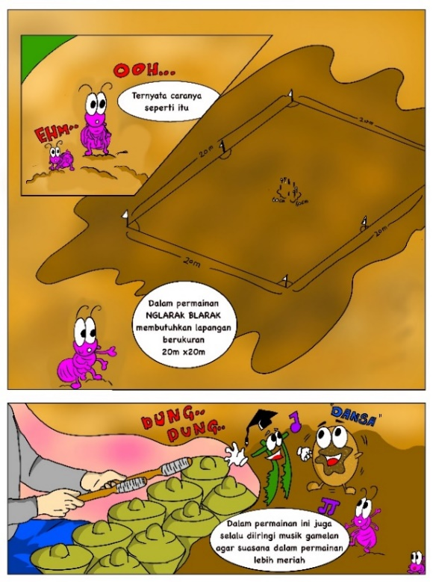
(e) | (f)
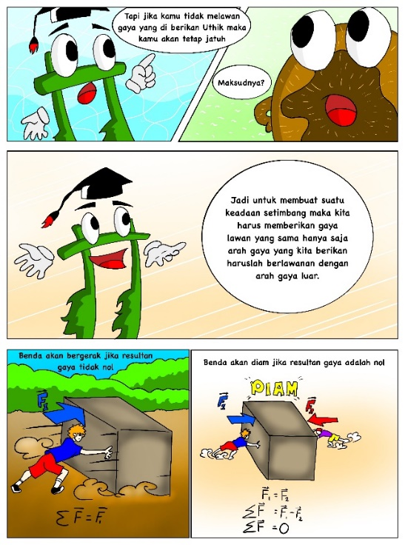 | 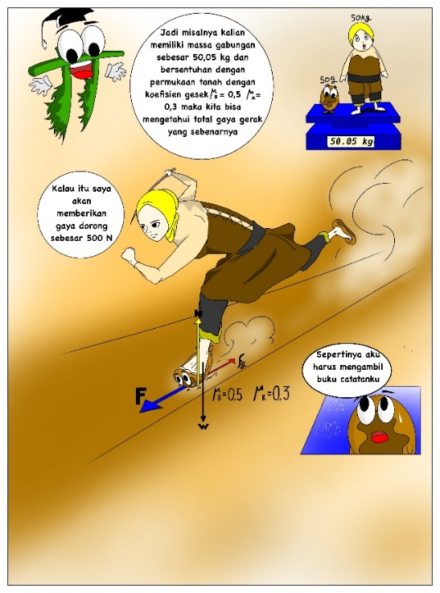
(g) | (h)
Figure 3. Final Comic Physics Products

CONCLUSION
Media of local wisdom Physics Comic; long and tall and assisted by android to improve the ability of mathematical representation, HOTS, and creative thinking of high school students contained a complete explanation of the material associated with local wisdom, learning videos, discussion sheets, experiment sheets, examples and practice questions. The product could be operated using a smartphone with the EPUB Reader application or a computer with an internet browser.
Physics comic media products based on the local wisdom (long bumbung) effectively used to improve the ability of physical representation were indicated by a significance value <0.05 and mean differences of -47,361; and HOTS were shown with a significance value <0.05 and mean differences of -66,111. Whereas, the partial eta square value of physics comics media based on local wisdom (long bumbung) in improving students' physical representation ability was 91% and HOTS was 95.4%, having a greater value than the discussion learning control class.
Physics comic media products based on the local wisdom were effectively used to improve the physical representation ability and HOTS of students. This valuation was based on product assessment of 2.24 with good categories. Furthermore, media of physics comic assisted by android developed effectively improved the ability of diagrammatic and mathematical representation which could be seen from the Cohen's value that Cohen's f variables which were 0.158 and 0.296 with the interpretation of each medium effect size and large effect size on both variables. It means that the product developed, the local wisdom comic media Nglarak Blarak assisted by android, gave a big influence on the ability of diagrammatic and mathematical representation.

Acknowledgment (Heading 5)
Media products are android-based physics comics with the use of local wisdom longumbumb and Nglarak Blarak. Comics are designed to attract students' interest in learning physics. In addition, the use of Android as a learning medium can be used by students to study physics anytime, anywhere. This physics comic is also sought as an enrichment material to strengthen the concepts and materials that students learn in class.

References
[1] E. Istiyono, “The analysis of senior high school students’ physics HOTS in Bantul District measured using PhysReMChoTHOTS,” in AIP Conference Proceedings, 2017, vol. 1868.
[2] C. Sin, “Epistemology, sociology, and learning and teaching in physics,” Sci. Educ., vol. 98, no. 2, pp. 342–365, 2014.
[3] M. Marušić and J. Sliško, “Influence of Three Different Methods of Teaching Physics on the Gain in Students’ Development of Reasoning,” Int. J. Sci. Educ., vol. 34, no. 2, pp. 301–326, 2012.
[4] A. H. Abdullah, M. Mokhtar, N. D. A. Halim, A. Dayana Farzeeha, T. Lokman Mohd, and K. Umar Haiyat Abdul, “Mathematics Teachers’ Level of Knowledge and Practice on the Implementation of Higher-Order Thinking Skills (HOTS),” EURASIA J. Math. Sci. Technol. Educ., vol. 13, no. 1, pp. 3–17, 2017.
[5] S. C. Moon and S. Hong, “Effect of using a smartphone sensor in a physics class on motivation for science learning,” New Phys. Sae Mulli, vol. 65, no. 1, pp. 66–70, 2015.
[6] A. Savinainen, A. Mäkynen, P. Nieminen, and J. Viiri, “Does using a visual-representation tool foster students’ ability to identify forces and construct free-body diagrams?,” Phys. Rev. Spec. Top. - Phys. Educ. Res., vol. 9, no. 1, 2013.
[7] A. Samkoff, Y. Lai, and K. Weber, “On the different ways that mathematicians use diagrams in proof construction,” Res. Math. Educ., vol. 14, no. 1, pp. 49–67, 2012.
[8] L. Kibona and G. Mgaya, “Smartphones’ Effects on Academic Performance of Higher Learning Students,” J. Multidiscip. Eng. Sci. Technol., vol. 2, no. 4, pp. 3159–40, 2015.
[9] C. Lee and S. J. Lee, “Prevalence and predictors of smartphone addiction proneness among Korean adolescents,” Child. Youth Serv. Rev., vol. 77, no. April, pp. 10–17, 2017.
[10] A. Van Den Beemt and I. Diepstraten, “Teacher perspectives on ICT: A learning ecology approach,” Computers and Education, vol. 92–93. pp. 161–170, 2016.
[11] Y. T. Chuang, “SSCLS: A smartphone-supported collaborative learning system,” Telemat. Informatics, vol. 32, no. 3, pp. 463–474, 2015.
[12] É. Duke and C. Montag, “Smartphone addiction, daily interruptions and self-reported productivity,” Addict. Behav. Reports, vol. 6, pp. 90–95, 2017.
[13] R. Egusa et al., “Improving the usability of manga-on-a-tablet for collaborative learning,” in CSEDU 2014 - Proceedings of the 6th International Conference on Computer Supported Education, 2014, vol. 1, pp. 446–451.
[14] H. Tolle and K. Arai, “Manga content extraction method for automatic mobile comic content creation,” in 2013 International Conference on Advanced Computer Science and Information Systems, ICACSIS 2013, 2013, pp. 321–328.
[15] F. Fatimah and A. Widiyatmoko, “Pengembangan science comic berbasis problem based learning sebagai media pembelajaran pada tema bunyi dan pendengaran untuk siswa SMP,” J. Pendidik. IPA Indones., vol. 3, no. 2, pp. 146–153, 2014.
[16] Ş. Atasoy and S. Ergin, “The effect of concept cartoon-embedded worksheets on grade 9 students’ conceptual understanding of Newton’s Laws of Motion,” Res. Sci. Technol. Educ., vol. 35, no. 1, pp. 58–73, 2017.
[17] E. Özdemir, “Humor in elementary science: development and evaluation of comic strips about sound,” Int. Electron. J. Elem. Educ., vol. 9, no. 4, pp. 837–850, 2017.
[18] Parmin, Sajidan, Ashadi, Sutikno, and Y. maretta, “Preparing prospective teachers in integrating science and local wisdom through practicing open inquiry,” J. Turkish Sci. Educ., vol. 13, no. 2, pp. 3–14, 2016.
[19] I. N. Dewi, S. Poedjiastoeti, K. Prahani, and S. P. Professor, “Elsii Learning Model Based Local Wisdom To Improve Students’ Problem Solving Skills and Scientific Communication,” Int. J. Educ. Res., vol. 5, no. 1, pp. 107–118, 2017.
[20] Y. M. Heong, J. M. Yunos, W. Othman, R. Hassan, T. T. Kiong, and M. M. Mohamad, “The Needs Analysis of Learning Higher Order Thinking Skills for Generating Ideas,” Procedia - Soc. Behav. Sci., vol. 59, pp. 197–203, 2012.
[21] J. Widodo, “Urban Environment and Human Behaviour: Learning from History and Local Wisdom,” Procedia - Soc. Behav. Sci., vol. 42, pp. 6–11, 2012.
[22] I. Han and W. S. Shin, “The use of a mobile learning management system and academic achievement of online students,” Comput. Educ., vol. 102, pp. 79–89, 2016.
[23] M. L. Crescente and D. Lee, “Critical issues of m-learning: Design models, adoption processes, and future trends,” J. Chinese Inst. Ind. Eng., vol. 28, no. 2, pp. 111–123, 2011.
[24] H. Kuswanto, “Android Used in The Learning Innovation Atwood Machines on Lagrange Mechanics Methods,” vol. 2, no. 1, pp. 338–345, 2017.
[25] P. D. Widyastuti, M. M., and S. D. R. S., “An Instructional Media using Comics on the Systems of Linear Equation An Instructional Media Using Comics on the Systems of Linear Equation,” Int. Conf. Math. Sci. Educ., vol. 895, pp. 1–7, 2017.
[26] D. Yulianti, S. Khanafiyah, and S. Sulistyorini, “Inquiry-based science comic physics series integrated with character education,” J. Pendidik. IPA Indones., vol. 5, no. 1, pp. 38–44, 2016.
[27] C. S. Babaian and A. A. Chalian, “‘The thyroidectomy story’: Comic books, graphic novels, and the novel approach to teaching head and neck surgery through the genre of the comic book,” J. Surg. Educ., vol. 71, no. 3, pp. 413–418, 2014.
[28] J. Kim, M. S. Chung, H. G. Jang, and B. S. Chung, “The use of educational comics in learning anatomy among multiple student groups,” Anat. Sci. Educ., vol. 10, no. 1, pp. 79–86, 2017.
[29] E. Albrecht and M. R. Voelzke, “Creating comics in physics lessons: An educational practice,” J. Sci. Educ., vol. 13, no. 2, pp. 76–80, 2012.
[30] P. Grootens-Wiegers, M. C. de Vries, M. M. van Beusekom, L. van Dijck, and J. M. van den Broek, “Comic strips help children understand medical research. Targeting the informed consent procedure to children’s needs,” Patient Educ. Couns., vol. 98, no. 4, pp. 518–524, 2015.
[31] J. Hosler and K. B. Boomer, “Are comic books an effectiveway to engage nonmajors in learning and appreciating science?,” CBE Life Sci. Educ., vol. 10, no. 3, pp. 309–317, 2011.
[32] A. Anwari, M. S. Nahdi, and E. Sulistyowati, “Biological science learning model based on Turgo’s local wisdom on managing biodiversity,” AIP Conf. Proc., vol. 1708, 2016.
[33] Budihardjo, Eko.1997. Preservation and Conservation of Culture Heritage in Indonesia. Gadjah Mada University Press; Yogyakarta.
[34] Pramadi, I. P. W. Y., Suastra, I. W., & Candiasa, I. M. (2013). Pengaruh penggunaan komik berorientasi kearifan lokal bali terhadap motivasi belajar dan pemahaman konsep fisika. E-Journal Program Pascasarjana Universitas Pendidikan Ganesha, 3

