Development of Comics and M-Learning Based on Local Wisdom Assisted by Android to Improve HOTS Ability, Visual Representation and Critical Thinking

Heru Kuswanto
Physics Education
Yogyakarta State University
Yogyakarta, Indonesia
herukus61@uny.ac.id
Faruq Haroky
Physics Education
Yogyakarta State University
Yogyakarta, Indonesia
faruqht@gmail.com
Ratna Wardani
Electrinic Engineering and Informatic Education
Yogyakarta State University
Yogyakarta, Indonesia
ratna@uny.ac.id
Putri Diana Mirta
Physics Education
Yogyakarta State University
Yogyakarta, Indonesia
putridianaamirta@gmail.com

Abstract— Integration of a culture that has developed and is familiar with the community with learning science through mobile devices is needed so that there is no gap between rapid technological developments. Knowledge skills, application reasoning, need to be improved in an effort to reduce memorizing and less meaningful learning. Form of integration so that learning is more meaningful accompanied by the use of technology in content and learning activities can be done by the use of innovative learning media consisting of digital comics and mobile learning applications. The relationship between technology, learning processes, content, and skills is related to the application of Technological, Pedagogical, and Content Knowledge (TPACK). This research focuses on the development of the two products which are planned for 1 year using the Research and Development (R&D) approach for preliminary studies, planning, product design, product validation, product revision I, limited trial I, revision II, limited trial II , revision III, and product dissemination. The data generated in the form of increased ability of HOTS, visual representation and critical thinking of students.
Keywords— mobile learning, comics, HOTS, critical thinking, visual representation, ICT literacy

Introduction
Science or nature of science has actually been used by people since ancient times. Accidental discoveries by the public produce simple technology that benefits many parties. Belief in cultural truth based on life experience is a process of scientific knowledge that is not recognized by the public.
The problems that are often faced in science learning are learning that is still centered on the teacher, the concepts conveyed are memorized and are less associated with the daily lives of students so that learning is less meaningful.
Data Trend in International Mathematics and Science Study (TIMSS) which was licensed by The International Association for the Evaluation of Educational Achievement (IEA) (2015) was obtained that the ability of natural sciences 8th grade Indonesian students ranked 45/68 with 397 points based on three assessment domains that were knowledge, reasoning, and applications with ratings still below average. The assessment carried out includes the areas of knowledge, reasoning and applicative. This relates to aspects of students' critical thinking skills, representation and higher-level skills (HOTS) that are less developed.
Today is the age of technology. All activities have been influenced by technology, one of which is the use in daily life and learning. Smartphone is a newly released mobile application that offers learning content on mobile devices, giving students "anytime, anywhere" access to their blackboard learning. Mobile learning is becoming an increasingly promising way to deliver teaching in higher education [1]. So that mobile-based learning is widely developed in learning. M-learning that is implemented using a smartphone and included in the Information Technology and Communication (ICT) device can improve ICT literacy of students.
One of the learning media used in learning is digital comics. Comics are visual media to express ideas through images and combined with text for information. Usually comics are made as serial images. The implementation of comics for learning makes students enthusiastic [2]. A possible solution is the comic strip, which offers more personality than other multimedia data [3].
With the vast territory of Indonesia, local wisdom is many and different from one region to another, as well as limitations in accessing formal education. So the way of learning and access to learning becomes a problem in education. One way to make learning widely accessible without being limited by time and place is by mobile-based learning.
This study focuses on these three issues, namely the problem of developing critical thinking skills, visual representation and HOTS, learning based on local wisdom, and expanding access to learning through the use of mobile devices. The research title is the development of science mobile learning to improve critical thinking skills, HOTS visual representation, and ICT literacy.

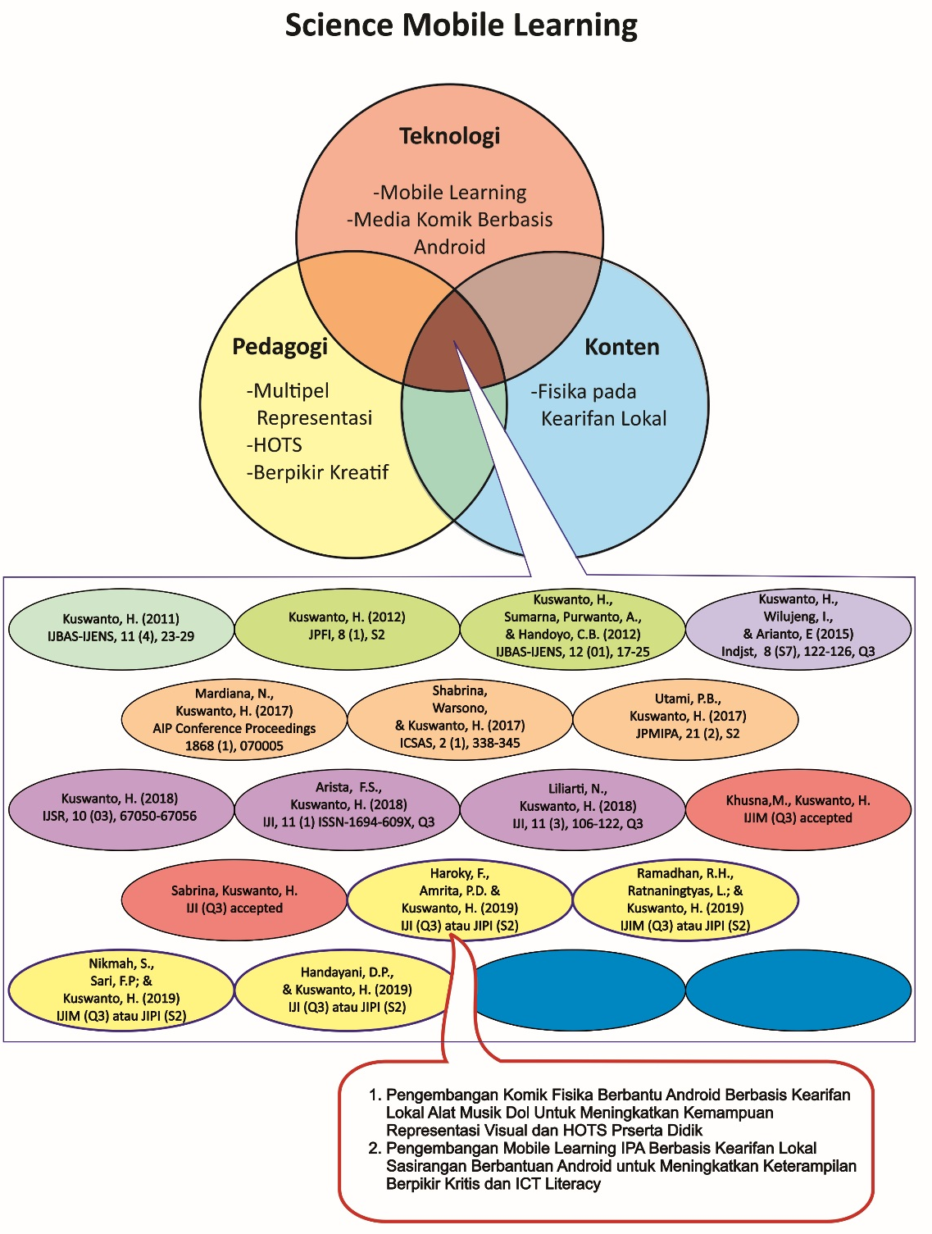

Literatur Review

Science Learning
Natural Science or Natural Science is a collection of knowledge related to objects and natural phenomena obtained from the results of scientific investigations through observation, data clarification, compiled and verified which involves mathematical reasoning and data analysis of natural phenomena [4].
Learning needs to be integrated by utilizing technology. A theoretical framework has emerged recently to guide research in the use of ICT is content knowledge technology pedagogy (TPACK) [5]. The development of TPACK in science education requires a curriculum system that can connect the three components of TPACK in a complex and multidimensional manner in an epistemologically and conceptually integrated way. One of the first steps in implementing TPACK in science learning is to clarify constitutional components and make explicit connections with science content, pedagogy, and technology which are meaningful and realistic for secondary education [6].
Critical thinking skills in a person has the characteristic of being able to interpret, analyze, conclude, explain and conduct self-regulation adapted from [7].

Science Mobile Learning
Mobile-based learning (m-learning) can be interpreted as learning in a flexible way without time or place restrictions, through the use of different mobile devices, such as smartphones, iPads, and e-Book Reader. Mobile devices after being activated with compatible technology can provide content such as various learning materials (audio, text and video), online exams, web references, exam schedules, homework and assessments. In connection with the definition above shows that mobile content is any type of media that is adjusted to fit the mobile phone such as; games, graphics, and films distributed via mobile internet using interactivity [9].
Mobile-based learning systems (mobile learning) are classified into three system uses [10]:
- A mobile learning system that supports access to the contents of teaching materials, including tests.
- A mobile learning system that supports access to school administration services.
- A mobile learning system that supports access to teaching materials and school administration.
One of the contents of teaching materials that can be developed from mobile learning is the making of instructional materials consisting of material, assignments and tests and learning comic media.
Comic booklets are a good educational tool for increasing knowledge [11]. Comics have graphic and fine art forms and are fundamentally a visual narrative that creates a virtual world that can tell a story, describe a procedure, teach a theory, present a hypothesis, answer a question, and engage the reader. Unlike textbooks, stories and comics allow multiple perspectives, visually and verbally, and they apply the beginning, end, climax moments, and focal points, as well as the complexity of complex stories. Learning with comic media is an innovative communication media that can be used to achieve learning goals [12]. So learning to use comics that include illustrations and written content may be an effective intervention to increase knowledge.
While the development of teaching materials in mobile learning can facilitate subjects (course), assignments (assignments), quizzes and tests (quizzes and tests) such as those found in one of the LMS-based mobile learning applications that have been available.

Local Wisdom

Local wisdom is a social, political, cultural, economic, and environmental order that lives in the midst of local people and is a legacy that has been developed over a long time. Some local wisdom in Indonesia are sasirangan from South Kalimantan, dol from Bengkulu.

Sasirangan or its products better known as sairangan fabric are made with a simple process through the technique of bare sewing accompanied by the pulling and binding of the barrier thread by heating with natural dyes and synthesis with various motifs [13].

While dol is a typical musical instrument from Bengkulu Province. Dol has the shape of a drum with a convex shape on the side and uses it by being hit using the bat so that it produces a loud sound.

Method

Research Type
This research included Survey, R&D, Quasi experiments. The survey was intended to determine the initial conditions in the field with android-based learning based on local wisdom. R&D was intended to develop products that are android-based learning media based on local wisdom, quasi experiment was intended for field trials to see the effectiveness of the products produced to improve critical thinking skills, visual representation, HOTS and ICT literacy.

Development Procedure
This R & D research used the stages that were opened by Borg and Gall (1989) covering ten steps, namely: (1) Research and Information Collections, (2) Planning, (3) Developing Preliminary forms of Product, (4) Preliminary Field Testing, (5) Main Product Revision, (6) Main Field Testing, (7) Operational Product Revision, (8) Operational Field Testing, (9) Final Product Revision, and (10) Disemination and Implementation.

Type of Research Data
The type of data to be obtained in this study was quantitative data. Quantitative data were obtained from product feasibility assessments, critical thinking, visual representation and HOIS capabilities. Quantitative data analysis techniques were used to determine the increase in critical thinking, HOTS and visual representation that showed the ability of XXI century students.

Result and Discussion

Media Development Result
Development of physics learning media comics with local wisdom andriod's dol musical instruments used R&D methods. The appearance of physics learning comics media based on local wisdom musical instrument dol can be seen in Figure 2. While the sasirangan based m-learning media can be seen in Figure 3.
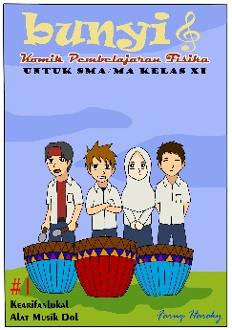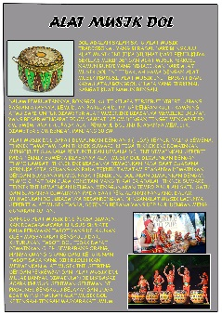
(a)
(b)

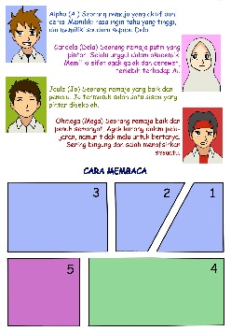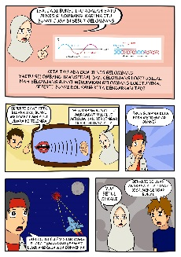
(c)
(d)

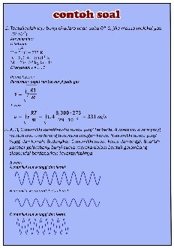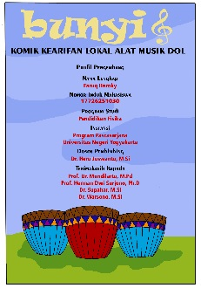
(e)
(f)

Figure 2. Comic Display a. Cover, b. Explanation of local wisdom, c. Figure and how to read, d. The flow of the comic story, e. Example problems, f. developer profile

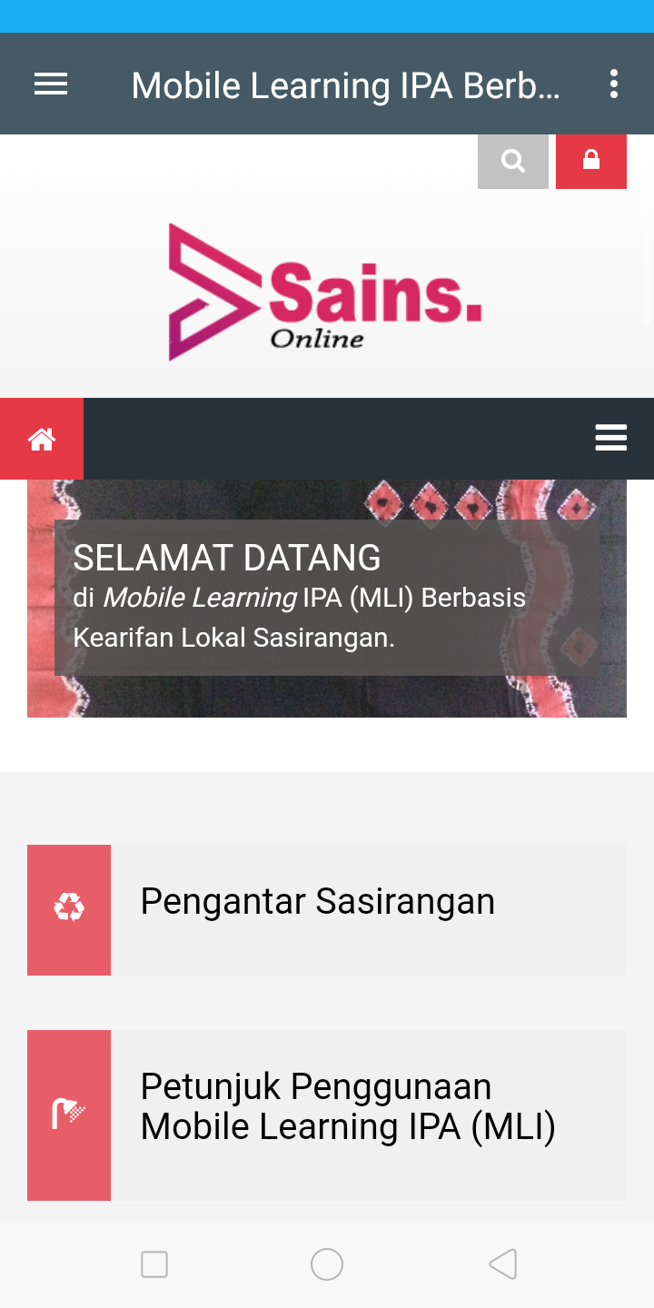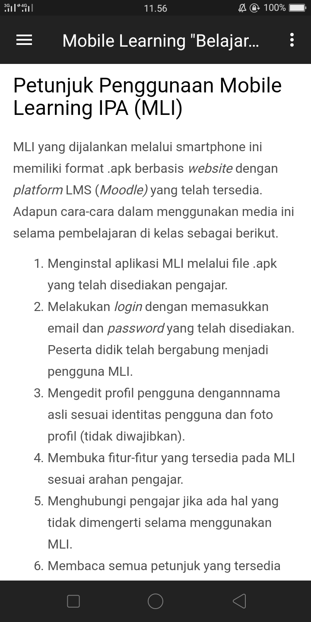
(a)
(b)

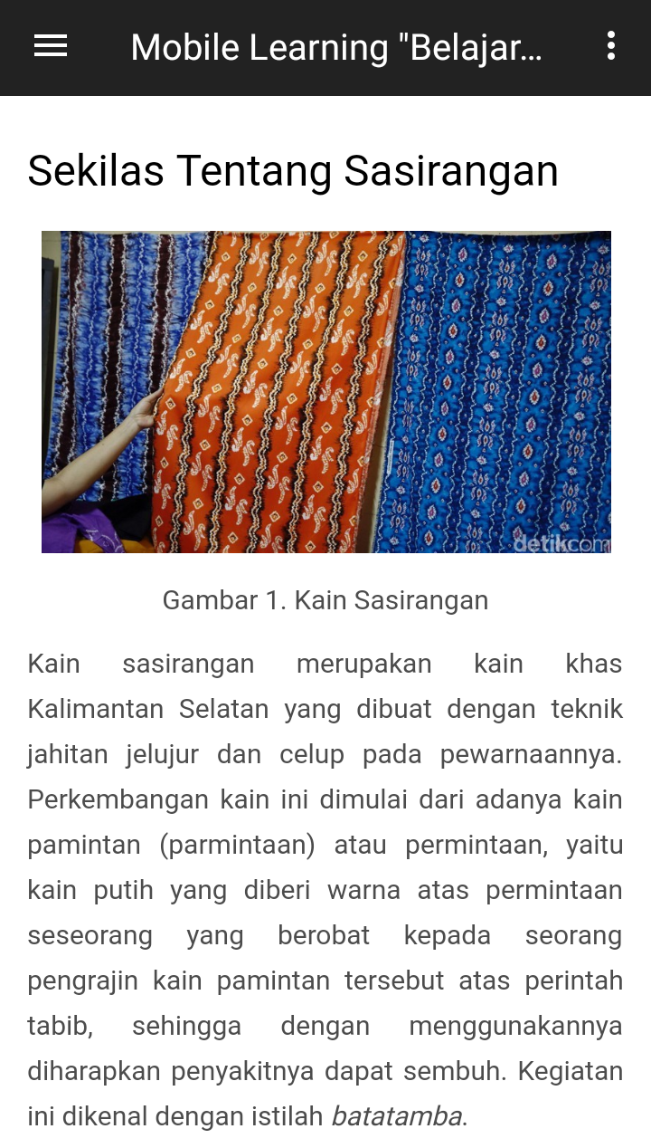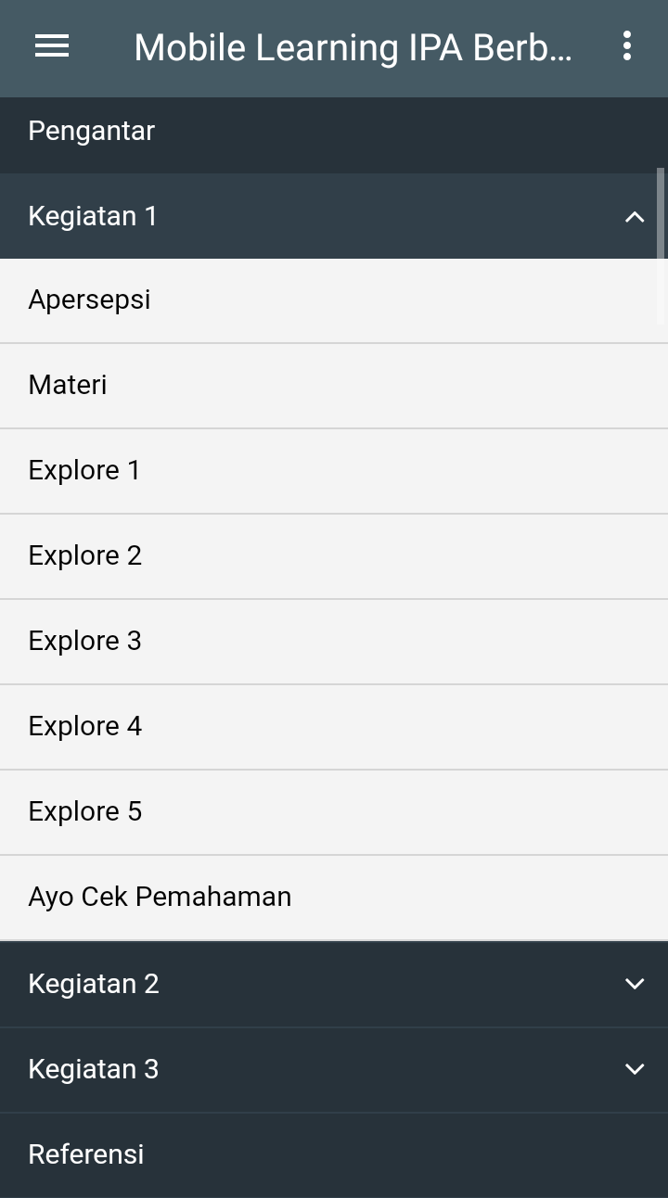
(c)
(d)

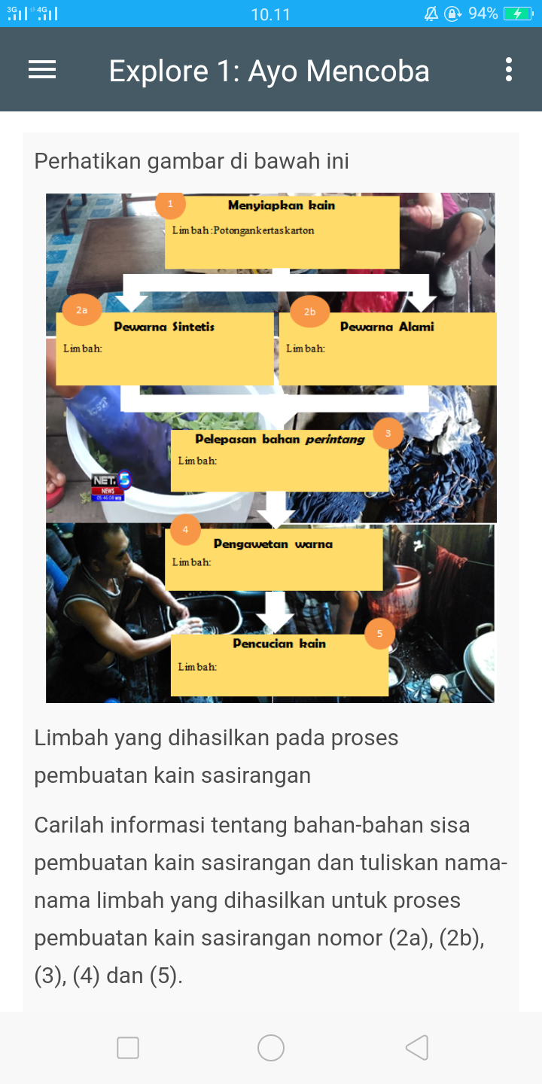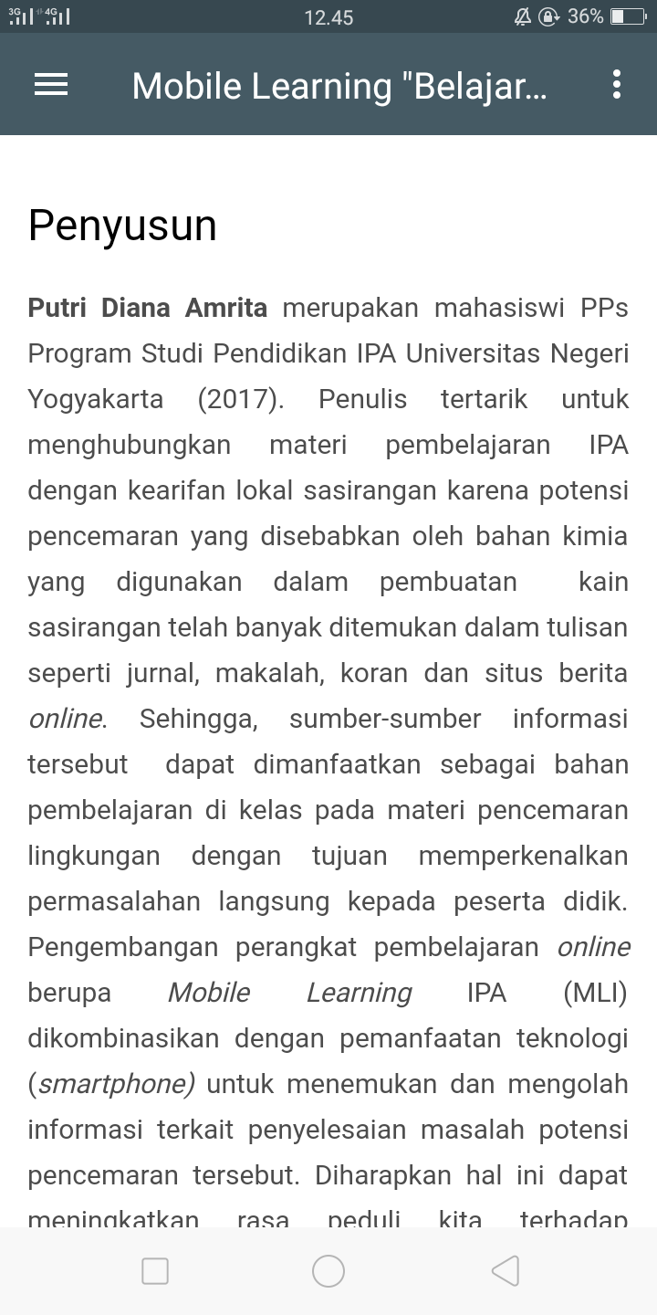
(e)
(f)

Figure 3. Display of Sasirangan-Based M-learning a. Home, b. media usage instructions, c. information about sasirangan, d. learning activities, e. one example of an activity, f. compiler profile

Product Feasibility
Analysis of the feasibility of comic media was based on assessments by media expert lecturers and material expert lecturers, junior physics and junior high school science teachers, and peer reviewers. Assessment of physics media comics local wisdom musical instrument dol and m-lerning sasirangan assisted android can be stated in the category very well. The results of the analysis can be seen in Table 1 and Table II.
- FEASIBILITY ANALYSIS OF COMIC MEDIA
No | Indicator rated | V | Information
1 | Comic Design | 1,00 | Very Good
2 | Visual quality | 0,86 | Very Good
3 | Content | 0,86 | Very Good
4 | Organization, language and readability | 0,95 | Very Good

- FEASIBILITY ANALYSIS OF M-LEARNING MEDIA
No | Indicator rated | Average Score | Information
1 | Display of interface | 4,44 | Very Good
2 | Reliability | 4,67 | Very Good
3 | Utilization of Software | 5 | Very Good
4 | Material | 4,74 | Very Good
5. | Linguistics | 4,5 | Very Good
6. | Pedagogy (Instructional) | 4,56 | Very Good

HOTS Results, Visual Representation and Critical Thinking
The field trial of dol instrument-based comic media was conducted on high school students of class XI IPA and sasirangan-based m-learning in class VII of junior high school. HOTS pretest and posttest data, visual representation skills and critical thinking skills generated are presented in Tables III, IV and V.
- HOTS Result
No | Class | Score |  | N Gain | Category
No | Class | pretest | posttest | N Gain | Category
1 | Eksperiment | 1,30 | 6,56 | 0,59 | Medium
2 | Control | 1,70 | 4,56 | 0,33 | Medium
- Visual Representation Result
No | Class | Score |  | N Gain | Category
No | Class | pretest | posttest | N Gain | Category
1 | Eksperiment | 2,91 | 7,36 | 0,61 | Medium
2 | Control | 3,56 | 6,68 | 0,48 | Medium
- Critical Thinking Result
No | Class | Score |  | N Gain | Category
No | Class | pretest | posttest | N Gain | Category
1 | Eksperiment | 2,54 | 6,64 | 0,54 | Medium
2 | Control | 2,38 | 5,33 | 0,39 | Medium

Tabel Tables III, IV and V show that the HOTS gain value, visual representation and critical thinking of students in the pretest and posttest classes are in the medium category.
Analysis of normality in the Shapiro-Wilk test obtained sig. more than 0.05. This means that the data of the two experimental and control class groups were normally distributed for all test results.
The MANOVA test was conducted to find out whether there was a difference in HOTS ability and visual representation of students between learning using comics media, Android-assisted local wisdom physics with learning using textbooks and the usual media provided by schools while the independent samples t test was conducted to find out whether there were differences in thinking skills critical learners who used sasirangan-based m-learning with learning that used ppt media, textbooks and additional printed handouts.
The results of MANOVA analysis show that the statistical value of the Hottelling's Trace test was = 0.548 and the significance value indicated that the value of 0,000 was <0.05. It shows from this multivariate test that there was a difference of HOTS and the students' visual representation ability, between learning using comics media, local wisdom physics, assisted by android, and learning using textbooks and the usual media provided by schools. While the analysis of independent samples t test shows that the statistical value of the test of the average gain score between the two classes gave a value of 0,000 <0.05. These results indicate that there was a difference between the gain score of critical thinking skills of experimental class students who used sasirangan-based m-learning media and control classes that used ppt media, textbooks and additional print handouts in learning.
The effective contribution of independent variables was applied to the experimental class, namely the physics media comics local wisdom instrument android assisted by dol to improve the dependent variable (HOTS) and visual representation. Whereas the control class used normal learning which was used in the classroom to increase the dependent variable. Effective donations were obtained by multivariate analysis using GLM (General Linear Model) viewed from the Multivariate Test Pillai's Trace. This effective contribution was only measured for HOTS ability variables and visual representation.
- The improvement HOTS ability, visual representation and critical thinking skills in the experimental and control classes.
- The effective contribution of the experimental and control class was 91.4% and 87.7% of the increase in HOTS.
- The effective contribution of the experimental and control class was 91.6% and 89.4% to the increase in the ability of visual representation.

Conclution
Physics comics with local wisdom dol and m-learning sasirangan assisted by android are suitable to be used as a learning process in class. Evidenced by the assessments and input from expert lecturers, physics teachers, and peer reviewers, the product development is categorized as very good.
Physics comics of local wisdom dol instrument can be seen its effectiveness in improving HOTS ability and visual representation of students in the learning process. The increase was seen again in the difference between the pretest and posttest scores in the experimental and control classes. Increasing the value of HOTS and the visual representation obtained by multivariate tests was carried out to determine the improvement of HOTS and the visual representation of students, which obtained sig. 0,00 <0,05 so that there was a difference in the average increase in HOTS and students' visual representation.
Meanwhile, m-learning sasirangan can be seen its effectiveness in increasing students' critical thinking skills through independent samples t test using the student gain score in control and experimental classes, where a sig value of 0.00 <0.05 was obtained so that there were differences in the average improvement in students' critical thinking skills.
Based on the results above, it can be concluded that the physics comics media based on dol musical instrument and Android-based sasirangan based on sasirangan can improve HOTS ability, visual representation and critical thinking skills of students.

References

- M. O. M. El-Hussein and J. C. Cronje, “Defining mobile learning in the higher education landscape,” Educational Technology & Society, Peninsula, 13(3):12-21, October 2010.
- J. Hosler and K. Boomer, “Are comic an effective way to engace nonmajors in learning and appreciating science?”, CBE life science education, 10(3):309-173, September 2011.
- M. Tatolvic, “Science comics as tools for science education and communication: a brief, exploratory study,” Journal of Science Communication, vol. VIII, November 2009.
- W. Djojosoediro, “Pengembangan dan Pembelajaran IPA SD”, Refika aditama, Bandung 2010.
- A. Ahmed and A. Qasem, “Blended learning approach to develope the teacher’ TPACK”, Coontemporary Educational Technology, Vol: VII(3),264-276, 2016.
- A. Jimoyiannis, “Developing a technological pedagogical content knowledge framework for science education: Implications of a teacher trainers’ preparation program”, Proceedings of Informing Science & IT …, 597–607, 2010.
- P. Facione, “Critical Thinking : What It Is and Why It Counts. Insight assessment”, (ISBN 13: 978-1-891557-07-1.), 1–28. 2013.
- ETS, “Digital Transformation: A Framework for ICT Literacy. A Report of the International ICT Literacy Panel”, Educational Testing, 1, 2007, Aviliable from: http://www.ets.org/research/ictliteracy.
- F. R. Shahroury,”A Framework for Mobile Learning Adoption”, Indian Journal of Science and Technology, 9(48), 3–8. 2016.
- E. Georgieva, A. Smrikarov and T. Georgiev, “A General Classification of Mobile Learning Systems”, International Conference on Computer Systems and Technologies - CompSysTech’2005, 1–6.
- A. Mendelson, N. Rabinowicz, Y. Reis, G. Amarilyo, L. Harel, P. J. Hashkes, and Y. Uziel,” Comics as an educational tool for children with juvenile idiopathic arthritis”, Pediatric Rheumatology, 15(1). 2017.
- A. Hanson, A. L. Drendel, G. Ashwal, and A. Thomas, “The feasibility of utilizing a comic for education in the emergency department setting “ Health Communication, 32(5), 529–532. 2017.
- E. S. Murwati, I. Kartika, “35 Teknologi Proses Sasirangan dengan Variasi Teknik Jelujur, 35–40”. 2012.

