**Digital Signal Processor Learning Media With Remote Laboratory-Based DSK TMS320C6713**

Galih Setiyo Budhi

*Electronis and Informatics Eduactional Engineering, Yogyakarta State University*

Setiyo.galih@gmail.com

Fatchul Arifin

*Yogyakarta State University*

Fatchul.ar@gmail.com

**Abstract— Remote Digital Signal Processing (DSP) learning media using the internet is a tool to learn and understand the basic of DSP and the application of DSP in industry. This DSP learning media uses DSK TMS320C6713 has several implementation of DSP system based on equipment in industrial application or in everyday life which are digital filter and audio effect. This DSP learning media is connected to a computer server in a laboratory and can be accessed by any user who already has permission to acces using a computer or laptop through the internet without being present in the laboratory. The research shows that the application program and trainer in this DSP learning media can be accessed using remote desktop system through the internet. One remote DSP learning media can be accessed by one user at one time. By using this remote DSP learning media, users can get direct learning experience as a real in the laboratory.**

***Keywords— Learning Media, Remote Laboratory, DSK TMS320C6713***

1. INTRODUCTION

The technology development are extremely increase in this 4.0 industrial era. The human resources must be prepared to contend for industrial needed. The human resources must be have an ability and competence in accordance with industrial needed. Industrial development is closely related with education world. Ideally, the world of education must refer to the industrial competences. The industry is now entering into the digital industry era, so learning related to digital signal processing also is very important. The digital signal processing has begun to be studied more than 30 years ago. The digital signal processing starts together with the computer and its development. The advantages of signal processing in the form of digital is the ease of storage processing easier and provide more accurate results [1]. By looking at the many advantages of digital signal processing than analog, digital signal processing is more widely used in the world of Insudtri and in everyday life.

Technological developments greatly enable learning to be performed remotely online. So that the differentiates can be done anywhere and anytime other than in school or campus. Experiments can be done by remote laboratory methods where students can conduct experiments from outside of the laboratory. The purpose of this research is to make a media learning DSP-based remote laboratory using the internet network. In addition, we also develop materials and practical facilities in the laboratory of Eletrical Engineering at Yogayakarta State University. The benefit of this research is that users can perform DSP learning without necessarily being in a practice laboratory. In addition to the remote laboratory system, it is expected that the simulator limitation can be solved and can provide a more noticeable experience in DSP learning implementation.

Some of the research on information technology in everyday life, making learning media related to technology in particular DSP, as well as a system of remote laboratory-based learning has been carried out. Sintadewi Julian and Sanctos conducted a research on the media-based programmable logic control (PLC) remote laboratory to secure internet network [2]. A remote laboratory is a computer that can remotely monitor and operate objects [3]. The main purpose of the remote laboratory is to provide students with an opportunity to interact with the object through their surveillance in real time [4]. Shyr has done research on the web-based Mechatronic learning system and concluded that the use of remote laboratory technology has several advantages, namely reducing costs for laboratory equipment, giving experience More for learners because they can experiment with the real tools, and the learning process for learners is not limited to space and time [5].

Rivat Benveniste and Cem Unsalan conducted research by developing the learning media DSP using DSK TMS320C6713 [6]. DSK TMS320C6713 is a Texas Instrument starter kit that is well-conceived for digital signal processing learning. With DSK TMS320C6713 The results of the DSP system design can be implemented in real time. The advantage of the DSK is that it can integrate with several simulator applications that are widely used in learning DSP, such as the Matlab Simullink app. MATLAB is widely used on learning DSP as a simulator software. The results of the DSP system design in Matlab can be implemented directly and realtime using DSK TMS320C6713. Michael G. Morrow et al in his research stated that DSK TMS320C6713 is more capable, stable and robust as a means of development of DSP learning [7].

1. METHODOLOGY

This research is included in the type of Research and Development. The development model used in this study adapted the Alessi and Trollip development models. The development procedure in this research consists of three phases, namely planning, design, and development as seen in Figure 1.

Planning

Design

Development

Figure 1. Alessi and Trollip Development Models (2001:410)

Product testing is done at the alpha stage of testing and beta testing. Alpha testing was conducted to determine the opinion of two media experts and the material experts about the products that have been made. Beta testing is done after revising the product after alpha testing. Beta testing is conducted by testing products to users for the performance of the products that have been fed and feedback from users as well as inputs for the final product revision. The results of alpha testing and beta testing are used as a reference for determining the tinjat of the feasibility of the tools that have been made

The technique of data retrieval in this research is by interview, observation and poll methods. Data obtained is then conducted in a quantitative descriptive data analysis. This study was conducted at Yogayakarta Negeri University at the program (D3) of electronic engineering education by involving 2 lecturers as media experts, 2 lecturers as material experts, and 10 students as the subject of trial or user.

1. RESULT

The results of the study obtained a media defuse digital signal processing which is a trainer kit using DSK TMS320C6713 based remote laboratory. The media has been tested to determine the performance of the media that has been produced.

* 1. Spesification

The systems created in this study have specifications designed as follows:

1. One system can only be used by one user at a time.
2. The system simulation covers the material on digital filters and audio effects where the resulting output is sound through the speaker.
3. Using DSK TMS320C6713 as a real plant base in remote laboratory system.
4. The server computer comes with Code composer Studio V 3.3 and Matlab Simullink version 2008 and above.
5. The server and client computer are equipped with software Teamviewer 12.
   1. How the System works

The work system of this trainer kit was developed on the following diagram block :

Figure 2. The Work System of the Remote Laboratory

In this system, the outline is divided into three main parts, namely the computer client, part of the computer server, and the real plant. In the computer client is equipped with software TeamViewer 12 and also connected to the Internet to be able to access the computer server. So the client must open the TeamViewer software and enter the Teamviewer ID from the computer server and password.

The computer server must have all supporting software on this system. The software is that of TeamViewer as a means of access to the computer client, Code Composer Studio Software as the default software of DSK TMS320C6713, and Matlab Simullink as a simulator on learning. In the Real plant, there is a TMS320C6713 DSK that is equipped with supporting peripherals on the Inpiut, which is a 3.5 mm audio jack that is connected to the computer server and the peripherals/output in the form of active speakers. As a feedback on this system, the real plant also comes with Web Cam as a visual medium.

* 1. Hardware

In the hardware section there are two main parts that are the trainer Kit DSK320C6713 which is equipped with all supporting peripherals and Web Cam part as a visual feed back on the system Remote Laboratory. The Trainer TMS320C6713 is connected to AN/output device that is an active speaker through a 3.5 mm audio jack, connected to the computer sever via USB and an input peripheral that is also connected to the computer server via a 3.5 mm audio jack cable.

In the second part is a Web Cam connected to the server Compuer via USB and placed in a position that can provide visualisai on DSK TMS320C6713 and its/output device is speaker. Overall the hardware is packaged in a box suitcase making it easier to save and also move it.

* 1. Software

In the software produces applications that have been installed and functioning properly as a supporter of the system namely Code Composer Studio V 3.3, Sofware Matlab Simullink version 2008, and Sofware Temaviewer 12. Software Code composer Studio V 3.3 as a built-in application of DSK TMS320C6713, Sofware Matlab Simullink as a simulator and design filter on the digital engineering and software development of Teamviewer 12 as a means of access from users ' computers with Computer server. All these programs run on Windows operating system 2007 and above. But specifically for the computer server must use the operating system Windows 32 bit version 2007 and above. This is because the features in the MATLAB related to DSK TMS320C6713 and connectivity or links with Code Composer Studio apliaction are only available on 32bit systems.

* 1. Testing

Testing was done with multiple processes, namely with hardware testing, software testing, and overall system testing. The system tests in a single-time basis are done twice for digital filter materials, such as FIR low pass and IIR high pass, according to the Shhet job. Testing was conducted using the Ingernet network available on campus, with a fairly stable internet network condition. From the test results, the system goes well and according to the design that has been made.

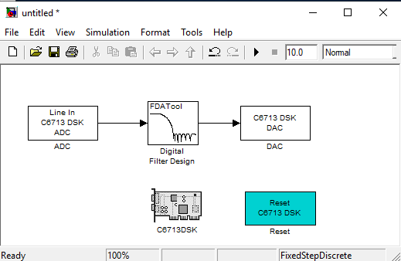

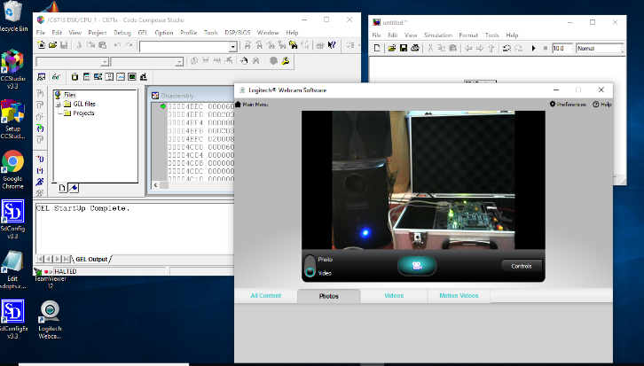Figure 3. The Model In the Matlab

Figure 4. DSP Trainer Kit with Remote Laboratory-Based DSK TMS320C6713

Figure 3 and 4 are the results of a system test that has been performed. In Figure 4, the left part is visualizated from the model design of DSP system that has been created as well as the display of the results of the signal/output in the form viewer Osciloscop. While on the right is shown the results of monitoring with the webcam in the trainer in the laboratory with the aim of the user can observe the design results in the output.

In accordance with the research objectives that have been formulated, the Internet network used has an important role so that users can access the learning media of PDS-based remote laboratory that has been created to learn the material about filters Digital. Testing was conducted to see if the overall system had been well integrated and also the performance of the systems visualizations in the Internet network conditions available.

In one test, tests were conducted four times to ensure that the system and the trainer Kit worked well, and clearly performed visual feedback.

Table 1. Result of the FIR Low Pass Filter Testing

|  |  |  |  |  |
| --- | --- | --- | --- | --- |
| **No** | **Trial** | **Connect Server Status** | **Running Program** | **Visual Feedback Delay (Second)** |
| 1 | Trial 1 | *Succes* | *Running* | 0,34 |
| 2 | Trial 2 | *Succes* | *Running* | 0,28 |
| 3 | Trial 3 | *Succes* | *Running* | 0,14 |
| 4 | Trial 4 | *Succes* | *Running* | 0,54 |

From the first test results on the low pass filter material, all the software is well-integrated, the hardware can work well, and visual feedback can display the experiment results well despite the time delay. Delay timer or delay in feedback is calculated based on the time lag that occurred while running the program results with the real actualization in DSK TMS 320C6713 displayed on Web Cam as visual feedback. However, the visual feedback is still relatively small, which results in a delay that occurs in less than 1 second.

The second test is done in the High pass filter type IIR material, but with the condition of the server computer using the campus Internet network and the computer client using the mobile Internet network. The difference between the Internet network used is intended to see the impact of Internet network on the overall system, and also to simulate when the trainer kit is accessed from outside the campus area.

Table 2. Result of the IIR High Pass Filter Testing

|  |  |  |  |  |
| --- | --- | --- | --- | --- |
| **No** | **Trial** | **Connect Server Status** | **Running Program** | **Visual Feedback Delay (Second)** |
| 1 | Trial 1 | *Succes* | *Running* | 0,89 |
| 2 | Trial 2 | *Succes* | *Running* | 0,97 |
| 3 | Trial 3 | *Succes* | *Running* | 1,01 |
| 4 | Trial 4 | *Succes* | *Running* | 1,05 |

From the results of the second test, the concept of remote laboratory applied can be run well, but there is still a greater delay with the condition of different ineternet network. The amount of delay that occurs is still relatively low with the biggest delay is 1.05 seconds. Overall from the test results that have been done, the trainer kit that has been made with remote laboratory based shows quite good performance, although there are delays that occur in the visual feedback Viewer. It is influenced by the Internet network used. By Kerna It was a smooth and stable Internet network that the system can run with maximum.

The learning Media in this study has some advantages compared to some studies that have been done before. The first advantage is that in one learning medium, users can learn some DSP system applications directly and in real time. The second advantage is with the remote laboratory system, users can experiment without limited time and space.

1. CONCLUTION

Based on the research that have been done, can be drawn some conclusions as follows:

1. Trainer DSK TMS320C6713 based remote laboratory can be used as digital filter system props and audio effect in digital signal processing learning.
2. One media learning DSP based remote laboratory can be accessed by a single user who is given access by Remote Desktop system using TeamViewer 12 software at a time.
3. The remote Desktop system used can be run over LAN, WAN, and Internet networks.
4. Internet network conditions on the computer server have an influence on the magnitude of the result of the simulation system display in the computer client on the remote laboratory based DSP Media.

REFERENCES

[1] Jhon G. Proaksis dan Dimitris G. Manolakis. “Digital Signal Processing. Principle, Algorithms, and Application. Third edition.” *Pretice-Hall.Inc*. 1996. Page 5.

[2] F. O. Sacntos P. Tukan dan Sintadewi Julian. “Media Pembelajaran Programable Logic Controller berbasis Remote Laboratory menggunakan Jaringan Internet.” *JETri*, Vol. 15, No. 1, Hlm. 13-28, P-ISSN 1412-0372, E-ISSN 2541-089X, Agustus 2017.

[3] Gustavsson, I., Nilsson, K., & Zackrisson, et.al, (2009). “On objectives of instructional laboratories, individual assessment, and use of collaborative remote laboratories.” *IEEE Transactions*, vol. 2, No. 4, pp. 263-274, 2009.

[4] Gustavsson, I., Nilsson, K., & Zackrisson, et.al, (2009).” On objectives of instructional laboratories, individual assessment, and use of collaborative remote laboratories.” *IEEE Transactions*, vol. 2, No. 4, pp. 263-274, 2009.

[5] W. J. Shyr. “Development and Evaluation of Mechatronics Learning System in a Web-Based Environment.” *The Turkish online Journal of educational Technology,* Volume 10 Issue1, Januari 2011.

[6] Rivat Beneviste and Cem Unsalan. “Hands-on DSP Education through experiment.” *International Journal of Electrical Enginering Education,* Volume 49, Number 3, Jully 2012.

[7] Michael G. Morrow et all. “Enhancing the TMS320C6713 DSK for DSP Education.” *Proccedings of American Society for Enginering Education Annual Conference*, 2005.