Smart Traffic Light based on IoT and mBaaS using High Priority Vehicles Method

Muhammad Izzuddin Mahali
Department of Electronics and Informatics Education
Yogyakarta State University
Yogyakarta, Indonesia
izzudin@uny.ac.id
Bekti Wulandari
Department of Electronics and Informatics Education
Yogyakarta State University
Yogyakarta, Indonesia
bektiwulandari@uny.ac.id
Eko Marpanaji
Department of Electronics and Informatics Education
Yogyakarta State University
Yogyakarta, Indonesia
eko@uny.ac.id
Umi Rochayati
Department of Electronics and Informatics Education
Yogyakarta State University
Yogyakarta, Indonesia
umi@uny.ac.id
Satriyo Agung Dewanto
Department of Electronics and Informatics Education
Yogyakarta State University
Yogyakarta, Indonesia
satriyoad@uny.ac.id
Nur Hasanah
Department of Electronics and Informatics Education
Yogyakarta State University
Yogyakarta, Indonesia
nurhasanah@uny.ac.id

Abstract-An increase of the number of vehicles which is not followed by the number of roads can lead to the increase of congestion, especially in big cities. Regulation of law no 22 Year 2009 explains that there are seven types of vehicles prioritized on the road. This research aims to build a Smart Traffic Light as a solution with the goal of making the prioritized vehicle journey smooth when crossing the road with Smart Traffic Light. The proposed system is "Smart Traffic Light on IoT and mBaaS (Mobile Backend As a Service) using High Priority Vehicles Method". The Smart Traffic Light has three important parts, including: (1) Smart Traffic Application; (2) Smart Traffic Controller; and (3) mBaaS. Prioritized vehicle drivers cross the road using the Smart Traffic Application when they are in an emergency situation. Smart Traffic Application and Smart Traffic Controller communicate using mBaaS. Smart Traffic Application has a vehicle track search facility as well as identification of traffic light location. A few meters before crossing, Smart Traffic Application will send the location to mBaaS and continue to be read by Smart Traffic Controller using internet. If it meets the criteria of High Priority Vehicle, then Traffic Light will be changed to green in the same path. The results show that when testing the data rate from Smart Traffic Application to Smart Traffic Controller, it takes no later than 8.15 seconds and 1.2 seconds (the fastest) with the average data transmission time of 3.39 seconds. Smart Traffic Light is able to identify the direction of the vehicle before passing through the Smart Traffic Application.
Keywords—smart traffic light, IoT, mBaaS

Introduction
“Internet of Things (IoT) is a network of physical objects embedded in electronics, software, sensors and connectivity which enables it to achieve greater value and services by exchanging data with manufacturers, operators and / or other connected devices. Each unique thing is identified through an embedded computing system, but it is able to operate within the existing Internet infrastructure. So far, IoT is the most closely related to machine-to-machine (M2M) communications in manufacturing and electricity, petroleum, and gas. Products built with M2M communication capabilities are called smart or smart systems (e.g. smart label, smart meter, smart grid sensor). According to research results obtained from Juniper’s study, there is a growth of IoT devices three times greater from 2016 to 2021. According to the results of research from Juniper, it is estimated that the number of IoT equipment connected to the internet either device, sensor or actuator is approximately more than 46 billion within the next four years.
Mobile Backend as a Services (mBaaS) is one of the categories of cloud computing services that are usually used by mobile application developers. MBaaS helps developers by connecting applications with backend cloud database as well as other features such as user management, push notification and Authentication integration. These services are provided through the support of Software Development Kits (SDK) and Application Programming Interface (API). The Cloud Computing platform, which supports all smart agents, empowers specialized resources [1]. Internet of Things connected with mBaaS is able to create smart systems that can be used with various purposes. Integrated IoT and Cloud computing applications enabling the creation of smart environments such as Smart Cities need to be able to (a) combine services offered by multiple stakeholders and (b) scale to support a large number of users in a reliable and decentralized manner [2].

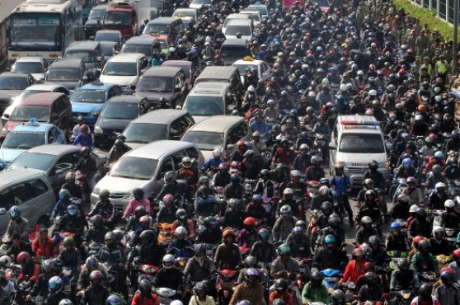
Figure 1 An Ambulance Stucked In Traffic Jam
According to Law No. 22 of 2009 on Road Traffic and Transportation Article 134 related to road users, those who have the primary right to take precedence are listed as follows: (1) fire-fighting vehicles carrying out duties (2) ambulances carrying sick people (3) vehicles to provide assistance to Traffic Accidents (4) vehicles led by the State Institution of RI (5) vehicles of leaders and officials of foreign countries as well as international institutions who are guests of the state (5) a funeral parade/procession (7) convoys and / or vehicles for particular circumstances.
A good driving behavior is shown when there is an ambulance, they should give a way to it. However, when at the intersection of roads that have traffic light facing long congestion even up to hundreds of meters, ambulance sirens are not heard up to the vehicle at the end of the traffic light. Then, the ambulance has to wait for its turn to cross the intersection as shown in Fig.1.

Related Work
Another traffic light system is also proposed by [3] who proposes intelligent traffic signal control system by connecting RFID technology system, Microcontroller Unit, Cloud storage and Android App. In a study proposed by [3], when implemented in real terms RFID utilization, it would have difficulty when it is in a junction that had long congestion. RFID technology has difficulty in detecting vehicle distance. In different scenarios, if failing in detecting using RFID, android Application can be used. In the study [3], the number of points passed by the vehicle and how the alternative methods in the detection of lanes and the location of the crossing which is passed are not mentioned.
Firebase usage as mobile Backend as a Service is the use of database in the form of Cloud. The utilization of firebase in the IoT field has been done by [4]. The study discussed the use of cloud databases and authentication used for home automation. Firebase has many features such as Analytical, Authentication, Cloud Messaging, Real-Time Database, Storage, REST, Hosting, Test Lab, Crash Reporting and Cloud Functions [4]–[6]. Utilization of Scientific Cloud (Infrastructure as a Service) in IoT [7] can bridge the communication between hadware that has limited ability in data access. Things in IoT can be either input sensor or output actuator [8], [9].
The research of Smart Traffic Light Solution for High Priority Vehicle has been done by [10]. This study is devoted to ambulance that will be given a priority when crossing the intersection. In the research that has been done using the parameters Amount of ambulance requesting, the ambulance emergency level, minimum distance and waiting time Smart Traffic Light Solution for High Priority Vehicle research have been conducted by [10].

Proposed Methodology

System Diagram
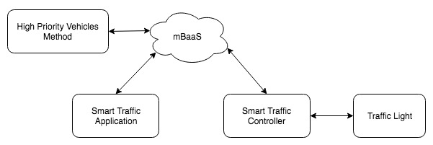
Fig. 2 General System Diagram

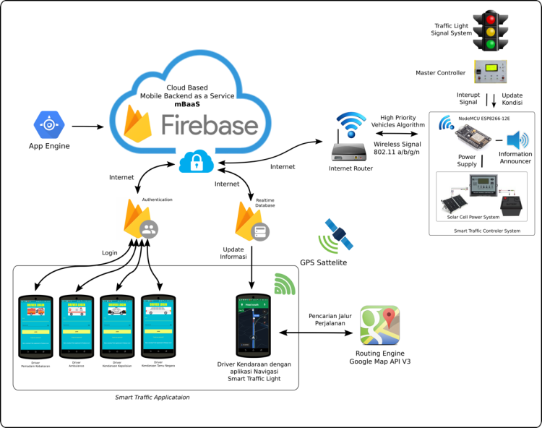
Fig. 3 System Diagram Detail
Broadly speaking, Smart Traffic Light System based on IoT and mBaas using High Priority Vehicles method has five main parts as in Fig-2. (1) Smart Traffic Application (2) Smart Traffic Controller (3) mBaaS (4) High Priority Vehicles Method and (5) Traffic Light.

Mobile Backend as a Service
The Smart Traffic Light system uses the Backend as a Service (mBaaS) Firebase mobile service in the form of Realtime Database, Authentication, Android SDK and REST Suport services. The firebase usage allows the use of data stored in the cloud. Communications that occur between Smart Traffic Controller System and Cloud utilize API (Application Program Interface) [5]. Smart Traffic Application communicates with Firebase using Android SDK.

Smart Traffic Application
Smart Traffic Application is an Android-based Operating System application used by vehicle drivers. This application has authentication login facility to maintain system security as well as identification of the vehicle type. In addition to using the application authentication feature, smart traffic also has Cloud Database facility that allows storage of cloud-based data (Cloud Database). The use of GPS facility from smart phone is used to know the position of the vehicle in real time. To support the map and navigation path, Smart Traffic Application uses API services from Google Maps [11] that provide digital map data, navigation routing and traffic density.

Smart Traffic Controller
Smart Traffic Controller is a hardware device that plays as Things in the Internet of Things system [3], [4], [12]. Smart Traffic Controller uses nodeMCU main device with base ESP-8266. To support energy independence, this system uses a battery with a solar cell that is used to recharge the battery. Traffic Light on this system is APPIL traffic light system that has been installed as a traffic control tool.
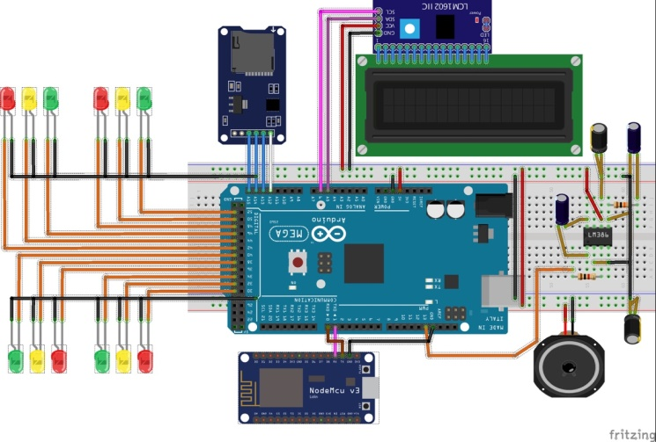
Fig. 4. Smart Traffic Controller System
Smart Traffic Controller Fig 3 is a hardware device used to control Traffic Light. This system consists of Controller Chip based on ESP8266 which has the function to read Realtime Database Firebase data using internet. The system is equipped with speakers used to play sound when there is a vehicle with a High Priority Vehicle crossing the traffic light. Voice mail files are stored in memory cards. The output is in the form of 12 output lines that functioned as input Traffic Light at the time of simulation.

High Priority Vehicle
Smart Traffic Light can be according to the rules of law requiring the system to apply High Priority Vehicles on App Engine. High Priority Vehicles are the implementation of regulation no 22 of 2009 which give priority of certain vehicles when passing on the road including at the intersection. The algorithm used to determine the most prioritized vehicles passes in the same location was the Analitycal Hyrarchy Process base. The determination of the value of High Priority Vahicles refers to the Journal written by [10] by introducing High Priority Vehicles (HPV) using 4 parameters while in this study three pieces were used, namely:
- The type of vehicle is a sequence of priority passing vehicle users grouped in three types (Fire extinguisher, ambulance and vehicles with special interests)
- The minimum distance is the calculation between the vehicle and the traffic light
- Traffic Density Level

Implementation of Working

Smart Traffic Application
Smart Traffic Application is developed using android studio software and Java programming language. The Smart Traffic application has the following features:
- Cloud Database (Firebase)
- SignUp and Login
- Location Determination by using GPS
- Loading Referral Hospital List for Locations
- Selecting a Destination Location using the map
- Displaying the Route of vehicle travel
- Displaying the level of Road density
- Location determination of Smart Traffic Light System
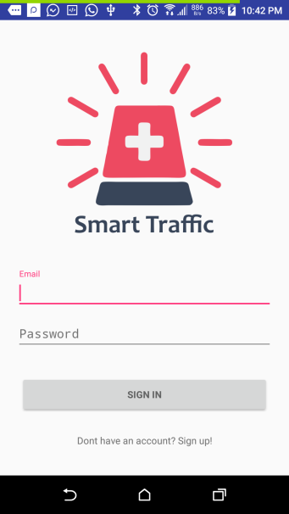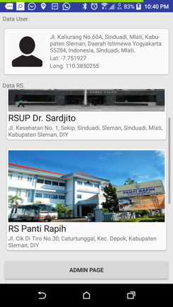
Fig. 5. Smart Traffic Application Authentication
Smart Traffic Application has a service for user account registrar. It aims at facilitating the addition of application users. Smart Traffic Application users should always be connected to the internet because user location updates will always be sent to the Firebase. When the Smart Traffic application is first opened, the user is prompted to enter a login username and password. All Smart Traffic Application users can use the same application simultaneously on the same or different Smart Traffic Light location.
Using the GP in the Smartphone Application will send the vehicle location update data to the Firebase using an internet connection such as a journal written by [8] that mentions that Science Cloud for IOT that we can use servers accommodating calculations on the Internet of Things system. Smart Traffic Application utilizes Google Map API V2 [11] to access digital maps, route searches, distance calculations, Smart Traffic System Location search and Traffic Level Traffic. This application is able to be used jointly by other users with unlimited amount.

mBaaS
Realtime Database Firebase Services are as Cloud data storage base for the communication bridging Smart Traffic Controller with Smart Traffic Application. Realtime databases on firebase have data structures in the JSON format (Java Script Object Notation) shown in bottom. The data which are saved include: user profile, traffic light location, Hospital location and Trip Log Request. Each location of traffic light that is added in the database is added with the detailed data about the traffic light. The stored data include name, location, coordinates, number of lights, detailed condition of each lamp direction, lamp flame condition, status request, emergency state, voice control and also activation threshold reference distance.

Traffic Light on Route Vehicle
Smart Traffic Light System has stored all coordinates of the traffic light location. The system will identify the path as well as the amount of traffic light that the vehicle will pass. The best route search takes the Google Maps V2 digital map. Once the route is obtained, it will be followed by searching the location of traffic light that has been inputted in the database.
Smart Traffic Application continues to update user position and distance with the nearest traffic light. The calculation of the distance between two coordinates of longitude and latitude is calculated using the Harversine formula [13].
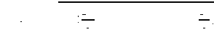
d is the distance between two point with longitude and latitude and r is the radius of earth

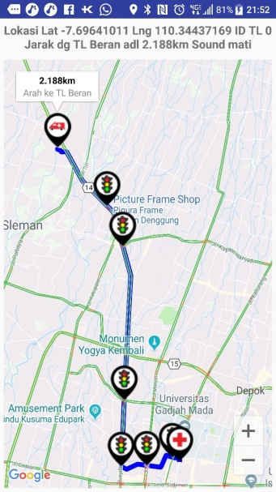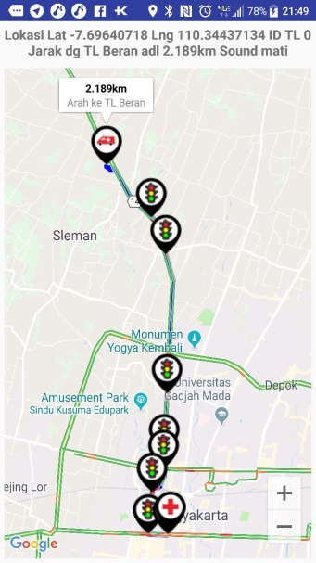
Fig. 6 Smart Traffic Application Route
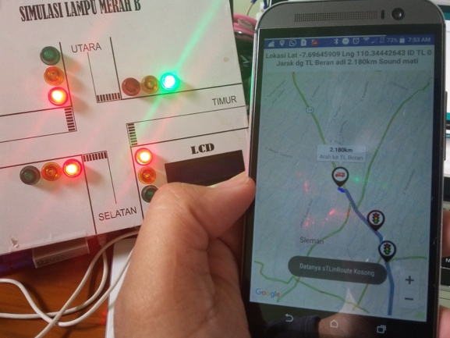
Fig. 7 Smart Traffic Application Route
High Priority Vehicles algorithm on this system is used to determine the path priority which will cross first. The distance between the vehicle and the nearest traffic light will be shown on the following icon of the nearest Traffic Light when the application is used in emergency conditions as shown in Fig-6. Several meters before the vehicle crossing, the green light signals will be generated on the same line with the vehicle in an emergency so that the path accumulation on the path no longer exists.

Internet of Things
The Internet of Things Principle on Smart Traffic Controllers uses NodeMCU (ESP8266-12E) devices. NodeMCU has the facility to communicate with other devices by using wireless 802.11 that is able to communicate utilize port 43 (https) so that it makes the communication with Cloud Server becomes more secure. NodeMCU when communicating with mBaaS uses Authentication Key. The Database in Real Time Database with JSON format is translated directly in NodeMCU before send signal control to the actual Traffic Light.

Data Delivery Speed
Smart Traffic Application and Smart Traffic Controller communicate using internet network. The level of signal stability and internet speed depends on location and internet service provider. Table-1 is the test results of speed data transmission from the application and is received by the
hardware Smart Traffic Light. The test of data transmission is done 10 times. Testing is done by utilizing manual configuration form that has been integrated in the application Fig-8. The calculation of time from the change in application happens until the data are received by Smart Traffic Controller. Data were obtained for each direction for north light traffic data with an average of 3,702 seconds, for the average speed of the eastern acceptance of 2.968 seconds, for the average speed of traffic data of the southern light is 1.857 and the last average speed of traffic reception Light west is 5.07 seconds. The fastest time of data transmission is 1.2 seconds and the longest time is 8.15 seconds. The average data transmission speed is 3.39 seconds.

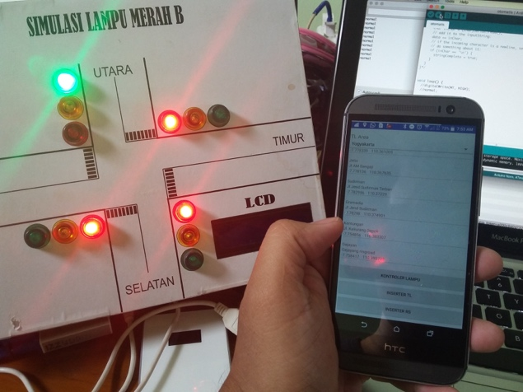
Fig. 8. The Data Delivery Speed Test
Table 1 Speed of data transmission
Test Data | Data Delivery Time (s)
Test Data | North | East | South | West
Data 1 | 8.15 | 2.39 | 3.09 | 4.03
Data 2 | 4.05 | 2.3 | 1.35 | 4.75
Data 3 | 3.05 | 1.64 | 1.94 | 3.1
Data 4 | 3.53 | 2.41 | 1.87 | 2.39
Data 5 | 4.29 | 5.38 | 1.55 | 6
Data 6 | 2.08 | 3.28 | 1.36 | 13
Data 7 | 2.29 | 4.05 | 2.27 | 5
Data 8 | 3.26 | 2.35 | 1.2 | 3.27
Data 9 | 2.62 | 2.92 | 2.09 | 6.16
Data 10 | 3.70 | 2.96 | 1.85 | 3
Average | 3.702 | 2.968 | 1.857 | 5.07

Conclusion
In this paper, a solution is proposed to reduce the travel time of the vehicle with special criteria (Fire Department, Ambulance, Special Vehicle) prioritized on the road. The travel time of the vehicle due to being trapped in long queues in traffic light can be reduced with Smart Traffic Light technology. Vehicle users can activate the Smart Traffic Application when in an emergency situation to get to a certain location e.g. ambulance that will take the patient to the hospital. Smart Traffic Application will find the fastest route and identify the Smart Traffic Light location to be traversed. Smart Traffic Light Application will send a location update to mBaaS which will be read by Smart Traffic Controller. Smart Traffic Controller will send commands to Traffic Light to provide green light signals before the vehicle passes on the same line. Smart Traffic Light can be used together for the same location or different location.

References
[1] G. Fortino, A. Guerrieri, W. Russo, and C. Savaglio, “Integration of agent-based and Cloud Computing for the smart objects-oriented IoT,” in Proceedings of the 2014 IEEE 18th International Conference on Computer Supported Cooperative Work in Design, CSCWD 2014, 2014.
[2] J. Gubbi, R. Buyya, S. Marusic, and M. Palaniswami, “Internet of Things (IoT): A vision, architectural elements, and future directions,” Futur. Gener. Comput. Syst., vol. 29, no. 7, pp. 1645–1660, 2013.
[3] B. J. Saradha, G. Vijayshri, and T. Subha, “Intelligent traffic signal control system for ambulance using RFID and cloud,” 2017 2nd Int. Conf. Comput. Commun. Technol., pp. 90–96, 2017.
[4] A. Daramas, S. Pattarakitsophon, K. Eiumtrakul, T. Tantidham, and N. Tamkittikhun, “HIVE: Home Automation System for Intrusion Detection,” in Proceedings of the 2016 5th ICT International Student Project Conference, ICT-ISPC 2016, 2016, pp. 101–104.
[5] N. Singh, “Study of Google Firebase API for Android,” Int. J. Innov. Res. Comput. Commun. Eng., vol. 4, no. 9, pp. 16738–16743, 2016.
[6] Firebase, “Firebase Realtime Database | Firebase,” April 13, 2017. [Online]. Available: https://firebase.google.com/docs/database/.
[7] A. Menon and R. Sinha2, “IMPLEMENTATION OF INTERNET OF THINGS IN BUS TRANSPORT SYSTEM OF SINGAPORE,” Asian J. Eng. Res., vol. I, no. 4, pp. 8–17, 2013.
[8] B. B. P. Rao, P. Saluia, N. Sharma, a Mittal, and S. V Sharma, “Cloud computing for Internet of Things & sensing based applications,” Sens. Technol. (ICST), 2012 Sixth Int. Conf., pp. 374–380, 2012.
[9] E. Marpanaji and M. Izzuddinmahali, “Internet of Things for Survey of Renewable Energy Potential ( SREP ) as the Basis for Hybrid Power Plant Development,” vol. 06003, p. 6003, 2016.
[10] D. Dang, J. Tanwar, and S. Masood, “A Smart Traffic Solution for High Priority Vehicles,” in 2015 1st International Conference on Next Generation Computing Technologies (NGCT-2015) Dehradun, India, 4-5 September 2015, 2015, no. September, pp. 467–470.
[11] G. Developers, “Google Maps Android API | Google Developers,” Google Developers, 2015. [Online]. Available: https://developers.google.com/maps/documentation/android-api/.
[12] R. Davies, “The Internet of Things The Internet of Things,” no. May, p. 6, 2015.
[13] N. Chopde and M. Nichat, “Landmark Based Shortest Path Detection by Using A* and Haversine Formula,” GH Raisoni Coll. Eng. …, 2013.

