CLASSIFICATION BETWEEN NORMAL HEARTBEAT AND ANGINA PECTORIS IN PHONOCARDIOGRAPH BY USING NEURAL NETWORK

Dyah Kurniawati Agustika*), Sumarna, Juli Astono, Agus Purwanto,

Department of Physics Education,

Universitas Negeri Yogyakarta,

Jl. Colombo No. 1, Yogyakarta, Indonesia

*)E-mail: [dyah_kurniawati@uny.ac.id](mailto:dyah_kurniawati@uny.ac.id)

ABSTRACT

Data from the Ministry of Health shows that heart disease is the highest cause of death in all ages after stroke. This death rate will continue to increase if heart disease is not treated early. Delay in the handling of patients with cardiac abnormalities due to the limited heart detection devices especially in health facilities in remote areas due to the high cost of heart detection devices such as electrocardiographs (ECG). For this reason, this study aims to build a cheap but reliable tool for detecting heart abnormalities to be applied to various health centers in remote areas. A phonocardiography (PCG) device has been built that can record acoustic heartbeat signals. The final step in this research is to build an artificial intelligence-based pattern recognition system to determine the type of heart defects suffered by patients. The results of PCG output have been analyzed using Short Time Fourier Transform and the results of the analysis found that the output of the system is consistent, this shows the system has good reliability. PCG has been tested on heart disease patients at PKU Muhammadiyah Hospital to differentiate heart rates from patients with various heart abnormalities. In this last year's research an artificial intelligence-based pattern recognition system will be built using the Reverse Propagation Artificial Neural Network. The research proves that the system can recognize a healthy heart rate and heart rate with Angina Pectoris up to 90%. After PCG validation, it will be tried to be applied in Giritontro health center which does not have a detection of heart abnormalities so that it can help early treatment of heart disease.

INTRODUCTION

n this study a heart rate recording system has been developed using Phonocardiography (PCG). PCG is one method to monitor abnormalities in the heart is a consultation technique or technique to evaluate the acoustic nature of heart sounds, including the intensity, frequency, duration, amount, and sound quality. Consultation techniques commonly performed by medical personnel is to use a stethoscope. However, diagnosis based on heart sounds through an electronic stethoscope requires special skills and is very difficult. Besides the use of a stethoscope can lead to subjective judgments by users, which causes a variety of perceptions and interpretations, thus affecting diagnostic accuracy. Stethoscopes can also only hear certain heart sound components, for low frequency components cannot be heard while these components sometimes carry unhealthy heart cues (Abbas & Bassam, 2009), (Kao & Wei, 2011)  
The Phonocardiography (PCG) system was developed to correct stethoscope deficiencies. PCG is a non-invasive diagnostic technique that can help compare cardiac acoustic signals obtained from normal and diseased hearts (Sinha, Aggarwal, & Das, 2007). Phonocardiography (PCG) signals can be utilized more efficiently by doctors when they can be displayed visually thereby eliminating the element of subjectivity (Cherif, Debbal, & Bereksi-Reguig, 2010) ... PCG is a medical aid that is cheap and simple and easy to use because it can be used by anyone. When compared with echocardiograph which is also a means of detecting heart abnormalities through sound, PCG is superior because it is economical and practical because echocardiography requires large costs and special expertise. If properly developed, PCG can be used in various hospitals and even puskesmas so that early detection of cardiac abnormalities in patients can be carried out and reach a wide range of people.

A PCG system consisting of the piecechest, acoustic impedance chamber, condenser mic and pre-amp has been built. This research began by designing and realizing a device that can record acoustic heartbeat signals. Piecechest membrane, acoustic impedance chamber, condenser mic character and pre-amp circuit are chosen so that a device that can record the heart rate is representative and reliable. This tool is intentionally not equipped with a series of filters so that all information can be recorded, because the cues that are often regarded as noise can be very important information related to the diagnosis of cardiac abnormalities. PCG heart record results can be seen in Figure 1.1

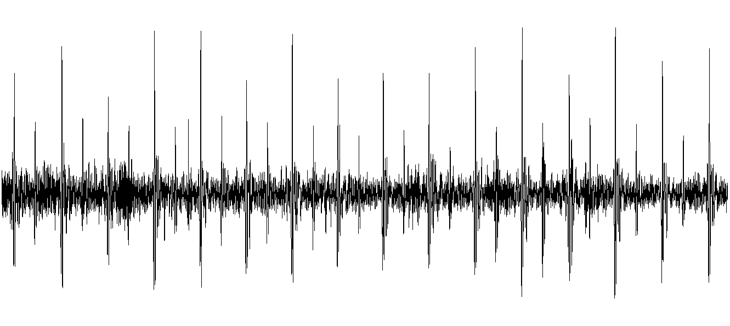

Figure 1. Output of PCG

To determine whether the device is made repeatable and reliable, PCG cues are analyzed first using Fourier transforms. This signal analysis is used to determine whether the system has a consistent output. The results of PCG output analysis from the same patients analyzed by Fourier transform showed the signal consisted of several frequency components. Of the five heart rate recordings in the same patient, the signal shows consistency with the same frequency formation. This shows that PCG has been made very reliable and consistent because for the same patient, but recorded in different circumstances shows the existence of relatively the same dominant frequency content.

Fourier transform converts PCG signal signals in the time domain into the frequency domain. However, analysis using Fourier transforms has a weakness because the timing information about what happens to the signal cannot be known. In addition, Fourier's analysis can only be applied to stationary signals while human heartbeats, especially those that are not healthy, are stationary. Therefore to complete the PCG instrument so that it can detect heart abnormalities, the right method is needed. The right analysis tool certainly produces an adequate analysis of the parameters. Processing adequate analysis of the parameters certainly produces adequate information as well.

Artificial Neural Network (ANN) is a reliable pattern recognition system because of its massive parallel structure, but also has the ability to learn from experience. ANN can be used for data classification, as long as it is trained first.

The accuracy of the classification depends on the efficiency of the training. Knowledge gained by learning experience is stored in the form of connection weights, which are used to make decisions on new inputs. Problems in designing an ANN are: (i) network topology, (ii) training algorithm and (iii) neuron activation function. (Al-Naima, Ali, & Mahdi, 2008)

RESEARCH METHOD

1. Short Time Fourier Transform Analysis

PCG signal is a type of non-stationary signal, so the extraction of features with Fourier transform cannot be done because at this transformation the time information that signifies signal oscillation cannot be known. This can be overcome by using windowing techniques with Short Time Fourier Transform (STFT). STFT can also only be used on stationary signals, while heartbeats are non-stationary signals. STFT is only used here to find out when oscillations occur and when changes in frequency occur. From the results of STFT we will get the coefficient values that provide information about the signal

b. Neural Network Analysis

The structure of back propagation is illustrated in Figure 2. In Figure 2 the network consists of three layers namely the input layer, the output layer and the hidden layer. Back-propagation networks can consist of many hidden layers. At the top of the diagram there is a vector which is an input. The target vector is the desired output as a result of the system's response to the input vector. Synaptic weights between the lower layer node and the upper layer are connected randomly at the beginning of the training process. As a result, the actual output of the system ie the vector will have a different value than the target vector. Correction signals that are proportional to the target vector and the actual output vector of the system will be entered into the system by an external computer. This correction signal adjusts the synaptic weight of the network so that the output produced by the system matches the target vector.

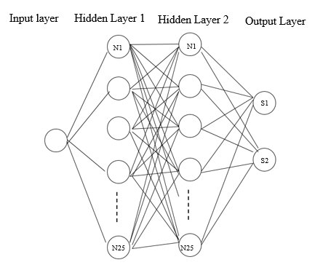

RESEARCH RESULT

Samples are grouped into two, namely STFT results in the form of the frequency of maximum amplitude taken for the purpose of feature extraction, namely the healthy heart group and the heart group with Angina Pectoris, so that the output of artificial neural network architecture are two neurons.

From the analysis results, the optimum hidden layer layer consists of two layers and the number of neurons is 25. After weight adjustment, the results show that the system can recognize samples with an accuracy level of 90 percent.

Reference

Abbas, A. K., & Bassam, R. (2009). *Phonocardiography Signal Processing*. *Synthesis Lectures on Biomedical Engineering* (Vol. 4).<http://doi.org/10.2200/>S00187ED1V01Y200904BME031

Al-Naima, F. M., Ali, A. H., & Mahdi, S. S. (2008). Data acquisition for myocardial infarction classification based on wavelets and neural networks. *2008 5th International Multi-Conference on Systems, Signals and Devices, SSD’08*, 3–8. [http://doi.org/10.1109](http://doi.org/10.1109/)/SSD.2008.4632817

Bhattacharyya, N. and Bandhopadhyay, R., 2010, *Nondestructive Evaluation of Food Quality,*

Springer Heidelberg Dordrecht London

Cherif, L. H., Debbal, S. M., & Bereksi-Reguig, F. (2010). Choice of the wavelet analyzing in the phonocardiogram signal analysis using the discrete and the packet wavelet transform. *Expert Systems with Applications*, *37*(2), 913–918. [http://doi.org/10.1016](http://doi.org/10.1016/)/j.eswa.2009.09.036

Hoyos, C. C. (2013). Heart Sound Segmentation in Noisy Environments, 254–263.

Kao, W. C., & Wei, C. C. (2011). Automatic phonocardiograph signal analysis for detecting heart valve disorders. *Expert Systems with Applications*, *38*(6), 6458–6468. [http://doi.org/10.1016](http://doi.org/10.1016/)/j.eswa.2010.11.100

Murillo Rendón, S., Hoyos, C. C., Travieso-Gonzales, C. M., & Castellanos-Domínguez, G. (2013). Phonocardiography signal segmentation for telemedicine environments. *Lecture Notes in Computer Science (including Subseries Lecture Notes in Artificial Intelligence and Lecture Notes in Bioinformatics)*, *7903 LNCS*(PART 2), 124–134. [http://doi.org/10.1007](http://doi.org/10.1007/)/978-3-642-38682-4_15

Patidar, S., & Pachori, R. (2012). A continuous wavelet transform based method for detecting heart valve disorders using phonocardiograph signals. *Convergence and Hybrid Information Technology*, 513–520. Retrieved from [http://link.springer.com/chapter/10.1007](http://link.springer.com/chapter/10.1007/)/978-3-642-32692-9_64

Saminu, S., Ozkurt, N., & Karaye, I. A. (2015). Wavelet feature extraction for ECG beat classification. *IEEE International Conference on Adaptive Science and Technology, ICAST*, *2015-Janua*[. http://doi.org/10.1109](http://doi.org/10.1109/)/ICASTECH.2014.7068118

Phaisangittisagul, E., *Signal Processing using Wavelets for Enhancing Electronic Nose*

*Performance* : 2007 ProQuest Information and Learning Company

Rao, R.M. and Bopardikar, A.S., 1998, *Wavelet Transform: Introduction to Theory and*

*Applications*, Addison Wesley Longman Inc., Massachusetts

Shlens, J., 2009, *A Tutorial on Principal Component Analysis*, New York University, New

York

Sinha, R. K., Aggarwal, Y., & Das, B. N. (2007). Backpropagation artificial neural network classifier to detect changes in heart sound due to mitral valve regurgitation. *Journal of Medical Systems*, *31*(3), 205–[209. http://doi.org/10.1007](http://doi.org/10.1007/)/s10916-007-9056-1