**Improving Students’ Speaking Skills in Generating Idea**

**through New Concept of Mind Mapping Technique**

Dwi Setiyawan   
*Madrasah Muallimaat Muhammadiyah Yogyakarta*Yogyakarta, Indonesia  
dwisetiyawan3103@gmail.com

*Abstract*— This study is conducted to describe the implementation of mind mapping to improve students’ speaking skills in generating idea. Speaking becomes an important and challenging skill in language learning. Speaking is needed in many aspects Such as in communication and in educational aspect. However, many students have problems in their speaking such as lack of vocabularies, lack of grammar knowledge, and lack of generating ideas. Then, the teacher should look for teaching strategy to solve students’ problem in speaking. One of the strategies is using mind mapping. Hence, this study clarified in detail about how mind mapping helped students to improve their speaking in generating idea.

Keywords—mind mapping, speaking skill, generating idea, improve

# Introduction

Mastering language skills is needed in using language. Aydoğan (2014) argued that language learner used four concept basic language skills such as listening, speaking, reading and writing for a long time. By mastering language skill, people can communicate with each other easily. They can share their feeling, perception and thoughts. Besides, people can easily catch our thoughts when we mastered language skills.

Speaking is one of important skills should be mastered by every person to communicate with each other. Speaking is used to communicate with each other’s in daily conversation, educational purpose and business purpose. For the example, in educational purpose, practice conversation in front of the class. Then, the functions of speaking are express opinion, feeling, desire, and perception. To mastered speaking skill, we should aware with some aspect in speaking skills such as accuracy and fluency. Brown (2004) stated that there are two important speaker goals are accurate (clear, articulate, grammatically and phonologically correct) and fluent (flowing, natural).

Speaking is challenging skill for some students. Jannah and Fitriati (2016) supported that speaking English challenged for most Indonesia students. For some students, English language is as a second language*.* Some students have difficulties to speak in English because English language is different with their mother tongue. The difficulties faced by students at speaking such as pronunciation, grammatical and vocabulary.

The second problem, students are rarely to practice speaking in English. The frequencies of using English language of some students in Indonesia are very low. They are just speaking English in English class and at home when their relative supports them to practice speaking English. Then, Students have difficulties to share their thoughts. When the teacher asked students to speak in English, they have difficulties to share their thought. It is because they lack vocabulary, grammatical mistake and do not confidents.

The third, problems of some students are generating idea. They have difficulties to generate idea when they are speaking in English. For the example, sometimes when the teacher asks them to speaking in front of the class, they will be confused. Students did not know how to answer it or they have an idea to answer it but did not now to share it. In addition, when they have ide, they will just produce few sentences without using correct grammar.

Consequently, the teachers should deal with some strategy to help students improves their speaking skills especially in generating idea. In generate the idea, the teacher has used some techniques such as using games, brainstorming, picture-Cued Story Telling and mind mapping. Game is one of techniques that the teachers mostly use. Students more interest in learning process by using games as learning activities in the class. Furthermore, students have not felt sleepy by moving activities. Brainstorming is also appropriate technique to improve generating idea in speaking skills. When the teacher gave students problem then they can use brainstorming to solve the problem. Picture-Cued Story Telling uses to improve student’s speaking skills. Students easily share their thought by seeing Picture-Cued Story Telling. Then the last technique is mind mapping. Mind mapping is appropriate technique to improve speaking skills. The students can make a mind mapping before they are speaking. It is very helpful for students when they want to share their thought. When students familiar to use mind mapping, they can easily share their opinion and it can improve their speaking skill. When students make a mind mapping, they will write some keywords and important vocabularies which can help them in speaking. Finally, the writer was chose mind mapping as technique to help students improve their speaking skills.

# Statement of the Problem

In language learning, there are four basic skills in learning English language such as reading, writing, listening and speaking. From those skills, Speaking is one of challenging skills for students. Based on my observation at Madrasah Muallimaat Muhammadiyah Yogyakarta, there were several problems that were faced by students in their speaking such as; worry to make a mistake at using grammar and lack of vocabulary, lack of practice. First problem was worried when made a mistake in grammar. The students always asked to memorize the grammar by teacher. This situation made them worried at speaking in English. They were always thought about grammar. They were also worried when made a mistake. So, they share their thought with few sentences at the teacher asked them to speak in front of the class. Lack of vocabulary made them worried when speaking in English. Although the teacher asked students to memorize three vocabularies every day, they think that did not have enough various vocabularies to help them in speaking.

Second problem was lacking of practice. When the researcher asked students to interview using English language, they chose to use *bahasa*. The students were rarely spoken in English. They were spoken in English just in some situations such as the teacher asked to shared their perception, in English camp, and in English class. Then, the students were spoken in *bahasa* with their friends although their school used bilingual language English and Arabic.

.

# Literature Review

## Speaking

Speaking is one ways to communicate with other orally.Aydoğan(2014) shared that speaking is the productive skill in the oral mode. Speaking can help people to show their desire, perception, hope and feeling. Efrizal (2012) stated that one way to communicate which share ideas and thought a message orally is by speaking. Speaking is one of basic skill should be mastered by students. speaking is very useful in communication especially for second language learner. Efrizal (2012) argued that the students should be able to communicate with each other through English because they are as language learners who had learned English intensively. There are some points that we have to know in speaking such as; basic types of speaking, micro and macro skills of speaking and challenging of speaking.

## Basic types of speaking

There are five basic types of speaking such asimitative, intensive, responsive, interactive and Extensive (monologue). First is imitative. Imitative is activity when speaker copy vocabulary, phrase and sentences. Rahmawati and Ertin (2014) supported that This type of speaking requires the test takers to copy a word, phrase, or a sentence. Immitative is good activity to improve student’s pronounciation in speaking English. When students try to copy the speaker model, they can know how to pronounce word or phrase correctly. Imitative also have correlation with listening. Brown (2004) shared that the role of listening here is in the short-term storage of a prompt, just long enough to allow the speaker to retain the short stretch of language that must be imitated.

Second, in intensive speaking do not focus on grammatical and phonological. Rahmawati and Ertin (2014) speaking does not emphasize on pronunciation or phonological aspect. Brown (2004) shared that a second type of speaking frequently employed in assessment contexts is the production of short stretches of oral language designed to demonstrate competence in a narrow band of grammatical, phrasal, lexical, or phonological relationships (such as prosodic elements—intonation, stress, rhythm, juncture). Third types is responsive. Brown (2004) explained that responsive assessment tasks include interaction and test comprehension but at the somewhat limited level of very short conversations, standard greetings and small talk, simple requests and comments, and the like. Fourth types is interactive. Brown (2004) supported that the difference between responsive and interactive speaking is in the length and complexity of the interaction, which sometimes includes multiple exchanges and/or multiple participants. Thus, Rahmawati and Ertin (2014) add that the number of the speakers also matter as sometimes it needs more than two people in the conversation. The last is Extensive. Rahmawati and Ertin (2014) shared that extensive speaking involves a wide range of speech production. Also, the speaker will need to interact with the counter speakers, which could be answering question, making discussion.

## Mind Mapping

Mind mapping is a technique to generate the idea. Ernidawatiand Sutopo (2017) supported that mind mapping is a graphic representation of ideas ( usually generated via a brainstorming session). Mind mapping can help the students to gennerate idea for speaking purpose. Then, this technique can more efficient than brainstorming. Ernidawati and Sutopo (2017) stated that the result of the research showed that the score of mind mapping strategy was higher than brainstorming strategy. So, mind mapping can be an appropriate technique in generating the idea. Pua, C., Li, D., Lui, C., and Cheng, S. (2015) stated that mind-mapping could be an effective tool that helps students to associate new information to their existing knowledge. By using mind mapping students can use their knowledge to generate the idea. After make their own mind mapping hopefully students can easily share their though. The form of mind mapping also can motivate the students in learning process. Pua, C., Li, D., Lui, C., and Cheng, S. (2015) shared that mind-mapping could motivate students to learn through the use of colourful pictures and drawings.

# The Implementation of New Concept of Mind Mapping

Mind mapping is a good technique tohelps students speaking directly. AR Murni (2017) shared that mind mapping was an effective media because the mind mapping gave the students inspiration to speak directly. Students can write some keywod and difficult vocabulary in the mind mapping. It can help students in generating idea. When students can generate their idea in speaking, they can feel confident to shere their though without apprehensive about anything. In the some research explain about the effectivenes of using mind mapping to generate the idea. Some researchers shared that the effectivenes of using mind mapping because students can put some pictures, symbol and diagram. Anggraeni (2014) shared that mind mapping is an effective visual way to connect and organize our thoughts because it conducts the color, picture/symbol, and association. By using mind mapping students can share their though directly. Mind mapping also help students to memories important things. Anggraeni, 2014 stated that By using mind map, students can produce oral language in a coherent, cohesive, clear, organized, and memorable way, because its advantages are to describe, compare, classify, make sequence, and make a decision. Students can use mind mapping to generate idea not only in the class activity but also in daily life. It is can help students to improve thire speaking skill.

There are two concept of mind mapping in improving students’ speaking skills in generating idea. These concepts are very interesting and beneficial to use. The writer always uses it in every year teaching English.

## New Concept of Mind Mapping: Using Drawing Pictures

There were two ways how to improve students’ speaking skills in generatingidea such as write important vocabulary or sentences, try to remember with the point and generate the idea in mind mapping and practice. First, students had written some important vocabulary or important sentences related with the topic. Before I asked students to make their mind mapping, I always asked them to looking important vocabulary or sentences which related with the topic. Students could look important vocabulary or sentences in the texts that I gave before. They also search their source by themselves. After they had some important vocabulary or sentences, they made their mind mapping by using their creativity. Anggraeni (2014) shared that mind mapping is an effective visual way to connect and organize our thoughts because it conducts the color, picture/symbol, and association.

Second, mind mapping helped students to remember with the points in their discussin and help them to generate the idea. Students made their mind mapping with creatively. They draw pictures based on the characteristic of the topic. They used some color pens and made some pictures and graphics in their mind mapping. It could helped them to remember with the poins discussin that they want to share. Brinkmann (2003) as cited in Pua, C., Li, D., Lui, C., and Cheng, S. (2015) supported that the strong visual appeal of mind maps can speed up the learning process and help students to memories and recall information effectively. Then, when students could memorize their important points in their discussion, students could generate their idea. Students tried to generate their idea when made a mind mapping. They tried to organize their idea and the points that they were remembering when made mind mapping. AR Murni (2017) shared that mind mapping was an effective media because the mind mapping gave the students inspiration to speak directly.

#### Third, speaking practice helped students to improve their speaking in the generating idea. After looking some important vocabularies or sentences and write it on the mind mapping, it was important for students to had speaking practice. Based on our learning, students had improved their generating idea in speaking by practice. Students had significant improvement in their speaking in generating idea. It was because I asked the students to present their mind mapping in front of the class. Beside students also tried to remembering their thought before practice using their mind mapping which is made students more easily to generate their idea. (Anggraeni, 2014) stated that By using mind map, students can produce oral language in a coherent, cohesive, clear, organized, and memorable way, because its advantages are to describe, compare, classify, make sequence, and make a decision.

**Here are some examples of students’s result**

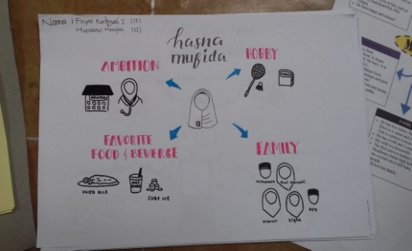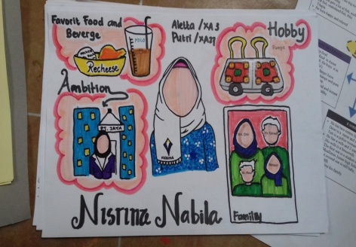

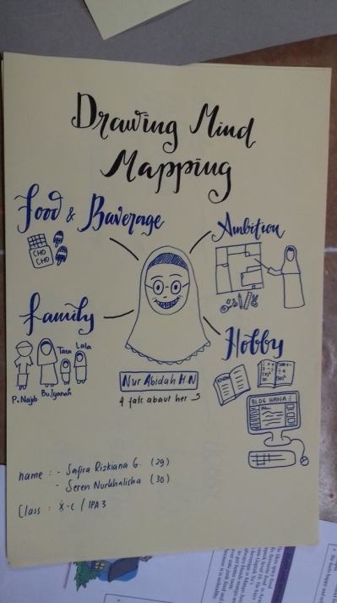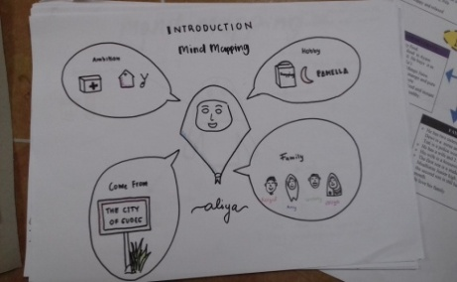

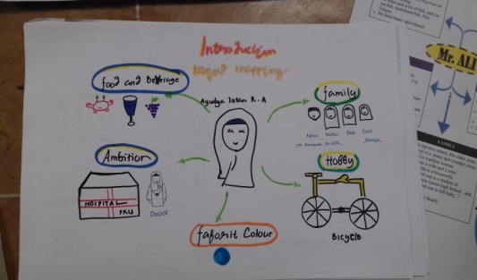

## New Concept of Mind Mapping: Using Canva.Com

*Canva* is a simplified [graphic-design](https://en.wikipedia.org/wiki/Graphic_design) tool website, founded in 2012. It uses a drag-and-drop format and provides access to photographs, vector images, graphics, and fonts. It is used by non-designers as well as professionals. The tools can be used for both web and print media design and graphics.

*Canva* is a tool that makes it possible to design anything and publish anywhere. With its user-friendly drag and drop tool and thousands of customizable templates, over 400 million designs from more than 10 million users across 179 countries have been created with Canva so far.

*Canva* is available in 100 languages and can be accessed in desktop browsers and mobile apps. This makes *Canva* accessible to practically everyone with Internet connection.

With *Canva*, you can easily create beautiful documents & designs for any occasion and purpose. From social media posts to presentations, you can browse more than 65,000 editable templates or you can start from scratch if you’re feeling adventurous.

*Canva* also makes it easy for you to access millions of stock images, illustrations, icons and fonts inside the app. Our media library content is available for use in all your designs. we can also store, organize and edit your images in a breeze, customize your templates and share them with your team to edit, and publish your designs anywhere to reach your audience.

This is the reason why using *canva* in learning is very important. *Canva* is an useful tool to write, to draw and to design mind mapping. It was very interesting for the students because it was the first time for them to open *canva.com* and make a mind mapping there.

Here are the steps to make mind mapping in *canva.com*

1. The students are asked to make e-mail account.
2. The teacher makes sure that each of students have to get e-mail account.
3. The teacher asks students to open website [www.canva.com](http://www.canva.com).
4. The teacher asks students to log in using their e-mail account.
5. Before the students use it, they have to choose one of the button “student”. It will be adjusted for the students design types and templates.
6. The teacher explain how to use it. It begin from choosing template, background, photos, text, elements, folder, upload and many more.
7. The teacher show how to make a good mind mapping (drawing or text).
8. The student try to practice it on purpose.
9. After finishing the work, the student have to download their word in JPG form.
10. And the last, they should send it to the teacher using e-mail.
11. They practice it to explain the result of the work infront of the class.

**Here are some examples of students’s result.**

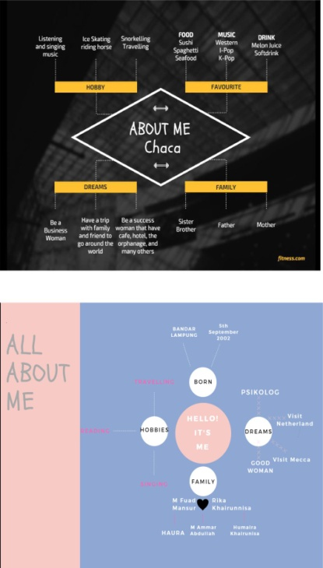

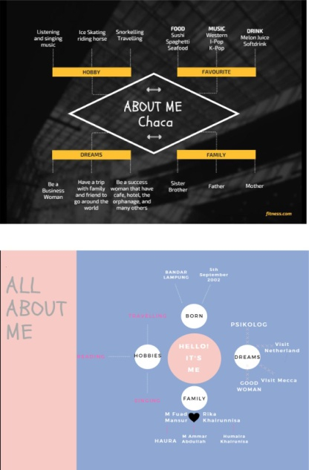

# *The improvement of students’ speaking skills in generating idea by using new concept of mind mapping*

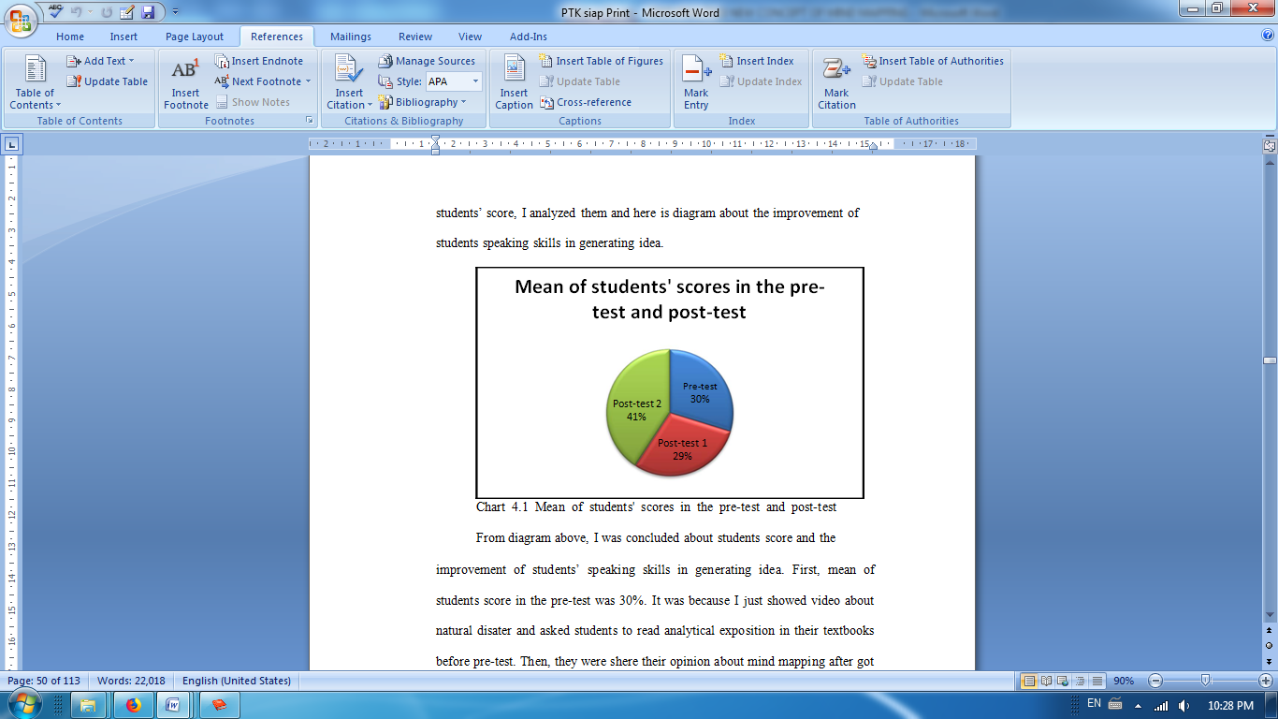

*Chart 5.1 Mean of students' scores in the pre-test and post-test*

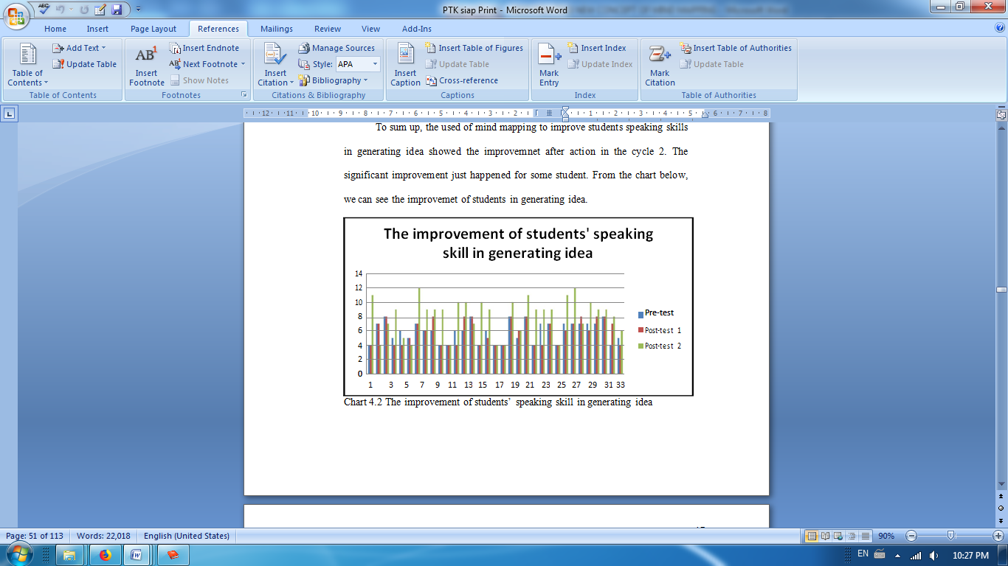

*Chart 5.2 The improvement of students’ speaking skill in generating idea*

|  |  |  |  |
| --- | --- | --- | --- |
| **Success criteria** | **Indicators of student performance** | | |
| **High** | **Medium** | **Low** |
| **Ability to identify key aspects of the design brief** | Accurately identifies most of the key aspects of  the design brief. | Identifies some key aspects of the design brief. | Identifies one or more key aspects of the design brief and develops criteria to reflect these aspect/s. |
| **Ability to describe the findings of the investigation and explain how it will help to inform**  **design ideas** | Clearly describes a range of things learnt from the investigation and  explains how the  findings will impact. | Describes somethings learnt from the investigation and explains how some of the findings will impact. | Lists some things learnt from the investigation and how the findings will impact on design ideas. |
| **Ability to generate ideas to address the design brief** | Generates a range of creative ideas that addresses all aspects of the brief. | Generates a range of ideas that eflects the main aspects of the brief and shows some  creativity. | Generates some ideas that cover aspects of the brief. Shows limited creativity. |
| **Ability to conclude the idea** | Clear, logical and detailed to conclude the idea. | Logical and detailed to conclude the idea. | Logical to onclude the idea but not detail. |

# *Conclusion*

Speaking is important skill in English language. As learner English language students should mastered this skill. Although speaking skills is important to communicate with each other and share our thought, the students faced some problem such as lack of vocabulary, worry make a mistake at using grammar and difficult to generate idea in speaking. From those problems, I tried to solve it and I was focused on improving students speaking skills in generating idea.

This study showed that mind mapping could be an effective to improve students’ speaking skills in generating idea. Mind mapping helped students to remembering the point or vocabularies that they want to use in speaking. Students also could generate their idea before speaking by make a mind mapping. Then, when students finished writing their mind, they could do speaking practice with using mind mapping. Based on those activities, students improved their performance in the second cycle.

The result also showed that the using of mind mapping in teaching-learning process was very interesting. Students were very excited when I asked them to make mind mapping in the paper or in *canva.com.* Then, when I asked them to collaborate with their friends to make mind mapping in the whiteboard, students very excited with this activities. So, Students could generate their idea by creating their mind mapping in some ways such as wrote in the paper in the whiteboard and using *canva.com*.

This strategy is a good strategy to be applied since it can solve the students’ problem in exploring vocabularies and generating ideas. On the other hand, mind mapping was interesting for students.

##### References

1. AlMutairi, A. N. (2015). The Effect of Using Brainstorming Strategy in Developing Creative Problem Solving Skills among male Students in Kuwait: A Field Study on Saud Al-Kharji School in Kuwait City. Journal of Education and Practice, 6(3), 136-145.
2. Anggraeni, F. M. (2014). The Effect of Mind Mapping Technique Towards the Students’ Speaking Ability at 7th Grade of SMPN 4 Bandar Lampung. The Second International Conference on Education and Language (2nd ICEL), 320-327.
3. AR Murni, i. (2017). Improving Students Ability in Speaking Descriptive Text by Using Mind Mapping. ENGLISH LANGUAGE TEACHING AND RESEARCH, 1(1), 97-111.
4. Aydoğan, H. (2014). The Four Basic Language Skills, Whole Language and Intergrated Skill Approach in Mainstream University Classrooms in Turkey. Mediterranean Journal of Social Sciences, 5(9), 678-680.
5. Brown, H. D. (2004). Language assessment. Principles and Classroom Practices. New York: Pearson Education.
6. Efrizal, D. (2012). Improving Students’ Speaking through Communicative Language Teaching Method at Mts Ja-alhaq, Sentot Ali Basa Islamic Boarding School of Bengkulu, Indonesia. International Journal of Humanities and Social Science, 2(20), 128-134.
7. Ernidawati, and Sutopo, D. (2017). Mind Mapping and Brainstorming Strategies in Students’ Writing with High and Low Interest. English Education Journal, 7(2), 164-168.
8. Farrell, T. S. (2008). Reflective Practice in the Professional Development of Teachers of Adult English Language Learners. Center for Applied Linguistics, 1-3.
9. Herring, S. R., and Jones, B. R. (2009). Idea Generation Techniques among Creative Professionals. Proceedings of the 42nd Hawaii International Conference on System Sciences, 1-10.
10. Kaminskienė, L., and Kavaliauskienė, G. (2014). Attitudes to Improving Speaking Skills by Guided Individual Activities. COACTIVITY: Philology, Educology , 22(1), 39–48 .
11. Rahmawati, Y., and Ertin. (2014). Developing Assessment for Speaking. IJEE, 1(2), 200-210.
12. Shabani, M. B. (2013). The Effect of Background Knowledge on Speaking Ability of Iranian EFL Learners. International SAMANM Journal of Marketing and Management, 1(1), 25-33.

**.**