DEVELOPING A PORTABLE FIELD LINE FOR GOBAK SODOR (LPGS) IN TRADITIONAL GAME LEARNING IN ELEMENTARY SCHOOL

1st Adnan Riyanto
Sport Science Department, Postgraduate Program
Yogyakarta State University
Special Region of Yogyakarta, Indonesia
ryanadnan7@gmail.com
2nd Raden Sunardianta
Sport Science Faculty
Yogyakarta State University
Special Region of Yogyakarta, Indonesia
sunardianta@uny.ac.id

Abstract - The research background is the lack of physical education learning facilities that facilitate teachers to teach traditional games more efficiently and effectively. This study aimed to develop a portable field line for gobak sodor (LPGS) as a traditional game learning facility in physical education. This was a research and development study. It used Borg & Gall’s development model adapted into seven stages, i.e. needs analysis, planning, and preliminary product development in the form of preliminary product making validated by a materials expert and an infrastructure facility expert. Then, the product was tried out to students through a small-group tryout, revision, a field tryout, and final product revision. The results of the study showed that the according to the field tryout for the portable field line for gobak sodor (LPGS) involving the students it was very good with a mean score of 4.28. It can be concluded that the developed portable field line for gobak sodor is appropriate as a traditional game learning facility in the physical education subject at school
Keywords— gobak sodor, learning facilities, traditional game, physical education

Introduction
Traditional games are one of the physical education learning materials in primary schools in Indonesia and are also included in the curriculum used in fifth grade elementary schools, namely the 2013 curriculum. In addition, traditional games are a means to introduce students to the cultural values and social norms needed to conduct social relations or contacts and play a role in accordance with social position in society.
Gobak Sodor game is a kind of traditional game from Indonesia which is played by children and is quite popular in Indonesia. This game is a group game consisting of two groups, where each team consists of three to five people. Each region has a game that has almost the same or a lot of similarities with games in other regions. About the name of the game there are the same, but not infrequently the name is different from other regions. As an example, it can be stated that in Central Java, it is known as the gobak sodor game, in Jakarta it is called galasin and others. (Soemitro, 1992: p172) [1].
Based on the Gobak Sodor game regulations by the Indonesian Ministry of Education and Culture in 1981 in the Gobak Sodor game the facilities and infrastructure needed are a 9 x 15 meter field divided into 6 sections with the size of each part being 4.5 x 5 meters lined with limestone , or painted with a line width of 5 cm.
The problems faced when learning physical education in the traditional game of the Gobak Sodor are when making the field of Gobak Sodor the students and teachers have difficulty in outlining and measuring the field so that the time used in making the field reduces the time for physical education learning so that the time that should be used for the delivery of material used to make the field. so we need a means that makes it easier for teachers to teach traditional games, especially the Gobak Sodor game.
The need for facilities in physical learning is very important meaning in learning physical education, health and sports must use learning facilities in accordance with needs. The existence of adequate learning facilities, the learning objectives of physical education will be more easily achieved, therefore the facilities are very important in supporting the smooth learning of physical education, sports and health. (Agus S. Suryobroto, 2004: 4) [2].
The development of physical education learning facilities, especially in the learning of the traditional Gobak Sodor game, is needed to make it easier for teachers to implement learning in addition to making the time spent in learning more effective and efficient. The innovation was in the form of research into the development of the Gobak Sodor portable field line (LPGS) Lapangan Portabel Gobak Sodor in traditional game learning in Elementary School.
II. METHODS
This research was conducted using development research According to Sugiyono (2012: p.297) [3] Development research is a research method used to produce certain products, and test the effectiveness of these products. Research and development aims to improve the quality of education.
In this study, the model that is a reference is the research model development of the Borg, Gall & Gall model. The development model was adapted to produce a simpler development model, which was used as a foundation in research.
This study aims to develop learning media on physical education and sports in health in elementary schools. The Borg, Gall & Gall development research model cited by Fajar Setyo P (2016: p.22) [4] research was simplified in stages to become as follows: 1) Preliminary Study, 2) Arranging Planning, 3) Initial Product Development, 4) Conducting Small Group Trials, 5) Product Revision, 6) Field Trials, 7) Revising Final Products.
The product trial is intended to collect data that is used as a basis for determining the quality of the Gobak Sodor Portable Field Line or Lapangan Portabel Gobak Sodor (LPGS) as a means of learning physical education produced. The trial design was consulted with material experts and Physical Education experts before the trial. After getting suggestions, revisions were made until the Gobak Sodor portable field line as a means of physical learning was appropriate for use in trials, the next step was trials that were expected to be able to find weaknesses, deficiencies, errors, and suggestions for improvement.
Trial subjects or respondents involved in this study are planned to amount to 10 students divided into 2 groups for small group trials in small trials 10 students were divided into two groups for the trial of playing the Gobak Sodor using the Portable Field Line of Gobak Sodor. In his book I Made Tegeh, et al (2014: p.7) [5] states that the Borg and Gall research model in preparatory field trials (small group trials) uses 6 - 12 subjects and 30 - 100 subjects of students for large group trials. . "The trial subjects in this study were fifth grade students of Sendangadi 1 Mlati State Elementary School, Sleman Regency.
The data generated in the form of qualitative data as the main data from this data in the form of suggestions and input from respondents as well as a description of the feasibility of the product. Data from material experts form the quality of the product in terms of the benefits of learning tools and the suitability of the physical education learning material and the benefits of validation using a questionnaire about the material provided. From the three aspects above, it can be seen that the feasibility of the Sodor Square field as a means of physical education learning. Data from physical education facilities and infrastructure experts in the form of product quality are reviewed from the aspect of appearance, aspects of facilities and infrastructure, aspects of benefits. From these three aspects, it can be seen that the feasibility of the Sodorobak portable field line as a means of physical education learning. Then the data from students are used to analyze the attractiveness and benefits of the LPGS for students.
The type of data used in research is qualitative and quantitative data. Qualitative data were obtained from the results of assessing the quality of portable field line products as a means of physical education learning. Quantitative data were obtained from questionnaires filled out by material experts, facilities and infrastructure experts, and students. The instrument used in this study was the results of product validity from material experts and Physical Education experts. The instrument in the form of product validity was obtained using a questionnaire and evaluation sheet that had been made based on the needs of the assessment. Techniques used in collecting data in this study include: 1) Observation, Observation is done at the beginning before the production of learning facilities (teaching practice activities) and carried out when the use of learning facilities. 2) Questionnaire, Questionnaire consists of the results of the feasibility test of material experts, physical education facilities and infrastructure experts, and students in the form of questionnaires.
Data analysis techniques used in this study were qualitative and quantitative. Qualitative data in the form of criticism and suggestions put forward by Physical Education facilities and infrastructure experts, traditional game material experts, and students were collected and abstracted to improve the LPGS as a means of physical education learning. The steps in data analysis include: (a) collecting rough data, (b) giving a score, (c) the score obtained is then converted to a Likert scale using a conversion reference from Sukardjo cited by Nur Rohmah Muktiani (2008: 80) [6], in the following table 1:
Table 1. Student Observation Items
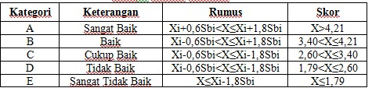

Results and discussions
The results of interviews with Physical Education teachers and writer's observations found that physical education learning facilities are needed that make it easier for teachers to teach traditional games as well as that physical education learning is effective and efficient. According to the statement above it is important to develop a learning tool that can accommodate the needs of teachers and students in the learning process of physical education, sports and health.
Making learning facilities products based on needs analysis that has been done before. After selecting the subject matter to be developed, the next step is to carry out a design process to produce learning tools with the stages of developing product concepts, creating visual designs, collecting materials, and making products from materials that have been collected. The material used for making the LPGS is webbing.
The data obtained from the validation of the material experts in phase I and phase II were then analyzed and used as a basis for revising the LPGS. Data from material expert validation consists of three aspects namely appearance, material and benefit aspects as follows:
Table 2. Results of Validation by Material Experts
Aspect  Assessment | Average  Score | Kriteria
Display Aspects | 4,8 | Very good
Material Aspects | 4,8 | Very good
Benefits Aspect | 4,4 | Very good
Average | 4,67 | Very good

Based on the data above, it can be seen that the results of the material expert's assessment of the LPGS are very good criteria that can be seen in the table. 29 after being converted on a scale of five that can be seen in table 4 as a reference assessment criteria. The overall score from the aspect of appearance, material aspects, and aspects of the benefits is 4.67 with very good criteria. The data obtained from the validation of facilities and infrastructure experts in phase I and phase II are then analyzed and used as a basis for revising the LPGS product. Data from the validation of infrastructure experts consist of three aspects, namely aspects of appearance, aspects of facilities and infrastructure, and aspects of benefits as follows:

Table 3. Validation Results by Physical Education Facilities and Infrastructure Experts
Aspect  Assessment | Average  Score | Kriteria
Display Aspects | 4,5 | Very good
Facilities and infrastructure Aspect | 4,4 | Very good
Benefits Aspect | 4,4 | Very good
Average | 4,43 | Very good

Based on the above data it can be seen that the aspects of the display got a score of 4.5 with very good criteria, then for the aspects of facilities and infrastructure got a score of 4.4 with very good criteria and the benefit aspect got a score of 4.4 with very good criteria, from all three aspects can be concluded that the results of the assessment of facilities and infrastructure experts on the product design of the LPGS are very good criteria with a mean of 4.43.
Small group trials are conducted after evaluations from material experts and media experts. The trial was conducted by ten respondents, namely fifth grade students of Sendangadi 1 Mlati State Elementary School, Sleman Regency with different characteristics. Data obtained from small group trials is a data quality of learning facilities developed with several aspects including display aspects, content / material aspects, and benefits aspects. The results of the small group trial are as follows:
Table 4. Small Group Trial Results
Aspect  Assessment | Average  Score | Kriteria
Display Aspects | 4,18 | Good
Material Aspects | 4,32 | Very good
Benefits Aspect | 4,49 | Very good
Average | 4,33 | Very good

The data above shows that the mean rating of the respondents in the small group trial as a whole regarding the quality of the learning tool of the LPGS from the aspect of appearance, material aspects, and aspects of benefits is included in the "very good" category with a mean score of 4.33. The scores were obtained from a questionnaire filled out by ten 5th grade students of Sendangadi 1 Public Elementary School who had tested the LPGS. The assessment criteria can be seen from the table. 4, namely the results of the conversion from quantitative to qualitative as a reference criteria for the assessment of the products of the Sodorobak portable field line.
Field trials are carried out after small group trials. The trial was conducted by 30 respondents, namely elementary school students Sendangadi 1 Mlati fifth grade. The data obtained from the field trial is a data quality of the learning facility of the LPGS that was developed which includes several aspects including the display aspect, the content / material aspect, and the benefit aspect. From field trials obtained data quality of learning facilities developed. The results of the field trial are as follows:

Table 5. Field Trial Results
Aspect  Assessment | Average  Score | Kriteria
Display Aspects | 4,19 | Good
Material Aspects | 4,31 | Very good
Benefits Aspect | 4,35 | Very good
Average | 4,28 | Very good
The data above shows that the average rating of respondents from 30 Sendangadi State Elementary School students in the overall field trial regarding the quality of learning facilities in the LPGS is included in the "very good" category with a mean of 4.28. Scores were obtained from questionnaires filled out by 30 fifth grade students of Sendangadi 1 State Elementary School who had conducted field trials on the LPGS products. The results of the field trial are then presented in the form of a diagram as follows:
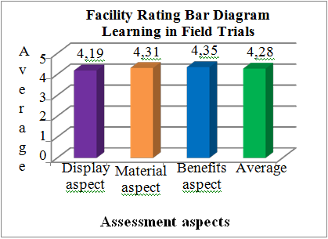
Product Revision
Based on suggestions from material experts as explained in the previous discussion, products in the form of learning tools that are being developed can be revised based on these suggestions. The first phase of the revision was to evaluate the design of material experts and physical education infrastructure. After evaluating the design of the material expert and infrastructure expert, then proceed with the manufacture of the LPGS in accordance with the advice and evaluation given by the material expert and physical education facility infrastructure expert.
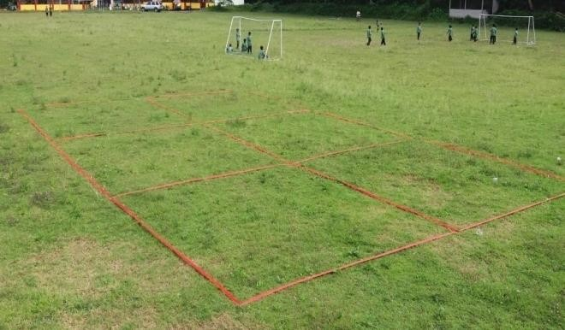
Figure 2. Stage One Product Revision Results
The second phase of the revision was carried out by refinement of the Sodorobak portable field line along with its completeness, in accordance with the evaluation in Phase 1 of the LPGS product, which was accompanied by completeness in the form of stakes made from iron for grass or soil. Then the difference with the product before being revised in the second stage is the color of the Sodor line which was originally red in color changed to blue, in addition to making the field lines more attractive also to show that the LPGS.
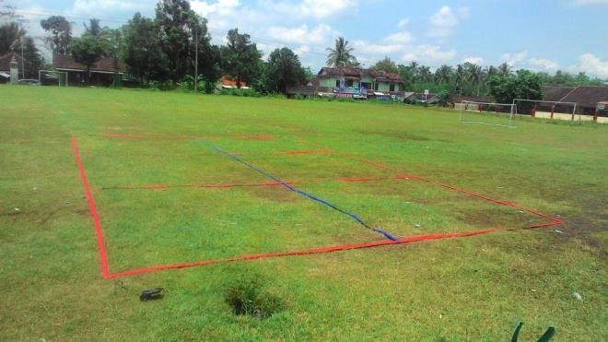
Figure 3. Phase Two Product Revision Results
The final product of the LPGS was further refined by making its completeness in the form of usage guidelines and tape sticks used to install the Sodor Gobar Portable Field Line in the block or cement field which previously in revision II could only be installed in the grass field. Besides being equipped with usage guides and also duct tape for installation in the field of the block, the portable field product line of Sodor Kobor also has a bag for easy storage and easy to carry everywhere. The final product line of the Sodorobak Portable Field Line can be seen in the following image:
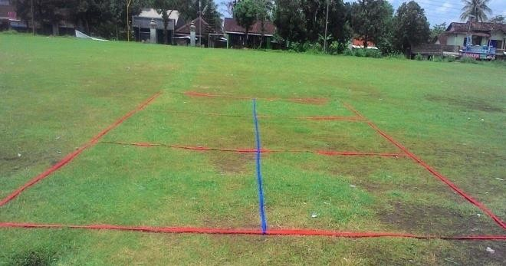
Figure 4. Final Product Results
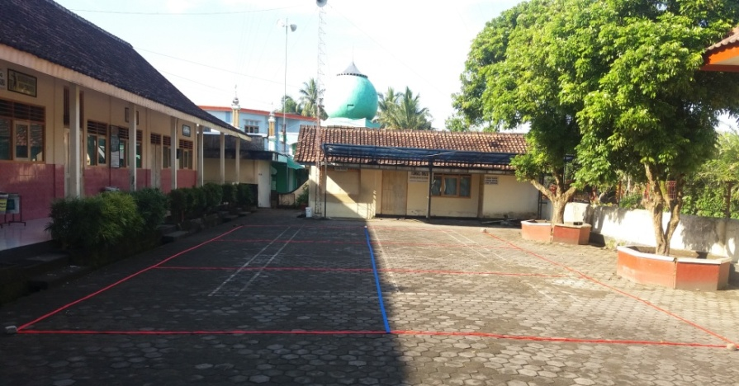
Figure 5. Portable Gobak Sodor Line in Conblock Field
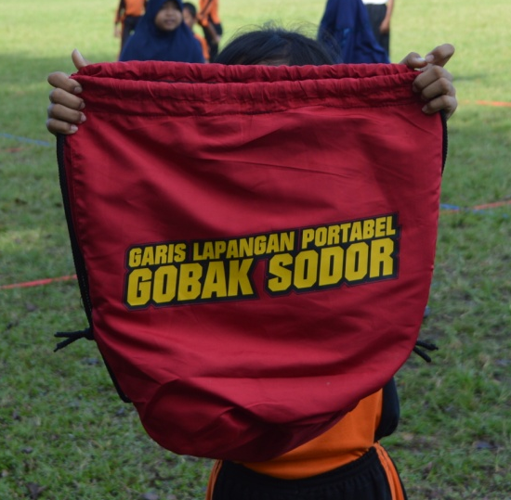
Figure 6. LPGS bag
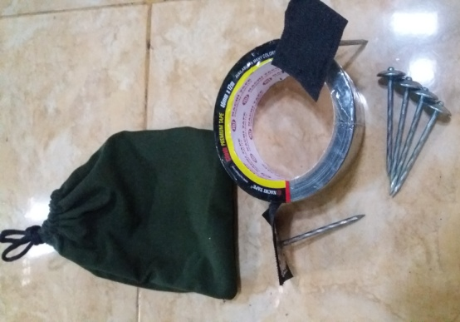
Figure 7. nails and duct tape
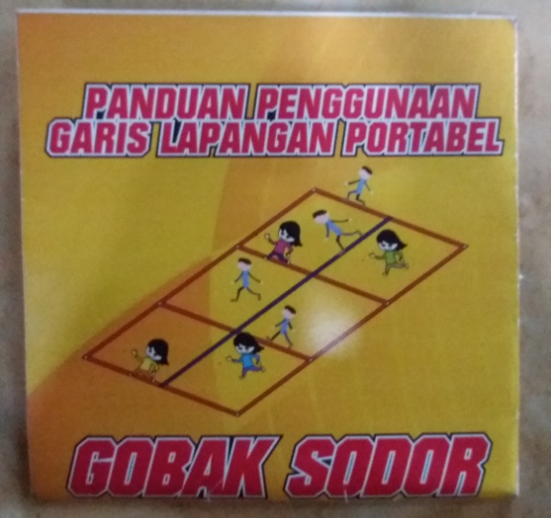
Figure 8. Guidance for Using the Portable Gobak Sodor Field
Product Development Results
This research is a type of development research. The results of this development research are Physical Education learning products in the form of the LPGS. Research and development is carried out with reference to the stages of development research according to Borg & Gall. There are ten stages in development, but in this research and development the ten steps are simplified into seven steps. The factors underlying the simplification are: 1) Time constraints, 2) Cost limitations 3) Borg & Gall's opinion quoted by Yunita Dwi Kartika (2014: 77) Suggest to limit research development on a small scale including limiting the research steps in thesis and dissertation research.
Final Product Review
Development of physical education learning facilities in the LPGS through various stages in accordance with research and development procedures. The initial stage of making this learning tool is by observing problems and needs in the field and then doing a literature study. Thus the development of learning facilities products is carried out in accordance with the needs in the field. The process of making the learning facilities at an early stage is designing the product to be made. After the design is finished the design is then validated by traditional game material experts and physical education infrastructure facilities experts.
After the design is approved, the next step is to prepare tools and materials to create a product in the LPGS. The material used for making the LPGS is a webbing strap with a size 15 m x 9 m are then sewn to LPGS. After becoming a product of LPGS, it is then validated by experts, both traditional game material experts and physical education facilities and infrastructure experts, which are then carried out by small group trials and field trials.
Analysis of the data that has been done shows that the quality of the product of the LPGS from experts in infrastructure is included in the category of "very good" from the material experts got a score of "very good" from small group trials received a score of "very good" and in the final tryout namely trials LPGS also got a "very good" score. The opinions of students as respondents who have used the product informally expressed their opinion that learning tools like this make it easier for students to play Gobak Sodor games easily while attracting students to play Gobak Sodor games. Judging from the aspect of appearance according to students this learning tool has an attractive appearance and bright colors, besides that it is also easy to install the LPGS.

IV. Conclusions and Suggestions
Conclusions
Based on the results of research on the product development of physical education, sports and health learning facilities, it can be concluded that the product of the Sodorobak portable field line is feasible to be used as a means of physical learning and gets an average score of 4.28 with "very good" criteria.
Suggestions
Research on product development of physical education learning facilities, sports, and health in the LPGS is expected to provide benefits and advice from several parties. This learning facility product is used in the physical education, sports, and health learning process for fifth grade elementary schools as a tool that can help the learning process and be able to increase student interest. For developers / researchers learning facilities for physical education in the LPGS can be a guideline for conducting the next stage of research.

References
- Soemitro. (1992). “Permainan Kecil”. Jakarta : Depdikbud
- Agus S Suryobroto. (2004). “Sarana dan Prasarana Pendidikan Jasmani”. Yogyakarta: Universitas Negeri Yogyakarta.
- Sugiyono. (2012). “Metode Penelitian Kuantitatif Kualitatif dan R&D”. Bandung: Alfa Beta
- Fajar Setyo Pranyoto. (2016). “Pengembangan Bola Reaksi Sebagai Sarana Pembelajaran Pendidikan Jasmani Guna Meningkatkan Reaksi Serta Koordinasi Mata Tangan dan Kaki.” Skripsi. UNY
- I Made Tegeh, I Nyoman Jampel, & Ketut Pudjawan. (2014). “Model Penelitian Pengembangan”. Yogyakarta: Graha Ilmu.
- Nur Rohmah Muktiani. (2008). “Pengembangan Multimedia Interaktif Untuk Pembelajaran Pendidikan Jasmani, Olahraga, dan Kesehatan SMA”. Tesis. PPs-UNY.

